LIBRARY MANAGEMENT SYSTEM
ABSTRACT

This Project of Library Management System is developed for TRIZ Innovation Pvt Ltd. This project is basically for library management.

As most of library management system provides only physical resource management. But we have tried to give virtual and physical resource management both facility.

Library Management System includes adding,updating, and deleting of physical and virtual resources. We have facility for uploading data through csv so that directly without adding single resource we can add multiple resources.

Library Management System has facility of MARC and Z39.50 import which are the fastest and most acceptable import functionality by each e-library. It has membership creation and maintenance of membership functionality. It has bar code generator facility for each item and membership card generator facility.

Library Management System has member login available. Member can login and see particular resources. He can see any virtual resources which he has access. He can request for books available. He can create its own document using google docs and inbuilt editor system.

Library Management System is new generation system. It is made by focusing on future requirement of any library. This computer oriented world needs such kind of fast facility which we have tried to fulfill.

Library Management System is made on PHP and Apache MYSQL. We have tried our best to fulfill all requirements.

TABLE OF CONTENTS

Sr. No | Title | Page No.
1 | Introduction | 3
1.1 | Project Detail | 3
1.2 | Purpose | 3
1.3 | Scope | 3
1.4 | Objectives | 3
2 | Information Flows | 5
2.1 | System Flow Diagram | 5
3 | Database Structure | 6
3.1 | DB Schema | 6
4 | Module Description | 25
4.1 | Admin | 25
4.2 | Member | 111
5 | Future Integration | 127

1. INTRODUCTION

1.1 Project Detail

This project is made for library. This project will help to library of various schools and colleges. This is made on PHP and MYSQL.

1.2 Purpose

Basic purpose of this system is to provide virtual and physical resource management. Also this system has implemented new purpose of online read materials which we have integrated with this system. System's main purpose is to provide wide online resources to user. It will also manage physical resources like books, CD, newspapers etc. It can manage issue, return, renew of various physical resources.

1.3 Scope

This project will help librarian(admin) and members of library. Admin can add, update and delete members. He can add, update and delete of various library resources. He can start circulation transaction of member. He can make budget of library for various items. Admin can upload virtual resources.

Member of this system can login into system. Search his required material. Make request for material which he want. We have provided document creation facility in our library for members. Member can create his document and manage it.

1.4 Objectives

1. To provide wide and rich level of resources.
2. To provide facility of reading material online.
3. To provide easily and fast search facility of materials for members.
4. To provide management of physical resources without manually record keeping.

2. INFORMATION FLOW

2.1 System Flow Diagram

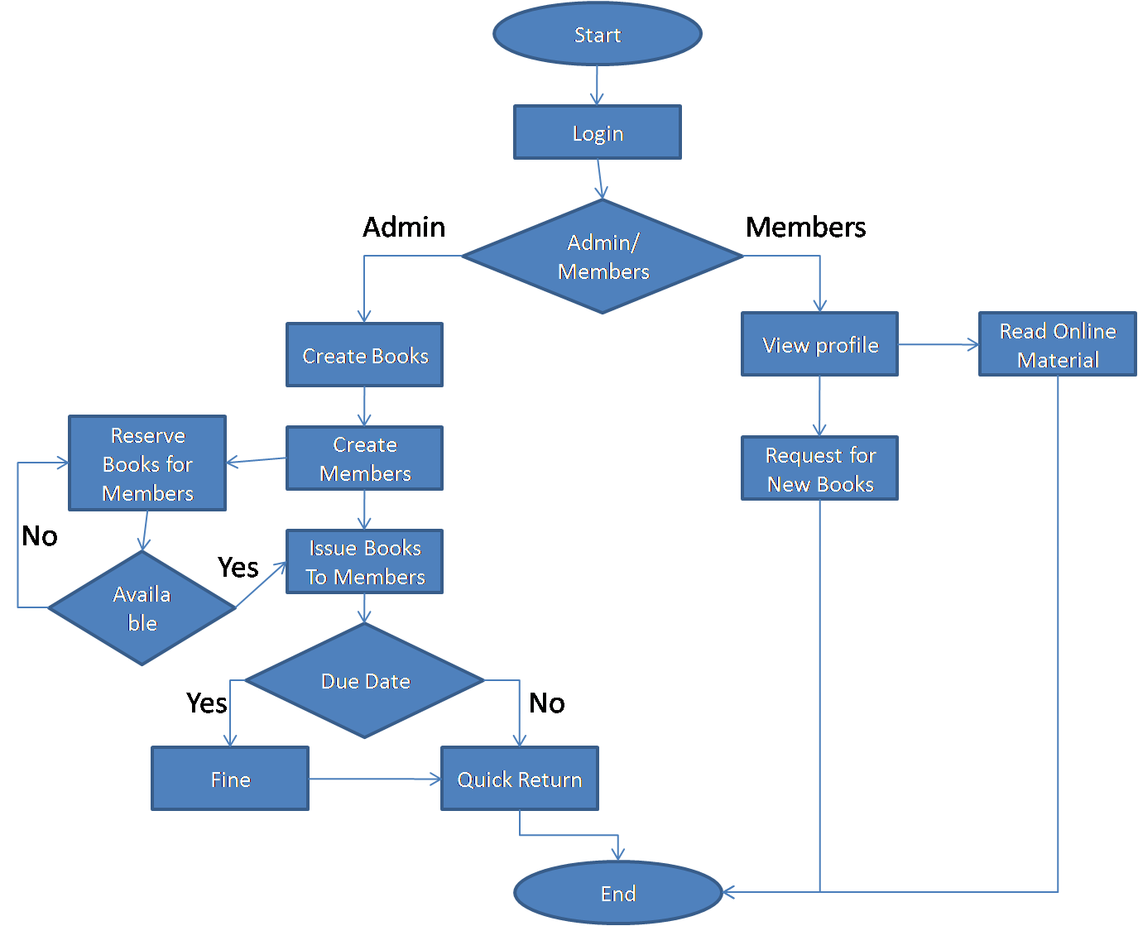

3. DATABASE STRUCTURE

3.1 DB Schema

1. user :- This table is for system user.
user
Field | Information
user_id | Id of created user
username | Username of user
realname | Real name of user
passwd | Password of user
last_login | Last login time and date
last_login_ip | Last login ip address
groups | User group info from user_group
input_date | input date
last_update | last updated date

2. user_group :-This table is for which type of user. It will create user groups.
user_group
Field | Information
group_id | id of usergroup
group_name | name of group
input_date | input date
last_update | last updated

3. setting :- This table is for setting configuration of system.
setting
Field | Information
setting_id | id of perticular setting properties
setting_name | name of setting properties
setting_value | value of setting

4. member :- This table will keep record of members.
member
Field | Information
member_id | id of perticular member
member_name | name of member
gender | value of gender
birthdate | birthdate of member
member_type_id | member type id from mst_ member_type
member_address | address of member
member_email | email address of member
postal_code | postal code of member
inst_name | name of institute
is_new | member is new or old
member_image | image of member
pin | pin code of member
member_phone | phone number of member
member fax | fax of member
member_since_date | date of membership started
register_date | date of registration
expire_date | date of expiration
member_notes | notes of member
is_pending | pending membership
mpassword | password of member
issue | any issued book or bebliography
checkin | any checkins
reserves | reserves any taken
last_login | last login date and time
last_login_ip | last login ip address
input_date | input date
last_update | last updated date

5. mst_member_type :- This table is for member type detail of members.
mst_member_type
Field | Information
member_type id | id of member type
member_type_name | member type name
loan_limit | limit of loan
loan_period | period of loan
enable_reserve | reserve is enabled or disabled
reserve_limit | reserve limit
member_period | membership period
reborrow_limit | reborrow limit
fine_each_day | fine each day
grace period | grace period given for any member
issue | any issue set
checkin | any checkin set
reserve | any reserve set
input_date | date of input
last_update | last updation made

6. mst_material_resource_type :- This table will include details of material resource type.
mst_material_resource_type
Field | Information
material_resource_id | id of material resource
material_resource_name | name of material resources
active_inactive | active or inactive perticular material
input_date | date of input
last_update | last updated date

7. mst_gmd :- This table will include child type material of material_resource_type.
mst_gmd
Field | Information
gmd_id | id of gmd
gmd_code | id from mst_material_resources_type
gmd_name | name of gmd
active_inactive | activated or inactivated
icon_image | icon image of perticular gmd
input_date | date of input
last_update | last updated date

8. mst_material_sub_type :- This table will include child type material of mst_gmd.
mst_material_sub_type
Field | Information
material_sub_id | id of sub material of material resource
gmd_id | id of material resources from mst_gmd
material_sub_name | name of sub material
input_date | date of input
last_update | last updated date

9. mst_author :- This table will include author details.
mst_author
Field | Information
author_id | id of perticular author
author_name | name of perticular author
author_type | type of author
auth_list | list of author
input_date | date of input
last_update | last updated date

10. mst_coll_type :- This table will define collection type of particular resources.
mst_coll_type
Field | Information
coll_type_id | id of collection type
coll_type_name | name of collection type
input_date | date of input
last_update | last updated date

11. mst_frequency :- This table will include frequency of particular material publish.
mst_frequency
Field | Information
frequency_id | id of frequency
frequency | frquency name
language_prefix | language prefix or used
time_increment | like if quarterly so 1/3 such kind of flag set
time_unit | unit of time increment
input_date | date of input
last_update | last updated date

12. mst_item_status :- This will include item status of item of particular material.
mst_item_status
Field | Information
item status_id | id of status of items
item_status_name | name of status of item
rules | any rules set for item status
no loan | set or not set
skip_stock_take | set or not set
input_date | date of input
last_update | last updated date

13. mst_label :- This will include which type of label in system.
mst_label
Field | Information
label_id | id of label
label_name | name of label
label_desc | description of label
label_image | image of label
input_date | date of input
last_update | last updated date

14. mst_language :- This will include language of particular material.
mst_language
Field | Information
language_id | id of language installed
language_name | name of language
input_date | date of input
last_update | last updated date

15. mst_loan_rule :- This table is for particular loan rules for member type.
mst_loan_rule
Field | Information
loan rule_id | id of loan rule
member_type_id | id of member type from mst_member_resource_type
coll_type_id | id of collection type coll_type_id
gmd_id | id of gmd from mst_gmd
loan_limit | limit of loan
loan_period | period of loan
reborrow_limit | reborrowing limit
fine_each_day | each day fine
grace_period | period of grace
input_date | date of input
last_update | last updated date

16. mst_location :- This will include location detail of materials where it has been put in library.
mst_location
Field | Information
location_id | id of location
location_name | name of location
input_date | date of input
last_update | last updated date

17. mst_place :- This will include place detail of material.
mst_place
Field | Information
place_id | id of place
place_name | name of place
input_date | date of input
last_update | last updated date

18. mst_publisher :- This will include publisher detail.
mst_publisher
Field | Information
publisher_id | id of publisher
publisher_name | name of publisher
input_date | date of input
last_update | last updated date

19. mst_standard :- This table is for standard detail.
mst_standard
Field | Information
standard_id | id of standard
standard_name | name of standard
input_date | date of input
last_update | last updated date

20. mst_topic :- This will include topic detail of subject.
mst_topic
Field | Information
topic_id | id of topic
topic | name of topic
topic_type | type of topic
auth_list | list of auth
input_date | date of input
last_update | last updated date

21. mst_subject_type :- This will include subject type of subject.
mst_subject_type
Field | Information
subject_type_id | id of subject type
topic_id | id of topic from mst_topic
subject_type_name | name of subject type
input_date | date of input
last_update | last updated date

22. mst_supplier :- This will include supplier detail.
mst_supplier
Field | Information
supplier_id | id of supplier
supplier_name | name of supplier
address | address of supplier
postal_code | postal code of supplier
phone | phone number of supplier
contact | contact of supplier
fax | fax of supplier
account | account of supplier
email | email id of supplier
input_date | date of input
last_update | last updated date

23. stock_take :- This will include stock taking detail of the stock.
stock_take
Field | Information
stock take_id | id of stock taken
stock_take_name | name of stock taken
start_date | date and time of start
end-date | date and time of end
init_user | initiation type of user
total_item_stock_taked | total item stock taken
total_item_lost | item lost number
total_item_exists | item exists
total_item_loan | loan of total item
stock_take_user | user of stock taken
is_active | active or inactive
report_file | report generation file

24. stock_take_item :- This will include stock take item detail.
stock_take_item
Field | Information
stock take_id | id of stock taken
item_id | id of item taken of stock
item_code | code of item
gmd_name | name of gmd
classification | classification of stock_taken
coll_type_name | collection type name
call_number | call number
location | location name
status | status of stock taken
checked by | checked by user
last_update | last updated time and date

25. visitor_count :- This will include visitor count detail.
visitor_count
Field | Information
visitor_id | id of visitor
member_id | id of member from members
member_name | name of member
institute | institute of member
ckeckin_date | date of checkin

26. biblio :- This will include material detail of resources. Basically for all material this is master table for their details.
biblio
Field | Information
biblio_id | unique id of biblio
material_resource_id | id from mst_material_resource_type
gmd_id | gmd_id from mst_gmd
material_sub_id | material sub id from mst_material_sub_type
title | name or title of biblio
subtitle | subtitle of biblio
tags | important tags in biblio
edition | edition of biblio
isbn_issn | ISBN OR ISSN number of biblio
publisher_id | id of publisher from mst_publisher
publisher_year | year of publisher
collation | collation of biblio
series_title | series title of biblio
series_no | series number
call_number | call number
language_id | language name from mst_language
source | source of biblio
publish_place_id | place id from mst_place
classification | classification id from mst_classification
review | review of biblio
notes | notes of biblio
image | image of biblio
file_attr | attribute of file
opac_hide | opac is hide or set
promoted | promoted or not promoted
labels | labels of biblio
frequency_id | id of frequency from mst_frequency
spec_detail_info | detail information of biblio
price | price of biblio
price_currency | currency price
city | city name
state | state name
country | country name
vol_no | number of volume
issue_no | number of issue
publication_date | date of publication
duration | duration of publication
company | publication company
actors | actors of publication
age_group | age of group
awards | awards detail
qualification | qualification
college_inst_dept | department of college institute
university | university of college
index_no | index no of biblio
doc_type | type of document or biblio
editorial | editorial of biblio
subject | subject name from mst_subject_type
standard | standard name from mst_standard
input_date | date and time of input
last_update | last updated date and time

27. file :- This will include detail of any file attached with material.
file
Field | Information
file_id | unique id of file
file_title | title of file
file_name | name of file
file_url | url of file
file_dir | directory of file
mime_type | type of mime
file_desc | description of file
uploader_id | id of user uploaded file
input_date | date and time of input
last_update | last updated date and time

28. biblio_attachment :- This will include biblio attachment detail.
biblio_attachment
Field | Information
biblio_id | id of biblio from biblio
file_id | id of file from file
access_type | type of access
access_limit | limit of access

29. biblio_author :- This will include detail of authors attached with materials.
biblio_author
Field | Information
biblio_id | id of biblio from biblio
author_id | id of author from mst_author
level | level of author which kind of author

30.
biblio_standard
Field | Information
biblio_id | id of biblio from biblio
standard_id | id of author from mst_standard

31. biblio_topic :- This will include topic which is attached with biblio.
biblio_topic
Field | Information
biblio_id | id of biblio from biblio
topic_id | id of topic from mst_topic
subject_type_id | id of subject type from mst_subject_type
level | level of biblio topic

32. content :- This will include content detail information.
content
Field | Information
content_id | id of content
content_title | title of content
content_desc | description of content
content_path | path of content
input_date | date and time of input
last_update | last updated date and time

33. fines :- This will include details of fines.
fines
Field | Information
fines_id | id of fine
fines_date | date of fines
member_id | id of member
debet | debet amount
credit | credit amount
description | description of fines

34. group_access :- This will include user group access detail of modules.
group_access
Field | Information
group_id | id of group from user_group
module_id | id of module from mst_module
r | read mode set/unset
w | write mode set/unset

35. holiday :- This will include details of holiday.
holiday
Field | Information
holiday_id | id of holiday
holiday_dayname | holiday day name
holiday_date | date of holiday
description | description of holiday

36. item :- This will include item details of biblio. This is for item record of particular material.
item
Field | Information
item_id | id of item
biblio_id | id of biblio from biblio
call_number | number of call
coll_type_id | id of collectin type from mst_coll_type
item_code | code of item
inventory_code | code of inventory
received_date | date of receiving
supplier_id | id of supplier from mst_supplier
order_no | no of order
location_id | id of location from mst_location
order_date | date of order
item_status_id | id of item status from mst_item_status
site | any site given
sorce | set or not set
invoice | invoice of item
price | price of item
price currency | currency of price
invoice_date | date of invoice made
input_date | date and time of input
last_update | last updated date and time

37. loan :- This will include loan detail of particular item. This is for item issue,return, renew details.
loan
Field | Information
loan_id | id of loan
item_code | item code from items
member_id | id of member from members
loan_date | date of loan
due_date | due date of loan
renewed | if loan is renewed set/unset flag
loan_rule_id | id of loan rules from mst_loan_rules
is_lent | set/unset flag
is_return | set/unset flag
return_date | date of return
time | time of return

38. reserve :- This will include reserve detail of particular item.

reserve
Field | Information
reserve_id | id of reserve
member_id | id of member from members
biblio_id | Id of biblio from biblio
item_code | item code from items
reserve_date | date of reserve

39. budget_records :- This will include records of budget. This table is for budget modules.

budget_records
Field | Information
record_id | id of budget records
title | Title of particular material.
author | Author of particular material.
qty | Quantity of particular material.
price | Price of particular material.
total | Total of budget.
budget_id | Budget id from mst_budget

40. mst_budget :- This will include budget detail. This is for budget module.

budget_records
Field | Information
budget_id | id of budget.
expected_budget | Expected Budget
available_budget | Available Budget
total_budget | Total Budget
year | Year of budgeting.

4. Module Description(With Screenshots)

There are basically two types of flows one is for admin and another is for member.

4.1 Admin

1) Login

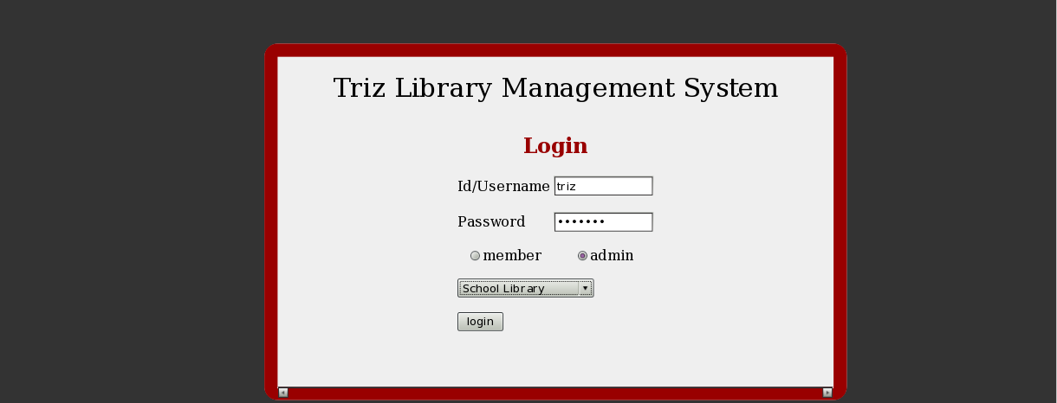
As shown in figure you can see there are two fields Id/Username and Password.

Before clicking on login you need to select which type of user you are whether member or admin. And also you need to select in which library you have to enter school library or engineering library.

Here we are selecting admin and school library and after clicking on login you will see following page.

2. Main Home Page

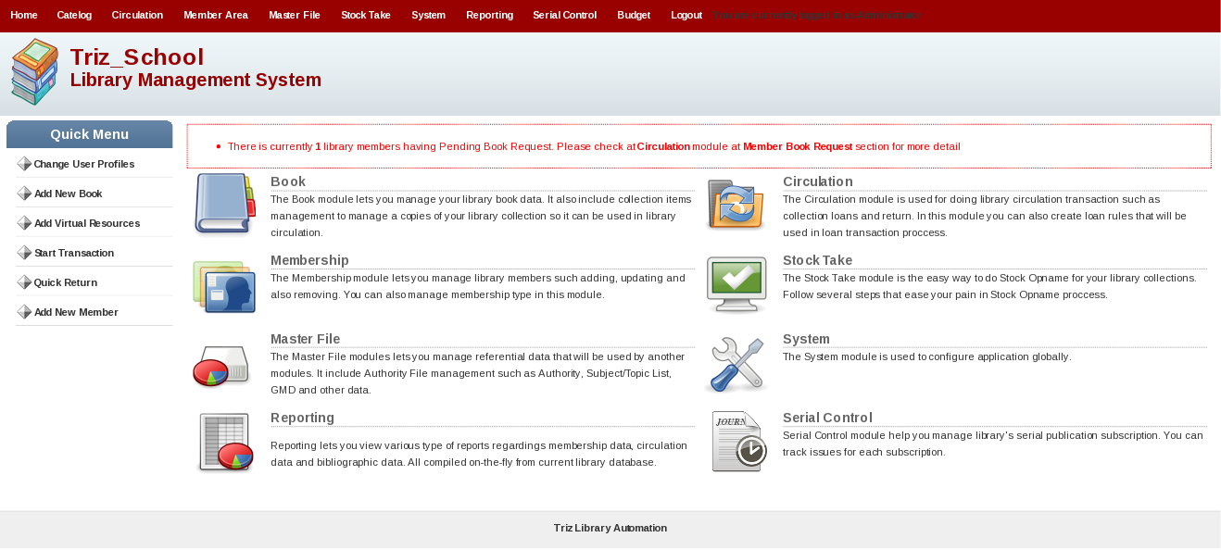
As shown in figure you will see 3 main parts

[1] Menu Bar on top side which have following menus

- Home
- Catelog
- Circulation
- Member Area
- Stock take
- System
- Reporting
- Serial Control
- Budget
- Logout

[2] Icon and Content Bar in Middle portion Right Hand side. This will be same as Menu bar but includes icon + description of that menu.

[3] Left hand side you can see Quick Menu which include following Menus

- Change User Profile
- Add New Book
- Add Virtual Resources
- Start Transaction
- Quick Return
- Add New Member

This will be explained in Home Menu.

3. Home Menu

Home Menu will include following links.

1. Change User Profile
2. Add New Book
3. Add Virtual Resources
4. Start Transaction
5. Quick Return
6. Add New Member

[1] Change User Profile

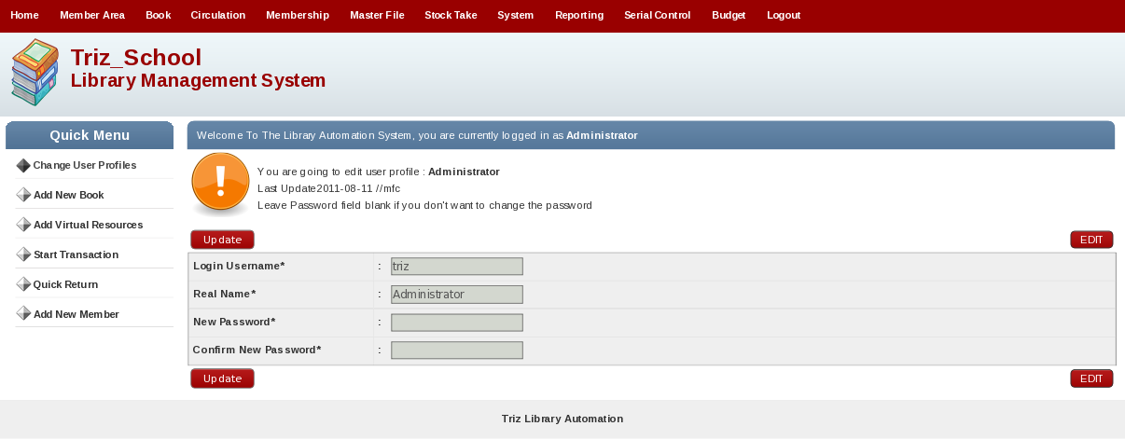

As shown in the above picture it shows the fields like Login User name, Real Name, New password and Confirm Password. From this page we can change the User name, Real name and password. On Clicking on the button Edit, the fields are ready for the edit. After making change click on the button Update to save the changes made.

[2] Add New Book

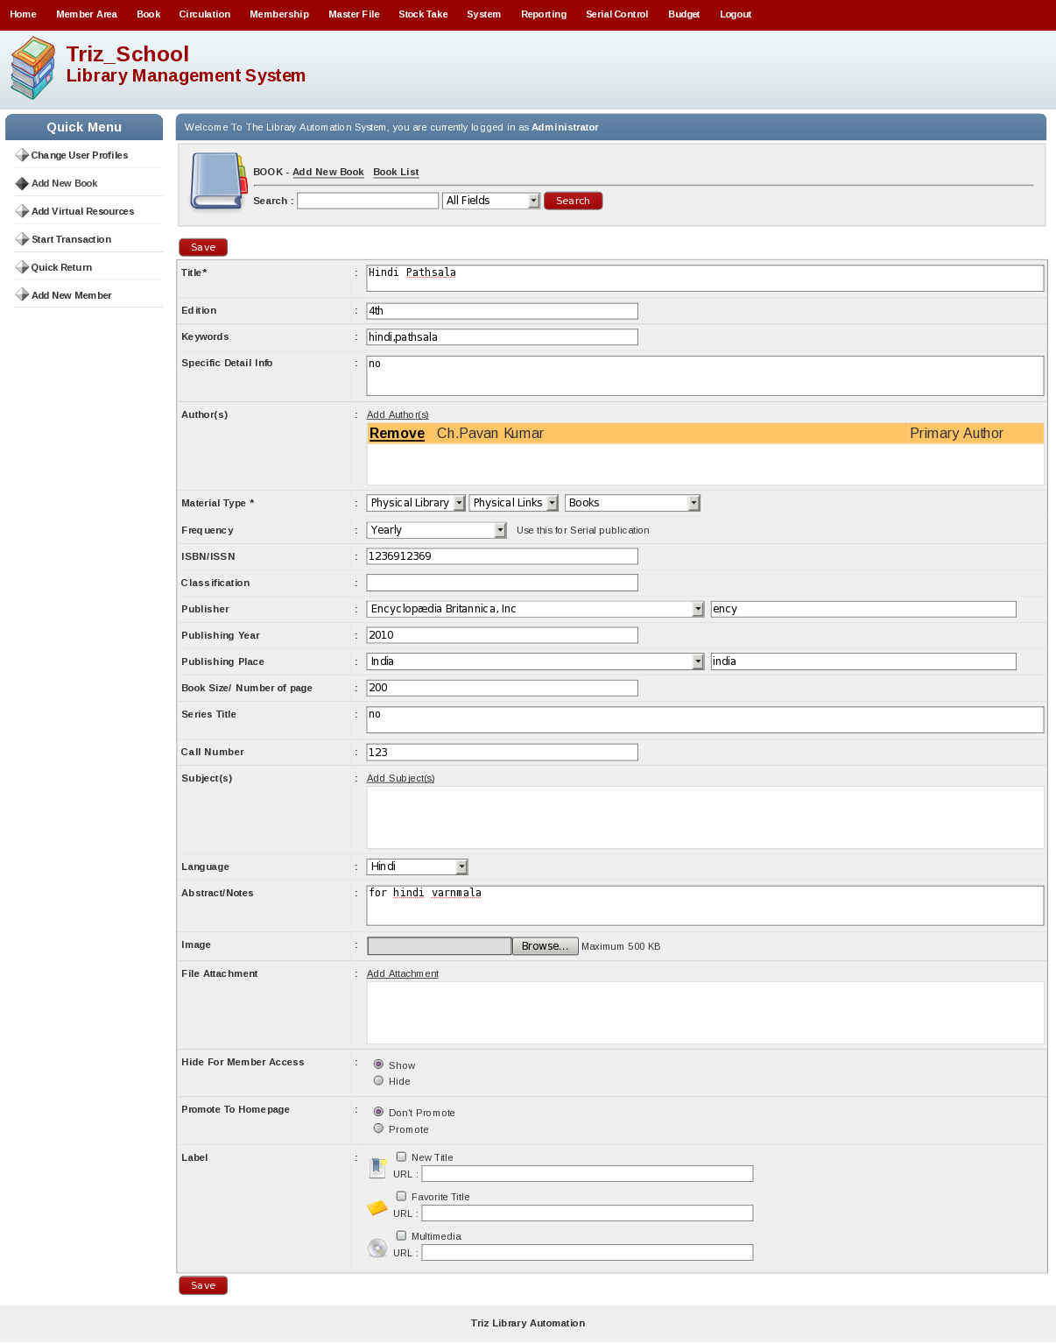
This will be explained in Book Module Later. But this will be direct link for Adding any physical resources.

[3] Add Virtual Resources

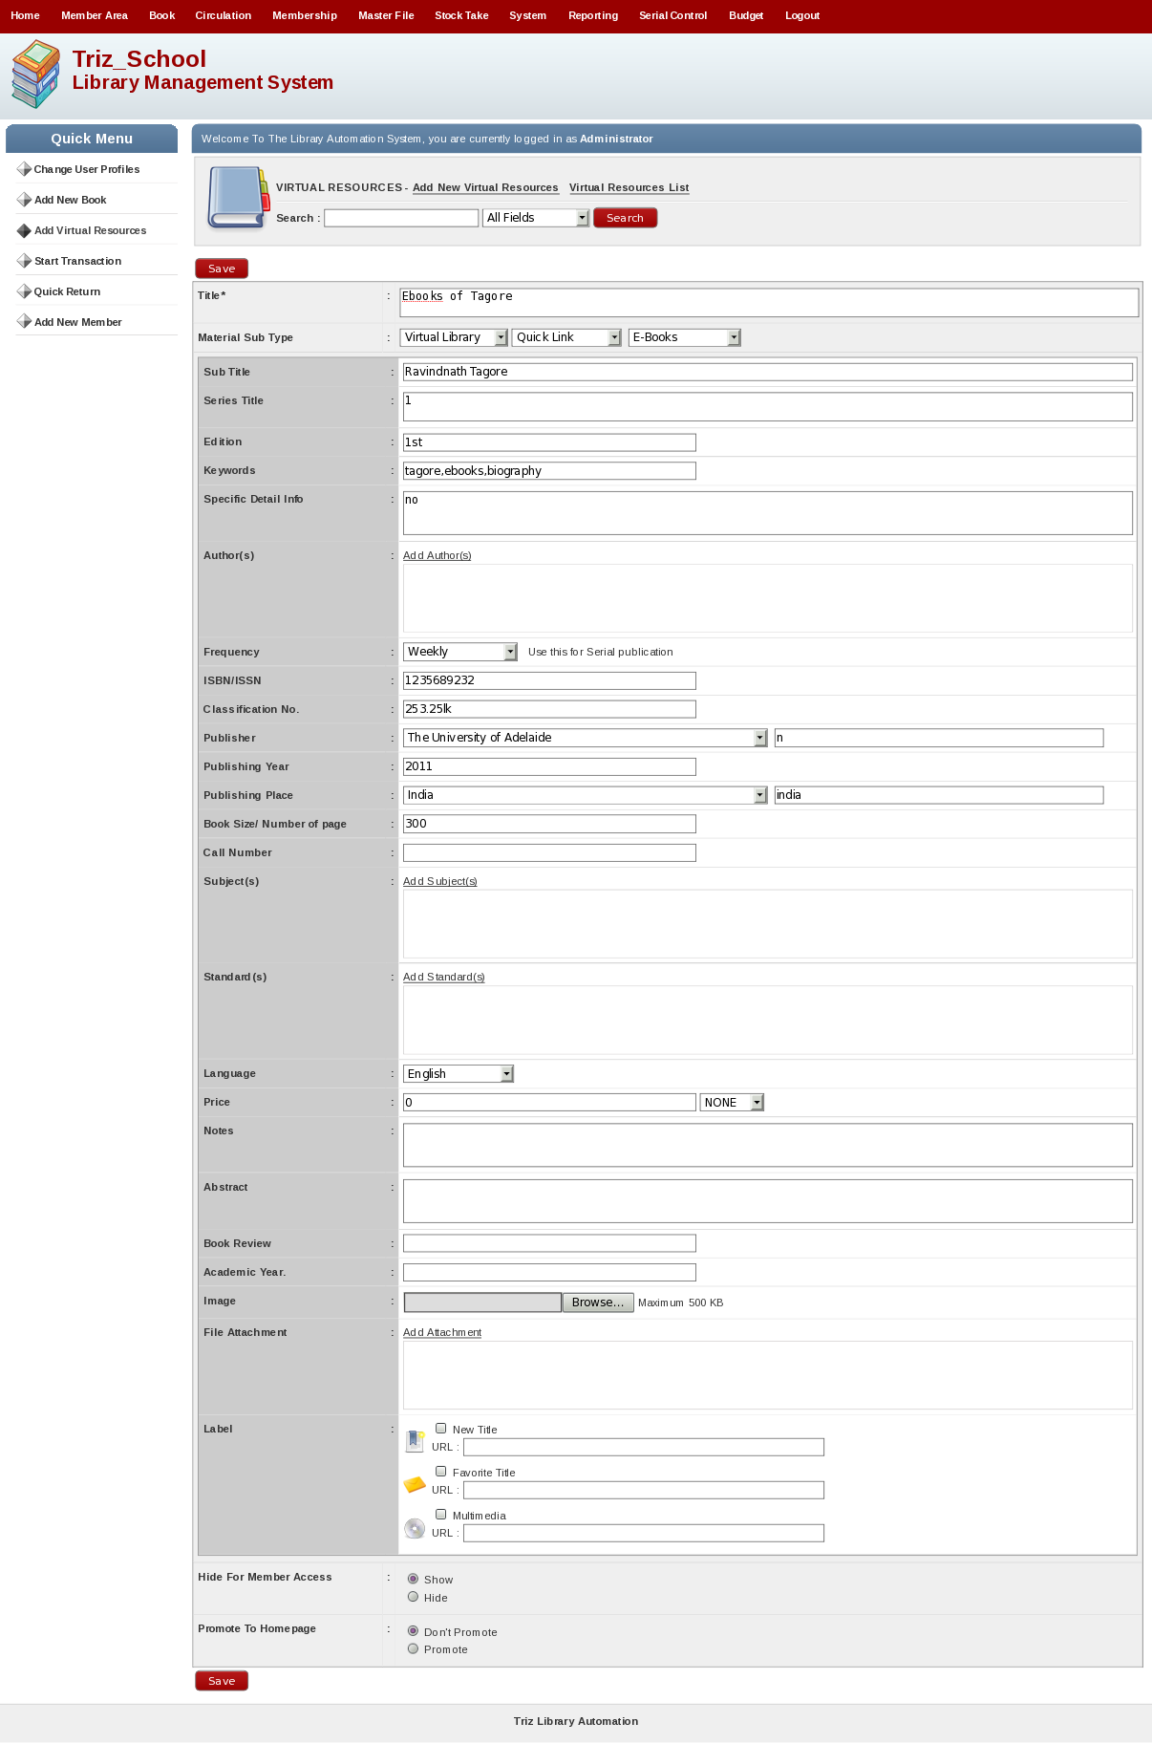
This will be explained in Book Module Later. But this will be direct link for Adding any Virtuall resources.
[4] Start Transaction

This will be explained in Circulation Module Later. But this will be direct link for Adding any Virtual resources.

[5] Quick Return

This will be explained in Circulation Module Later. But this will be direct link for returning any physical book issued.

[6] Add New Member

This will be explained in Member Module Later. But this will be direct link for adding new member in libarary.

4. Catelog

Book Menu Will display following screen and it will include following submenus.

- Book
- Item
- Z3950 Service
- Import MRC File
- Print
- Import
- Export

[1] Book

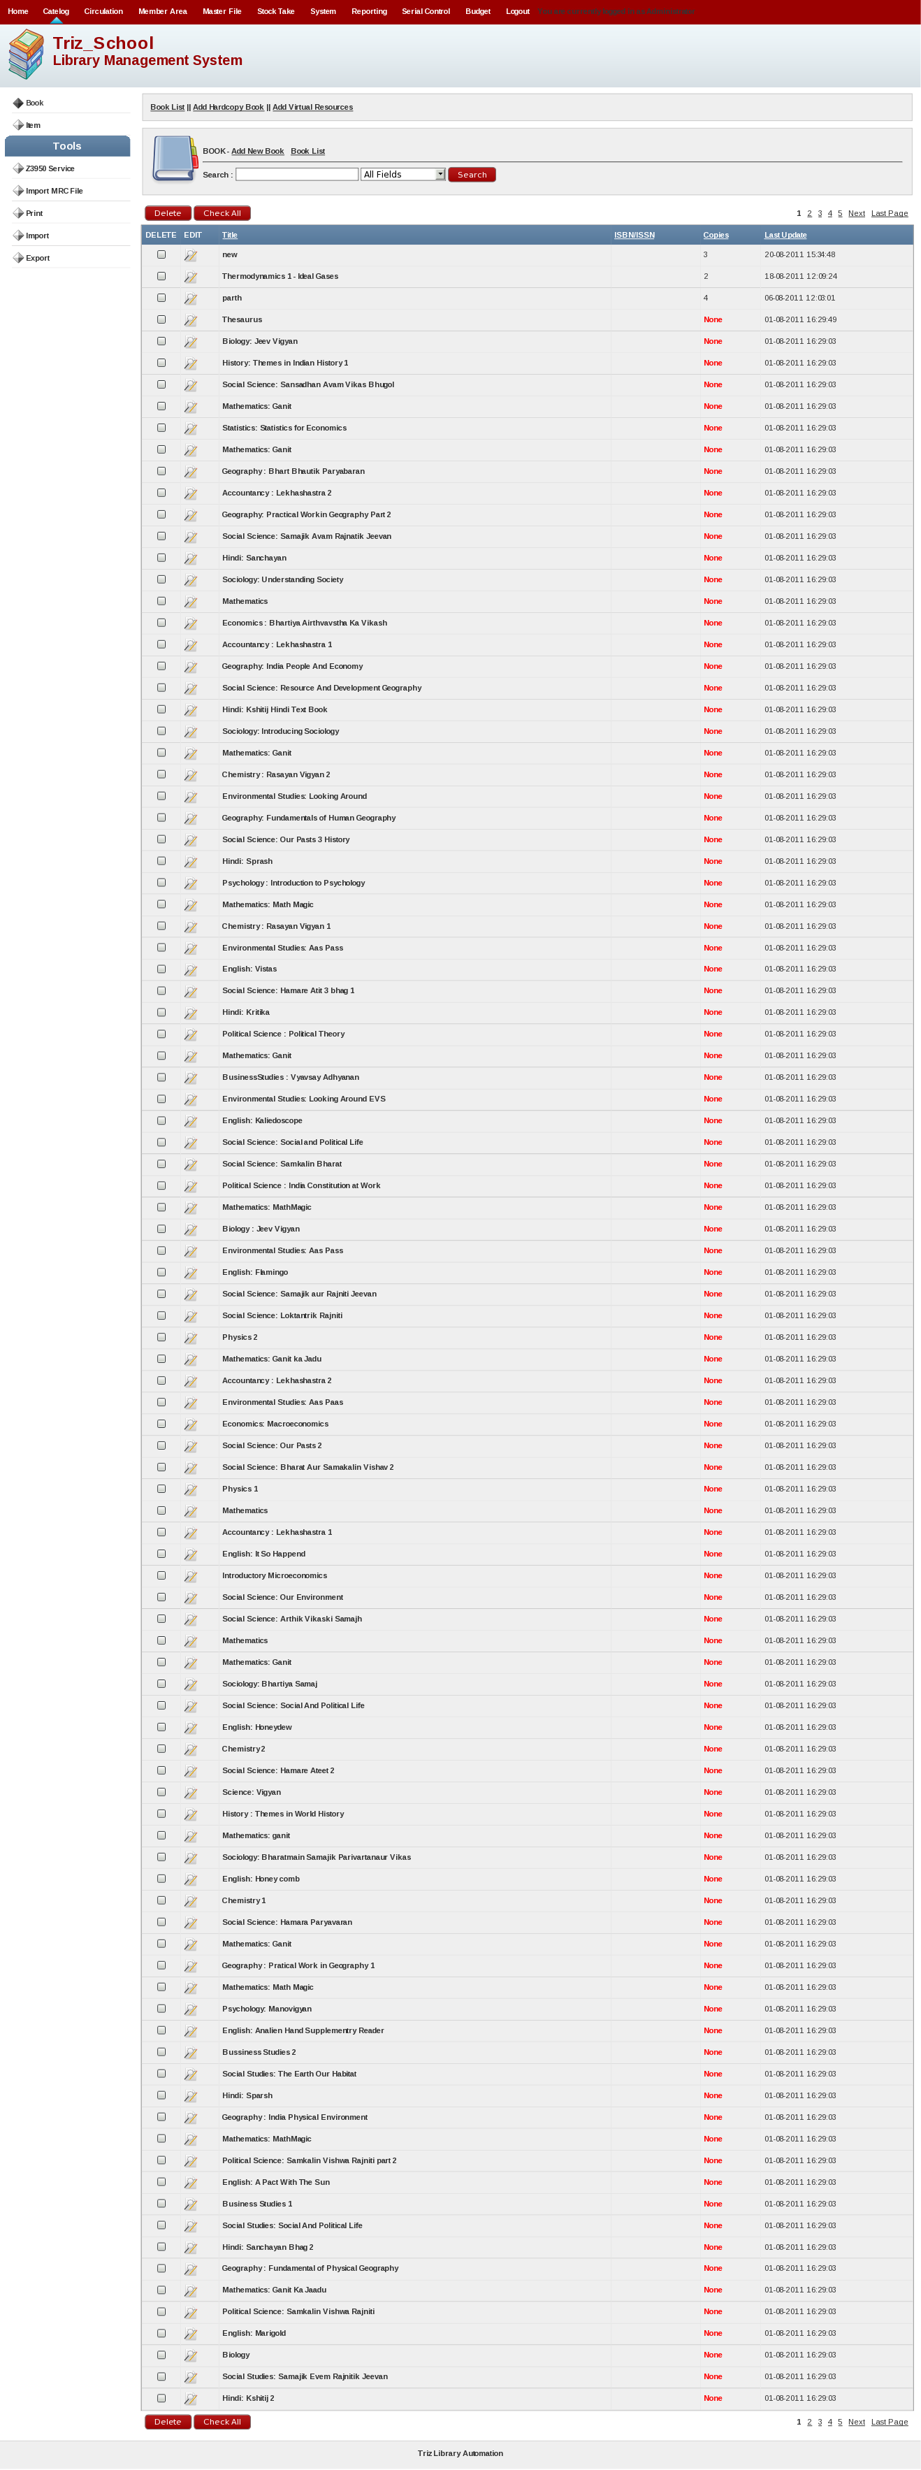

Shows the list of all material present in the database of the library system. From this menu we also can delete the material from the database. To delete the book from the database check the box which material you want to delete the material click on the button Delete the selected item will delete the material from the database. Also by clicking on Edit button you can edit the material.

Add Hard Copy Book
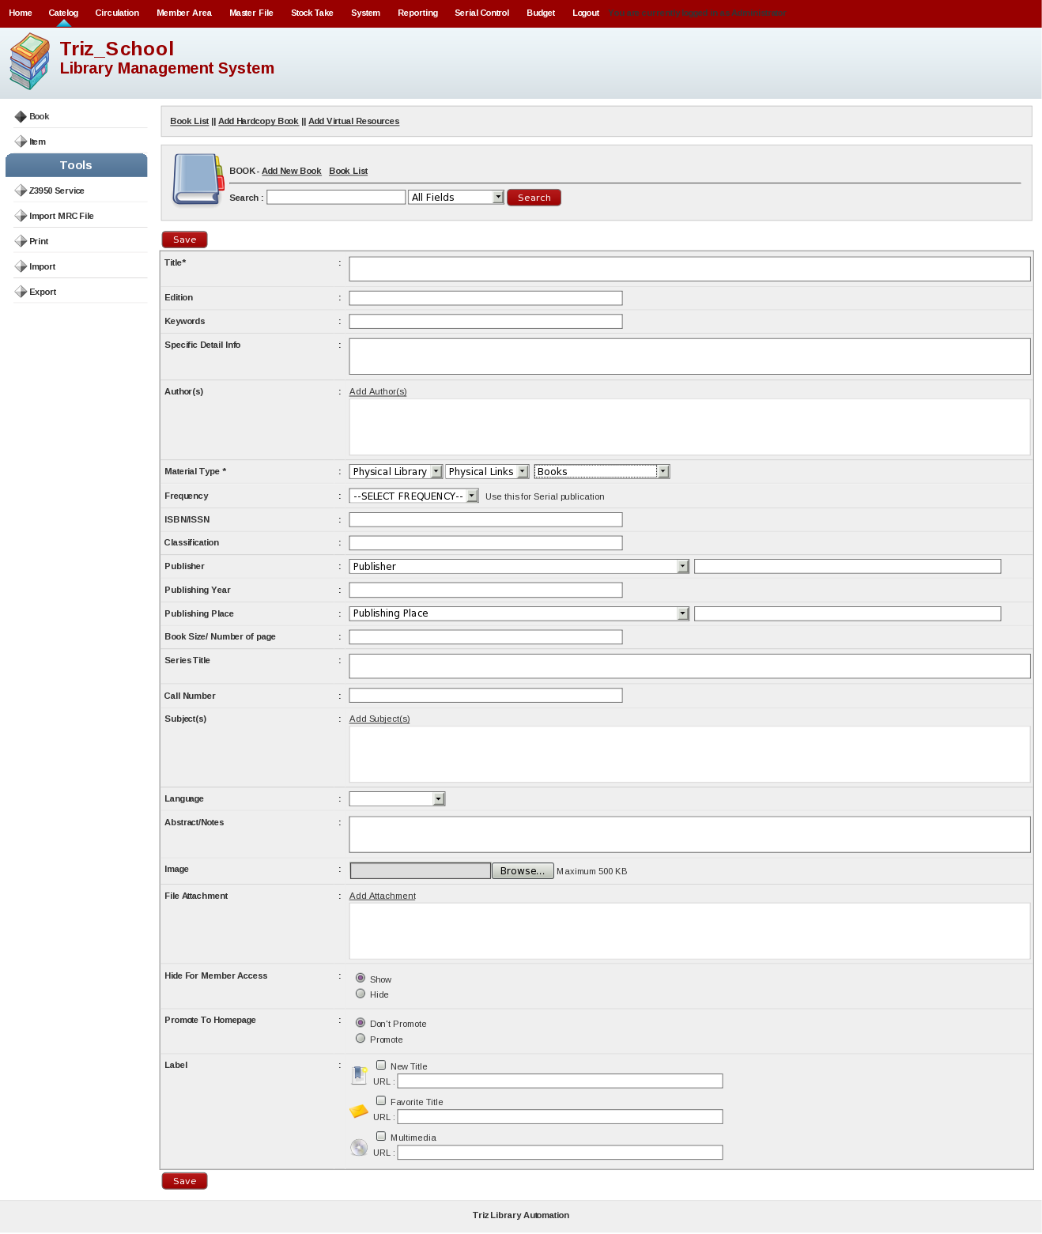

By entering detail in the form of the physical resource detail and then click on the Save button will add the material in the library database. This is only for physical resources.

Add Virtual Resources

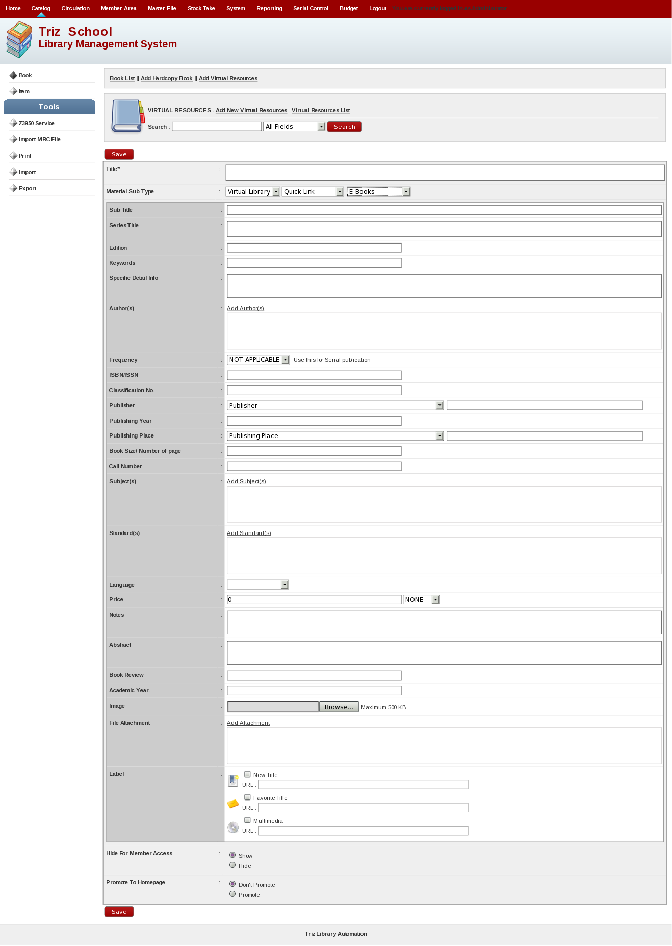
By entering detail in the form of the Virtual resource detail and then click on the Save button will add the material in the library database. This is for only virtual resources.

[2] Item

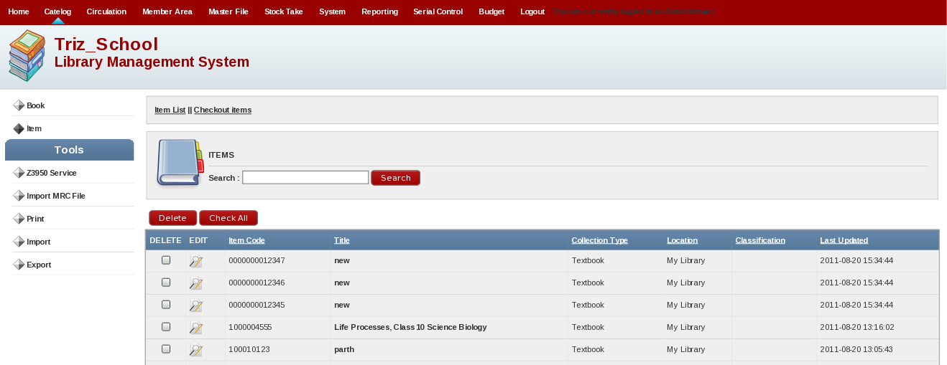
Shows the list of all physical resources present in the database of the library system. The below picture shows each copy of the physical resources in database means it will show the all copies of single physical resources. You can edit and delete this items.

Checkout Items

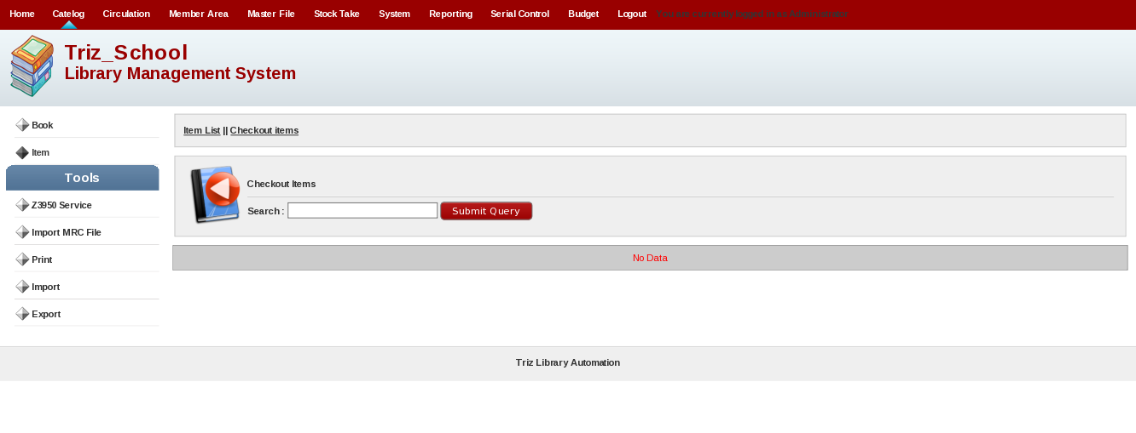
This menu gives information about the item being borrowed. In this menu equipped with a search facility to approach the title of the item The information contained in this menu are the Item Code, Member ID borrowers, Title, Loan Date (the date of loan), Due Date (date of return).

[3] Z3950 Service

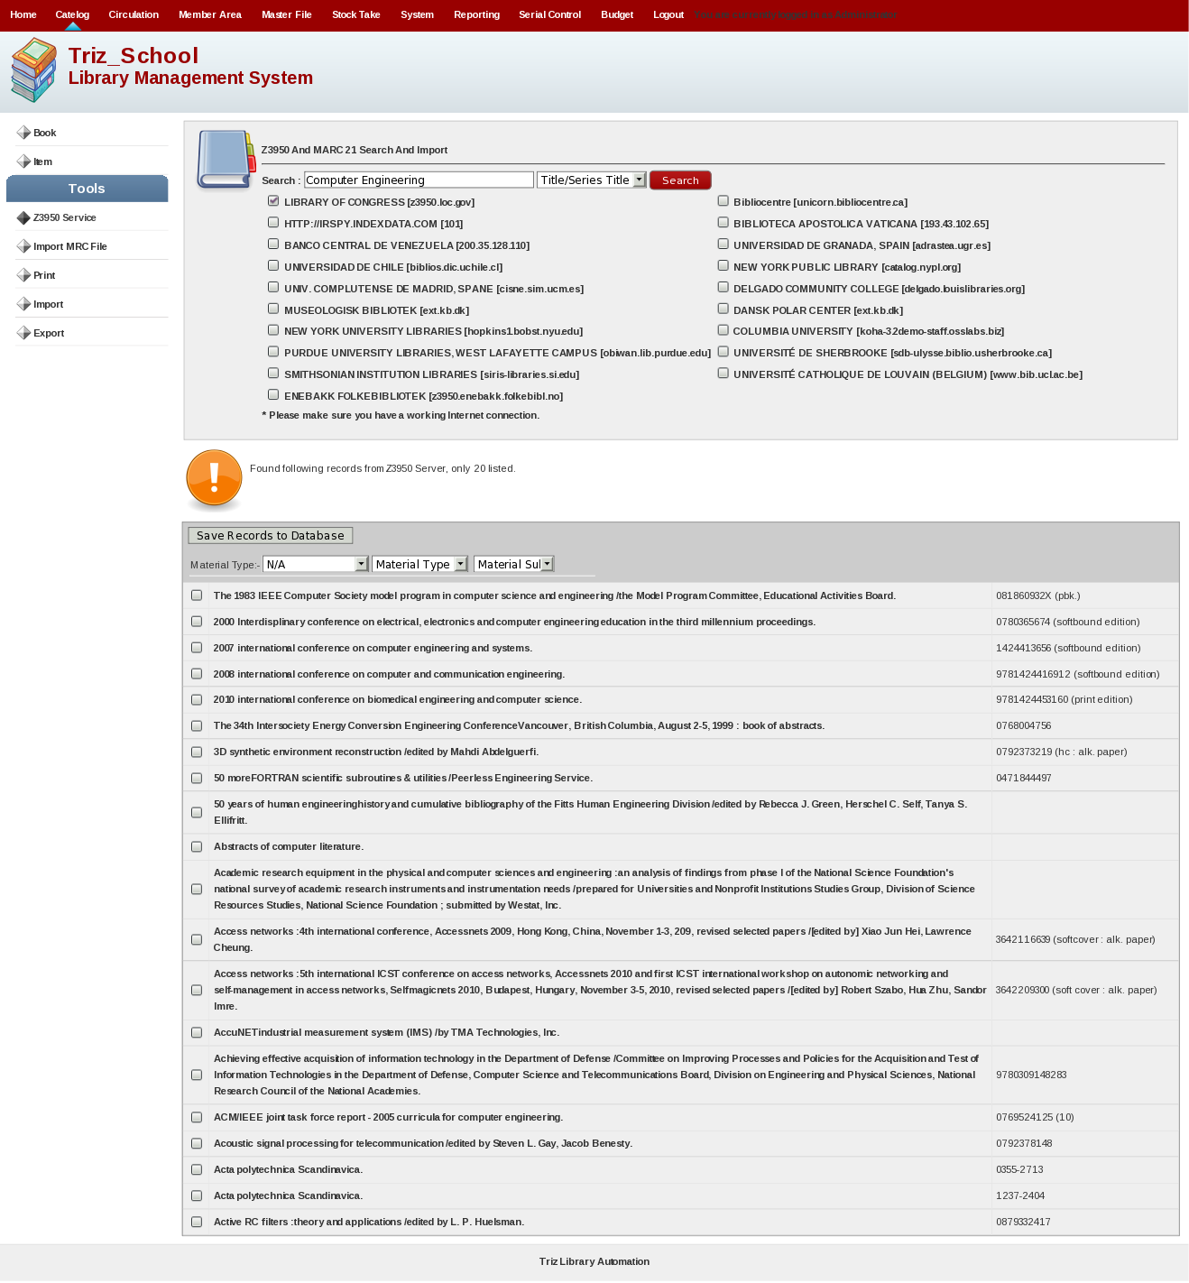
This is for importing MARC21 record from other available libraries. This facility will help to fast import data into database from external sources.

You can select library find records by title,isbn/issn,author using search facility. After searching you can see records available shown in figure. Then click on check box and save record to database which will save records into database.

[4] Import MRC File

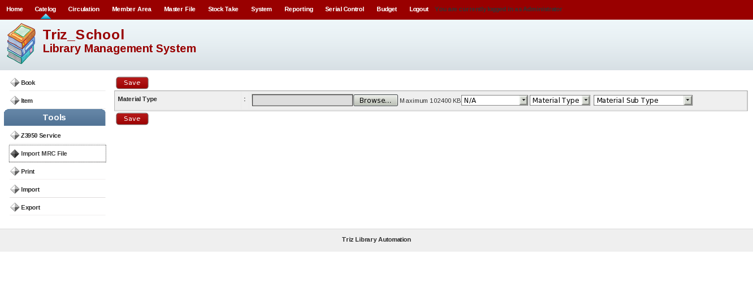
This facility is for importing .mrc file of records manually. You can upload .mrc file by uploading file from Browse button and click on save button to insert data into database.

[5] Print

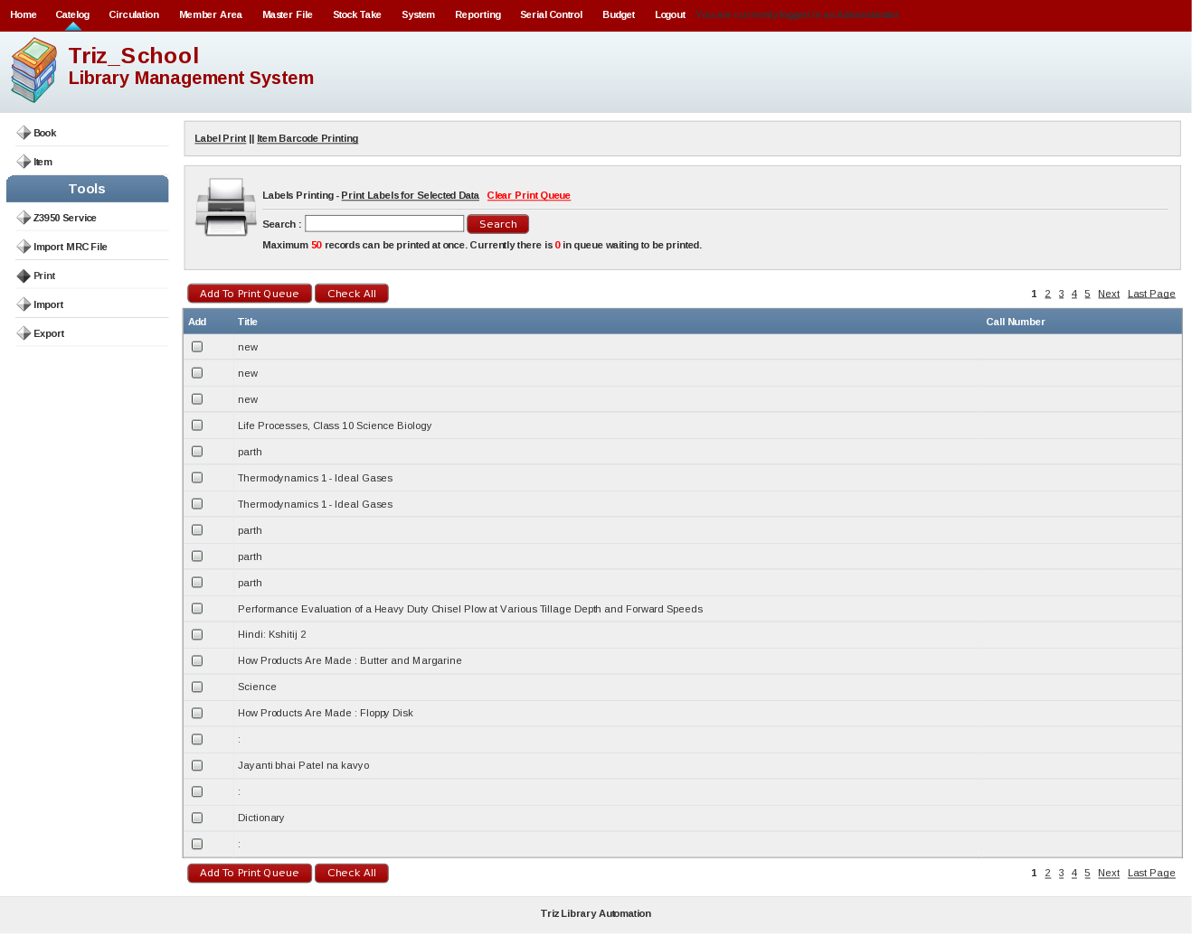
With this menu you can print labels based on the collection of bibliographic data that has been included in Library database. For printing label select the material for which you want to print the label. And then Click on the button Add To Print Queue to add it to the queue of the printer. To print click on the Print Label for selected data then it will show the images of the selected materials.

Item Barcode Printing

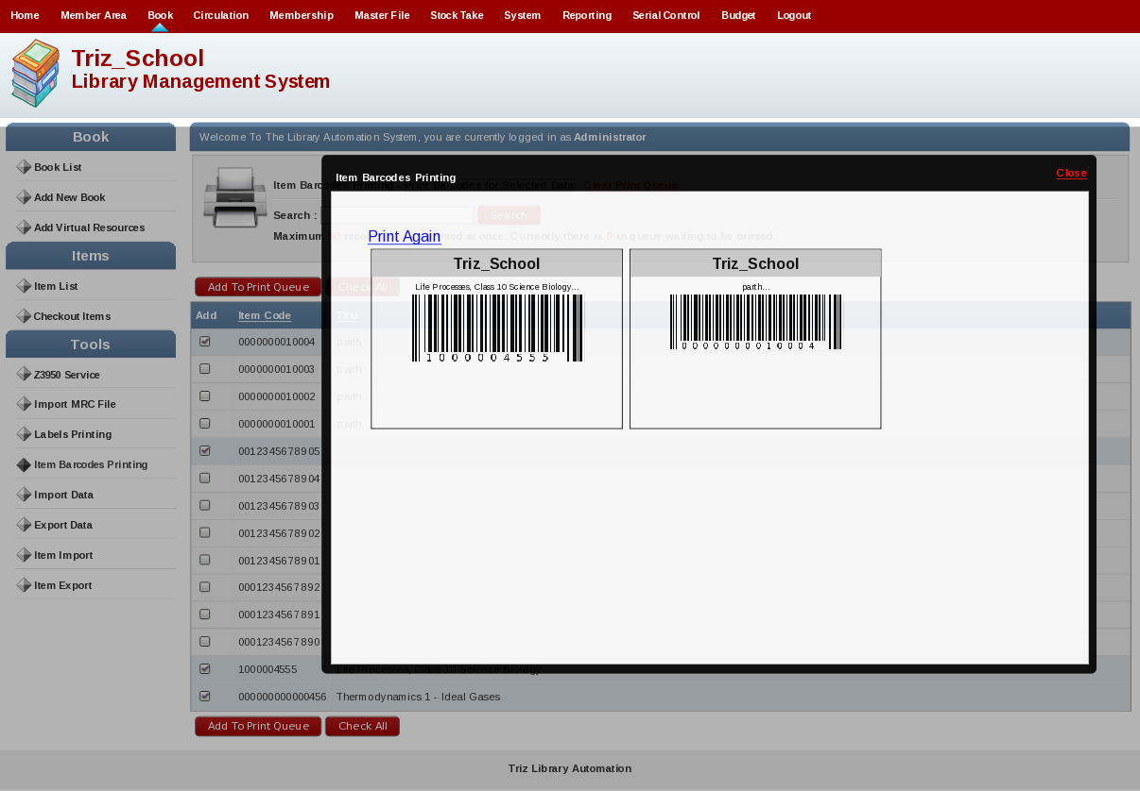
The item bar code printing is the same process as the Printing label but it prints the bar codes.

[6] Import

This will used to import the data to the library system by using database file like csv etc. This option is used to import the data in bulk. The following figure shows the Import data function.

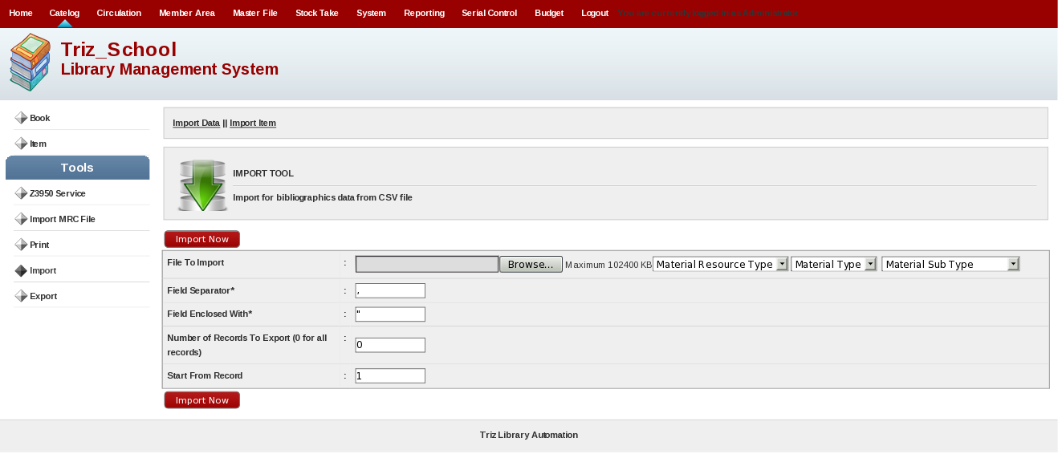
The fields that are presents are File to Import : Is used to select the file in to the computer, Field Separator which is used to separate the fields and you also can select the range of fields that you want to add.

Item Import

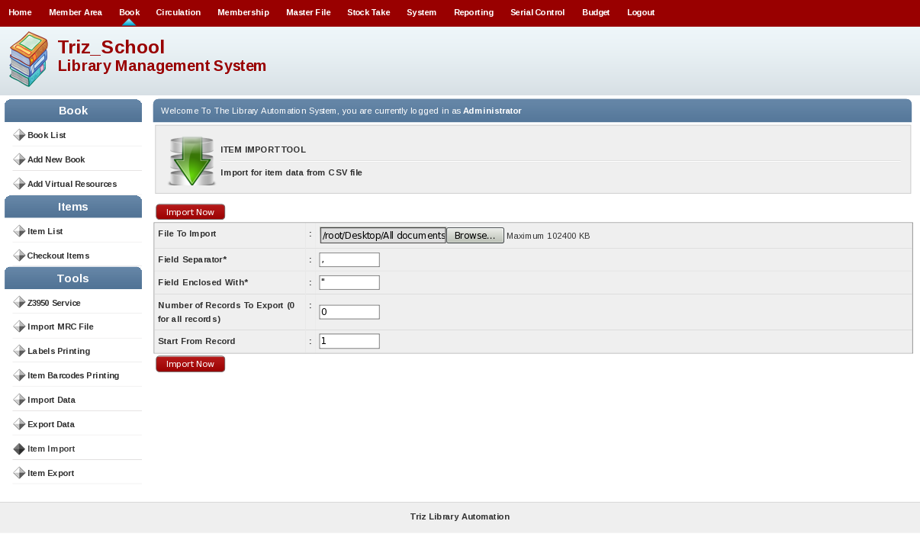
Item Import option is same as the “Import Data” option but in this option contains the information of each copy of the material in the library.

[7] Export

This field is used to take the backup/ record of the material database form the library system. The picture below shows the Export data Option.

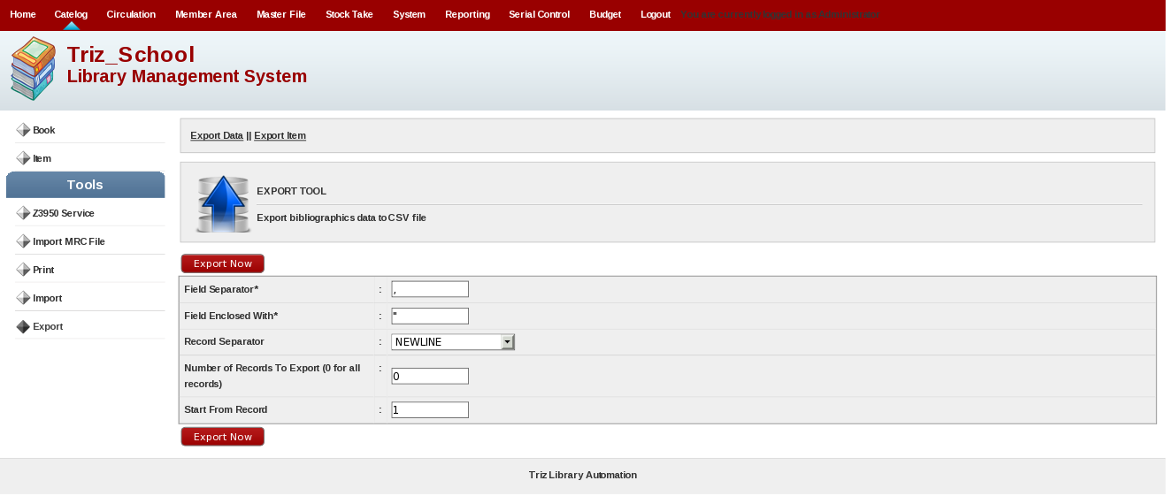
The different fields are used to separate the each record and we can also select the no. of items that we want to take as backup/record.

Item Export

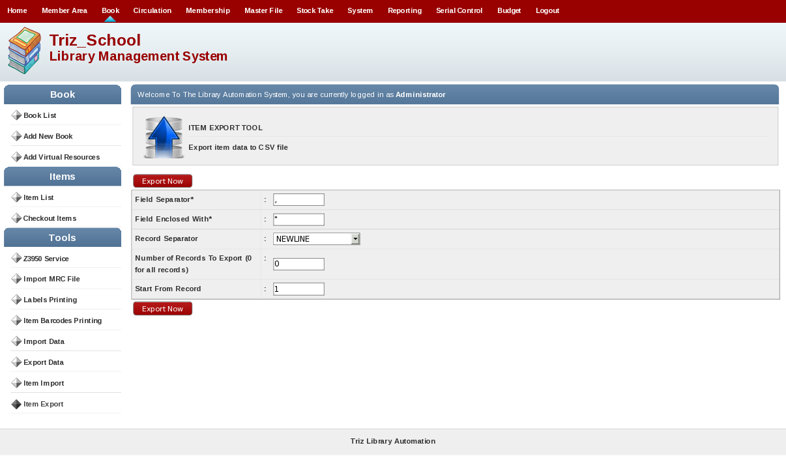
Item Export is also the same as the “Export Data”option but this will take the information of all copies of material present in the library as backup/record.

5. Circulation Menu

Circulation Menu Will display following screen and it will include following submenus.

- Book Circulation
- Quick Return
- Reservation

[1] Book Circulation

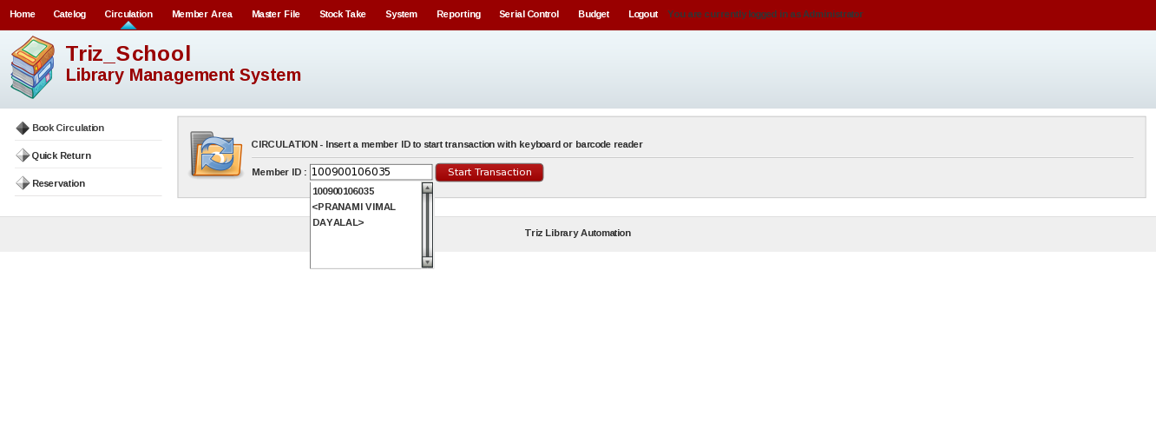
This menu is used to check the transactions of the student and also perform several tasks related to material issue,return,renew. As shown in the above picture Enter the User/Member Id and click on the button Start Transaction will open the page as shown in the below picture.

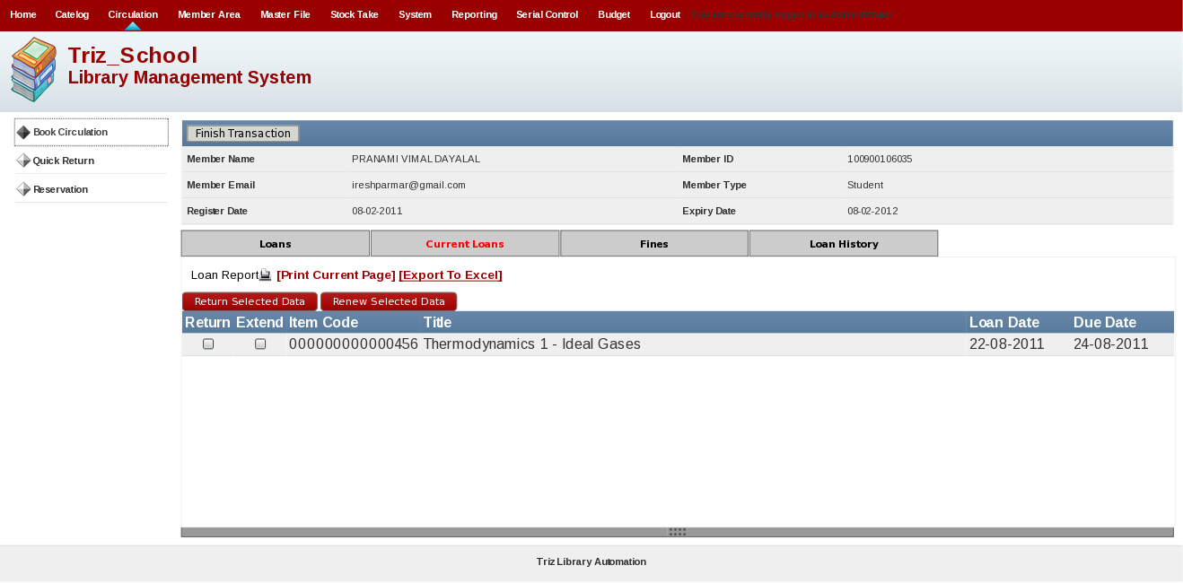
From this menu the admin can change the status like if the material is returned then Admin can change the status by selecting the returned material from the return menu and if Admin want to extends the period then he can click on the material in the extend menu. The rest menu shows the material information like Item Code, Title, Loan Date, And Due Date.

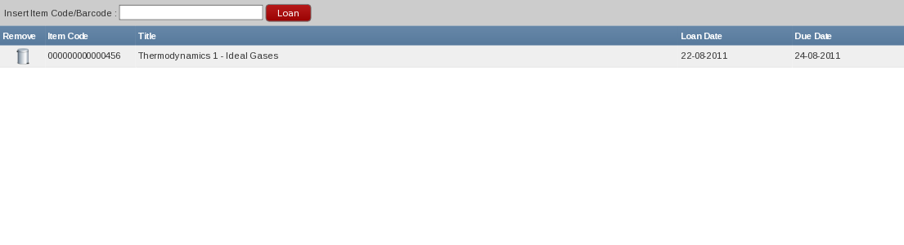
This option is used to grant the loan for the student by entering the material item code or bar code. After Entering the code press on the button “Loan”to give the loan. The above picture shows the Loan option.

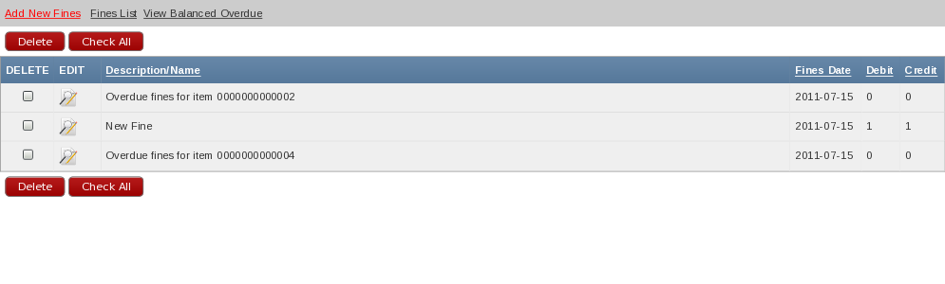
Shows any fines that is left or made to the user/member

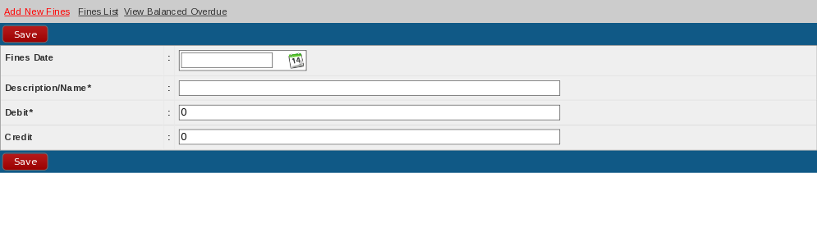
This will add the fines detail of particular member in system.

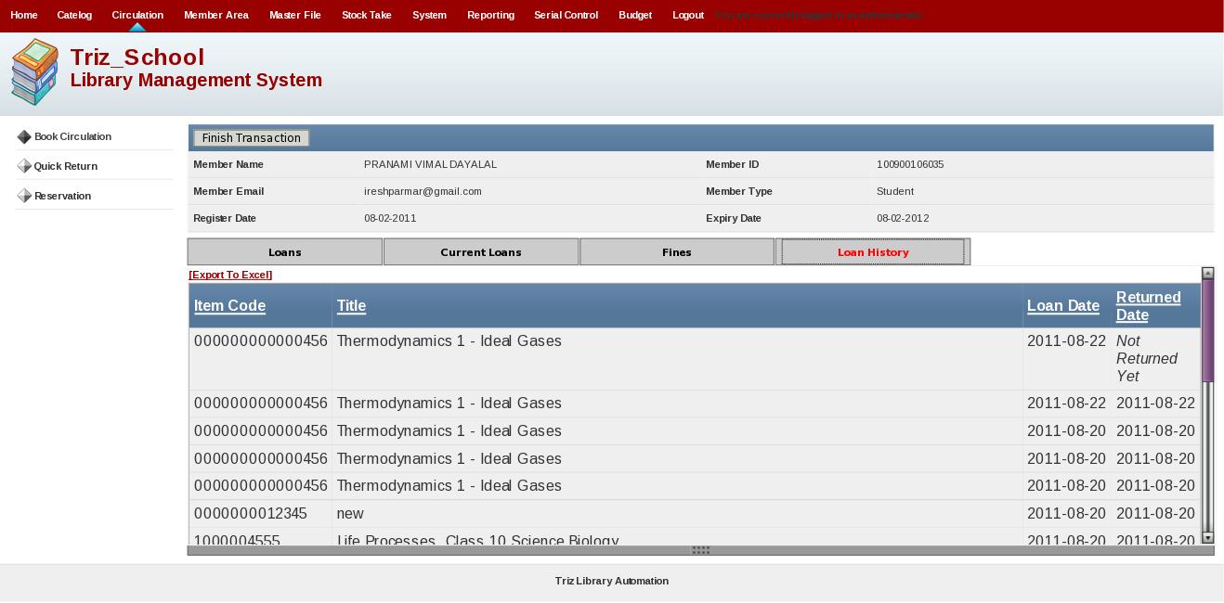
Shows the log of all the material member loan form library and any dues and current loan.

[2] Quick Return

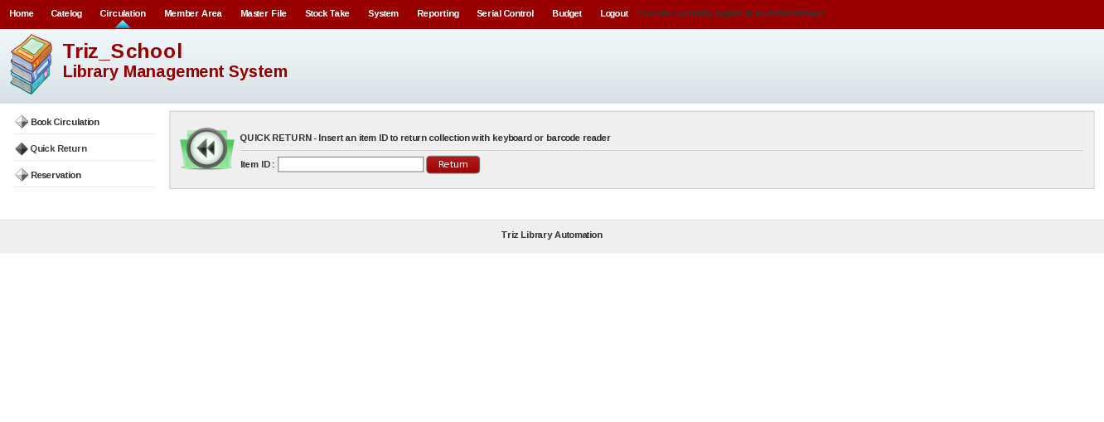
Quick return is used to return the book without knowing who loan that book. By entering the Id / Bar code of the book and clicking on the button return will return the book.

[3] Reservation

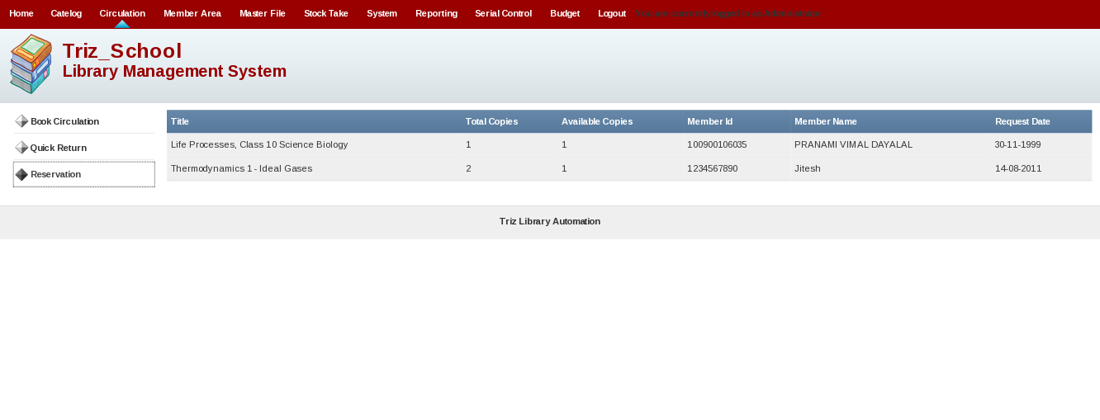
This module will display who has reserved the particular material. It will display title,total copies, available copies, member id, member name, request date.

6. Member Area Menu

Membership Menu Will display following screen and it will include following submenus.

- Membership
- Tools

[1] Membership

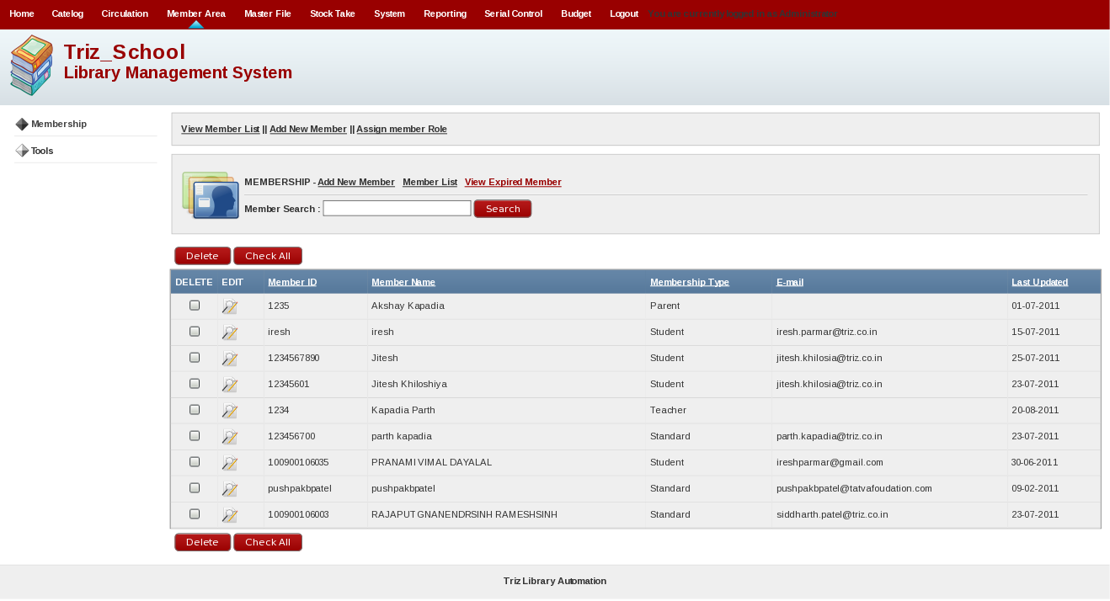
This will display members' list which display Member ID, Member Name, Membership Type, Email, Last Updated.

Add New Member

This will add new member details for using this library. This will be shown in following figures.

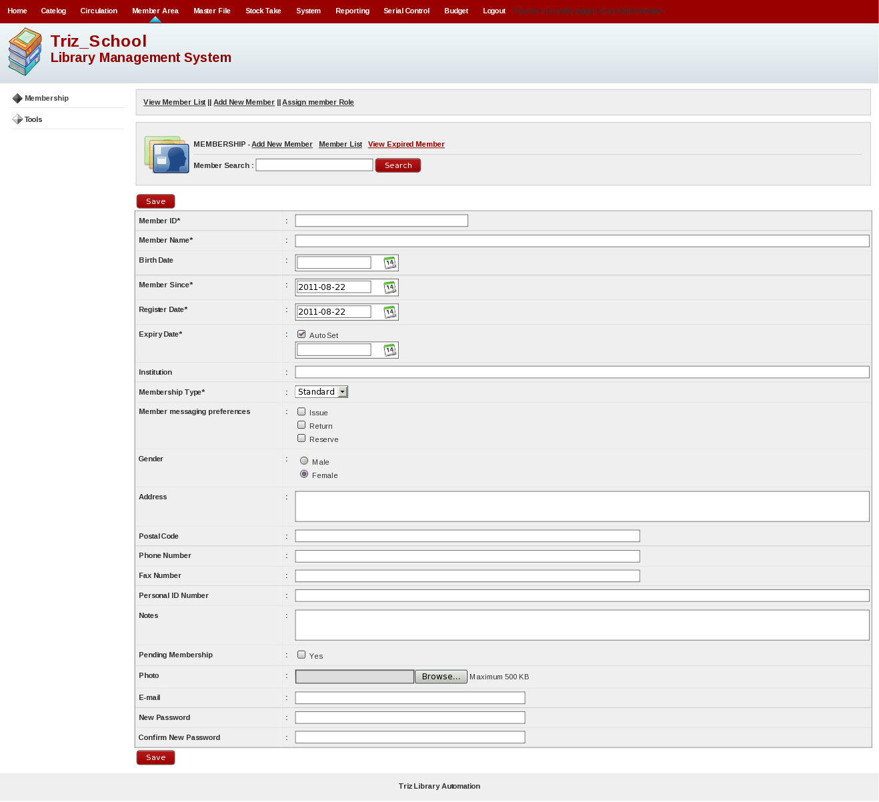

Assign Member Role

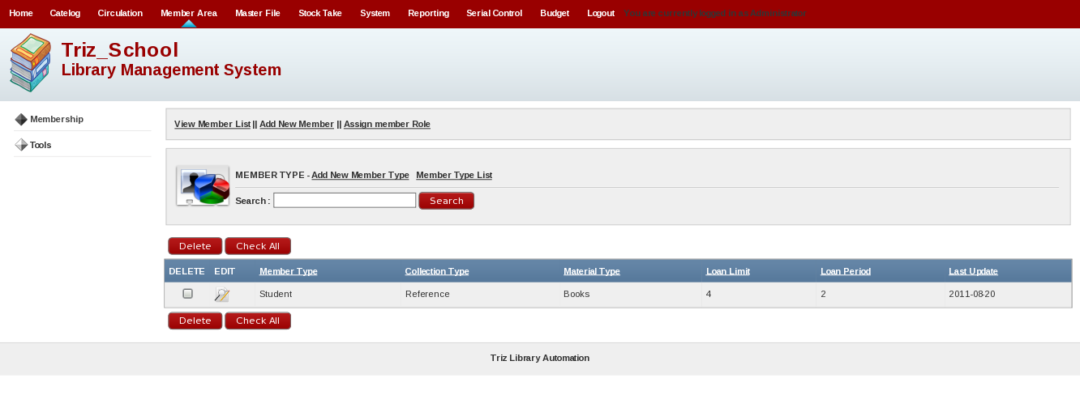
This will display member type detail. You will see Member Type, Collection Type, Material Type, Loan Limit, Loan Period, Last Update Caption. You can edit, delete such details.

[2] Tools

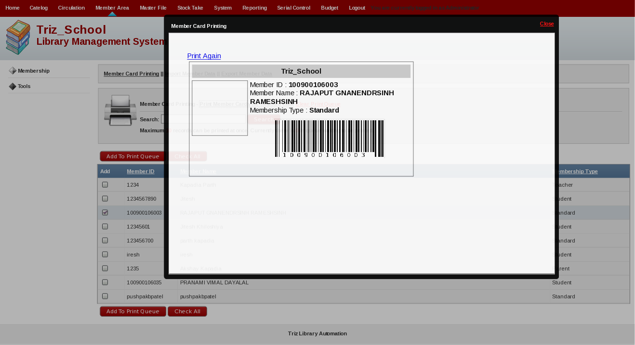
This is for making members' card and print it after making it. This will display Member ID, Member Name, Membership Type, Barcode of Member ID.

Import Member Data

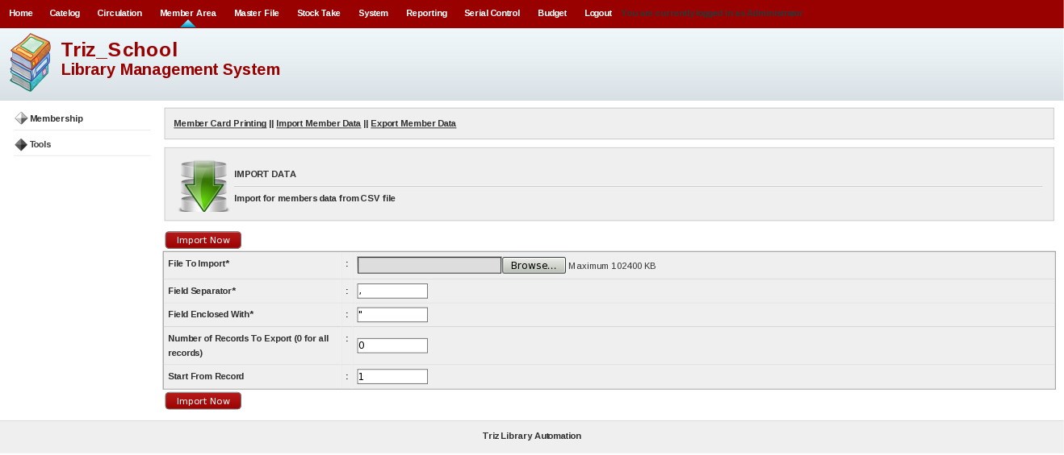
This will upload members' detail in bulk. You can upload bulk member data using .csv format file. You can see field separator which will separate your file from where you need to brake records. You can define from where you will start your records reading by specifying in Start From Record.

Export Member Data

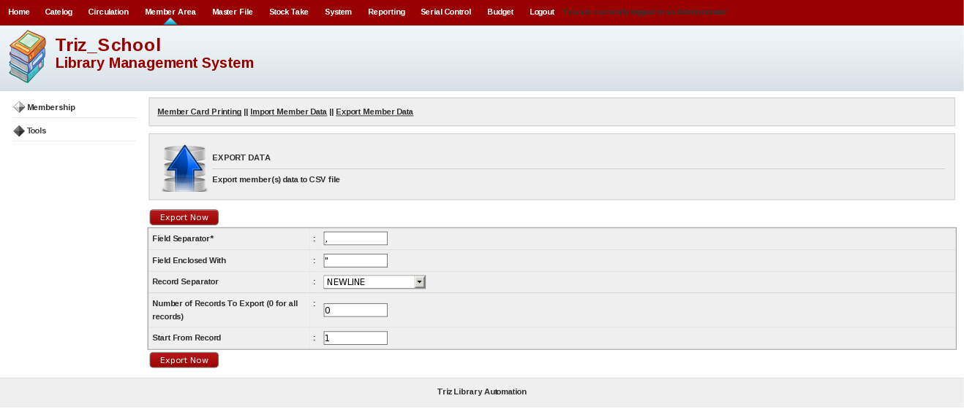
This is for exporting member data from system.

6. Master File Menu

Master File Menu Will display following screen and it will include following submenus.

1. Add Material Resource Type
2. Add Publisher
3. Add Supplier
- Add Author
- Add Subject
- Add Standard/Class
- Add Book Rack/Shelf
- Publishing Place
- Item Status
- Book Collection Type
- Add Label
- URL Check

[1] Add Material Resource Type

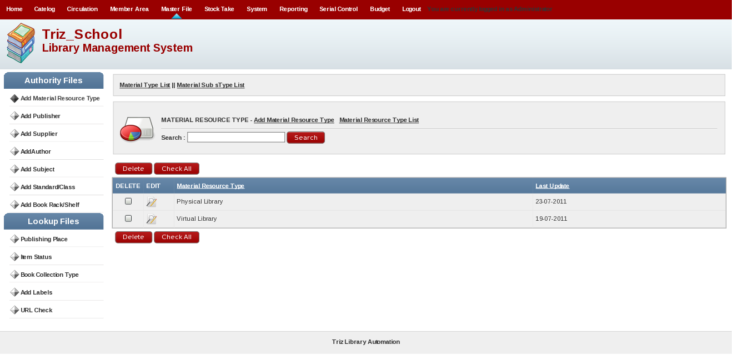
This will add, edit and delete material resource type.

Add Material Type

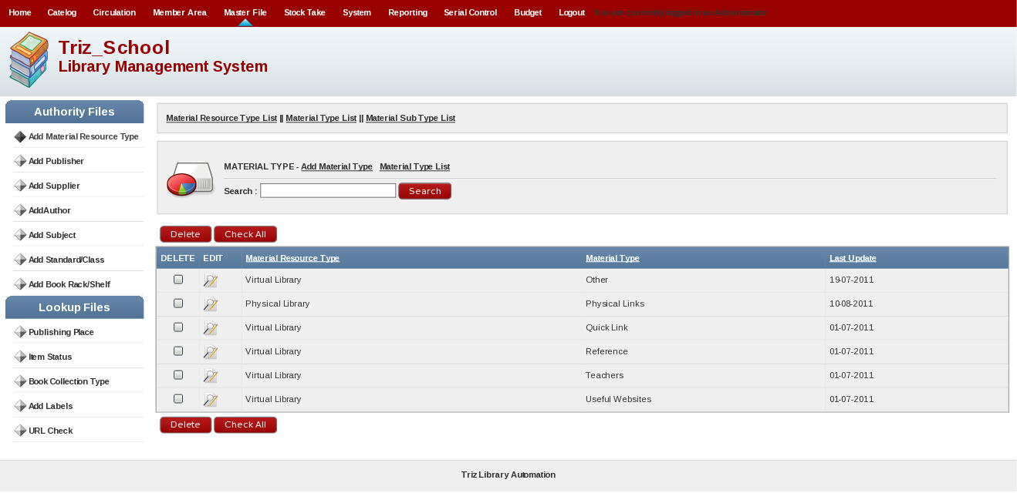
This will add,edit and delete material type. This is sub category of material resource type.

Material Sub Type

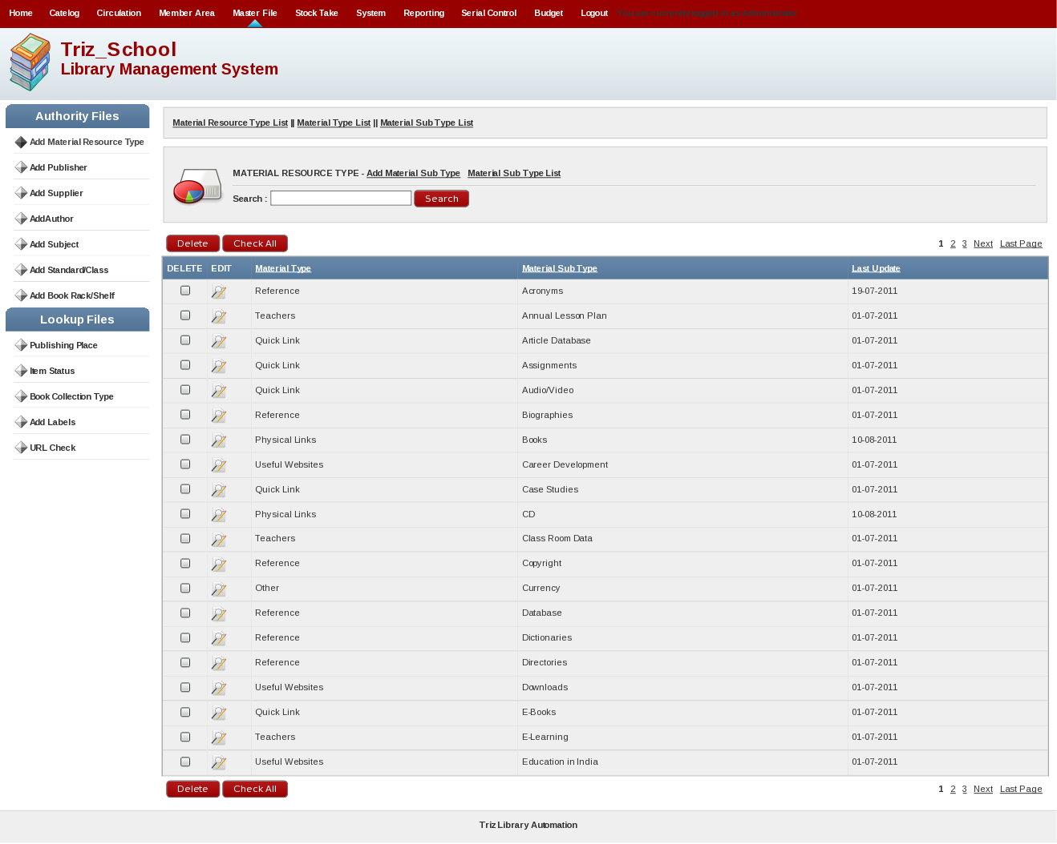
This will add,edit and delete material sub type. This is sub category of of material type.
[2] Add Publisher

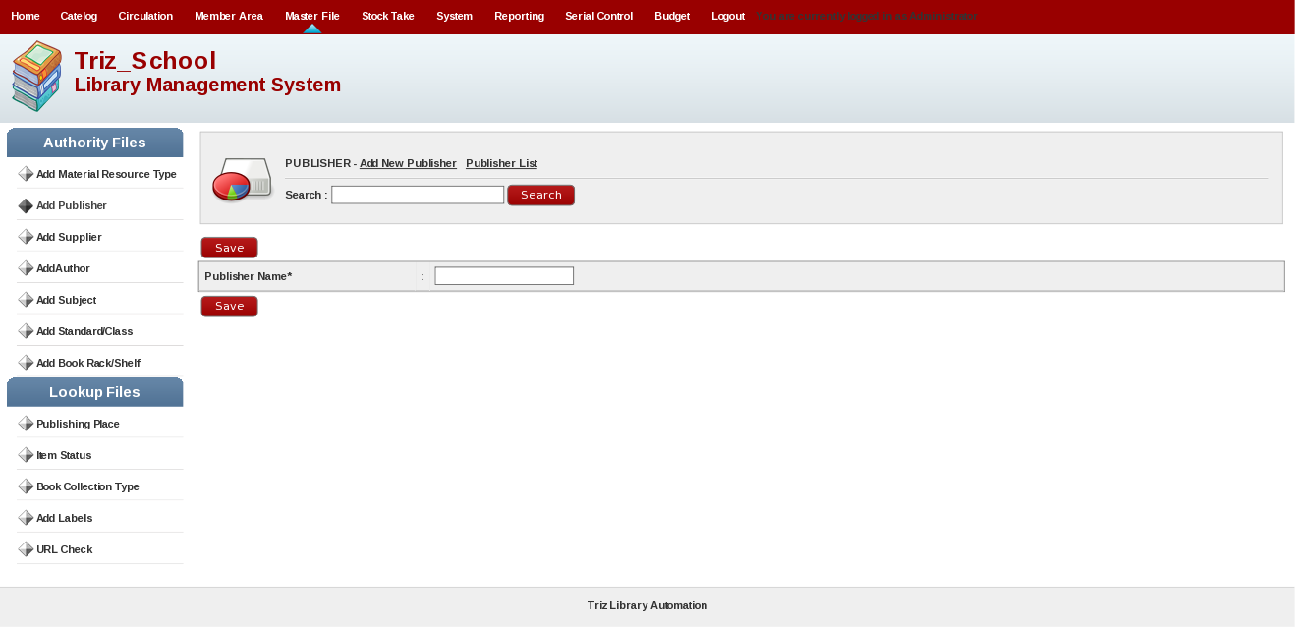
This will add,edit and delete publisher name.

[3] Add Supplier

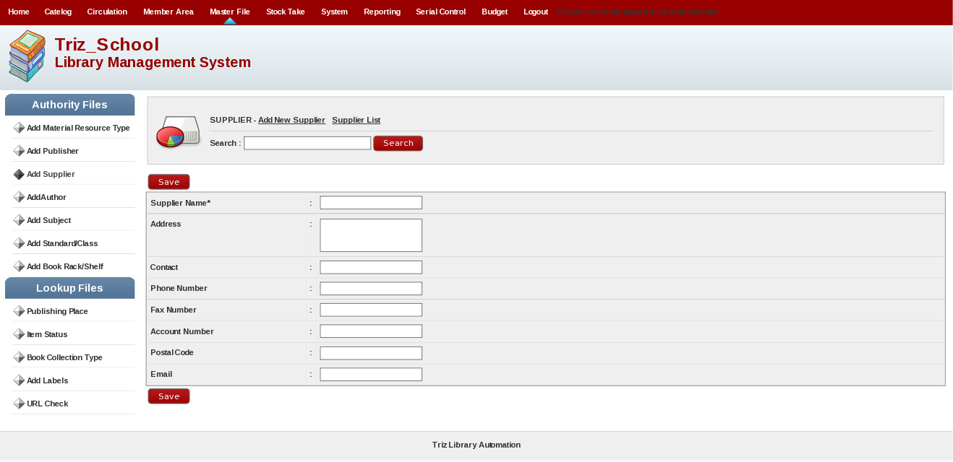
This will add,edit and delete supplier.
[4] Add Author

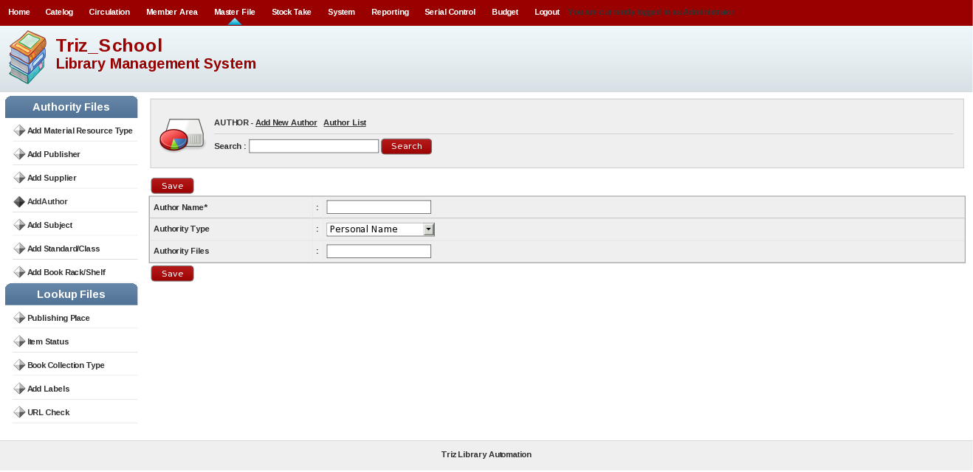
This will add,edit and delete author.

[5] Add Subject

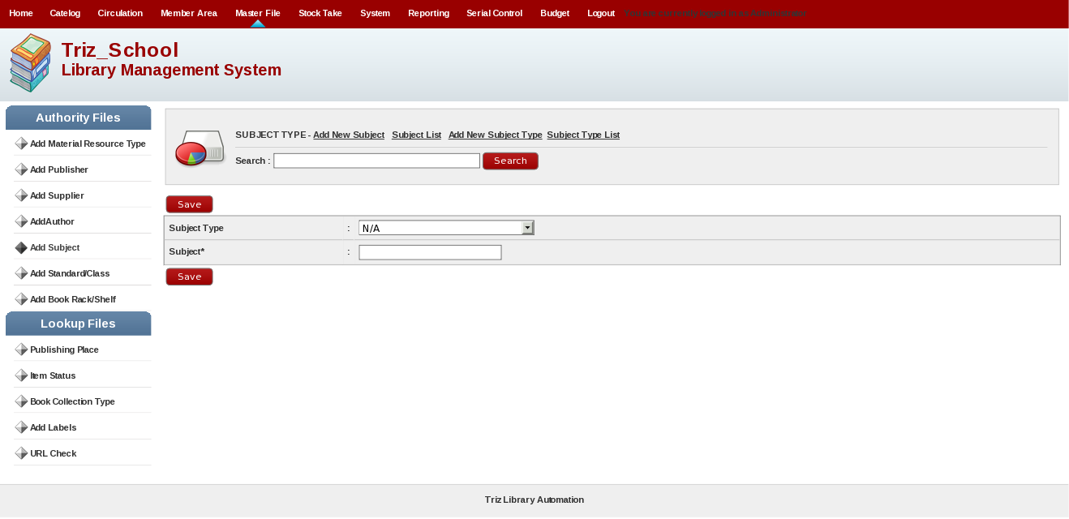
This will add new subject in the system.

Add Subject Type

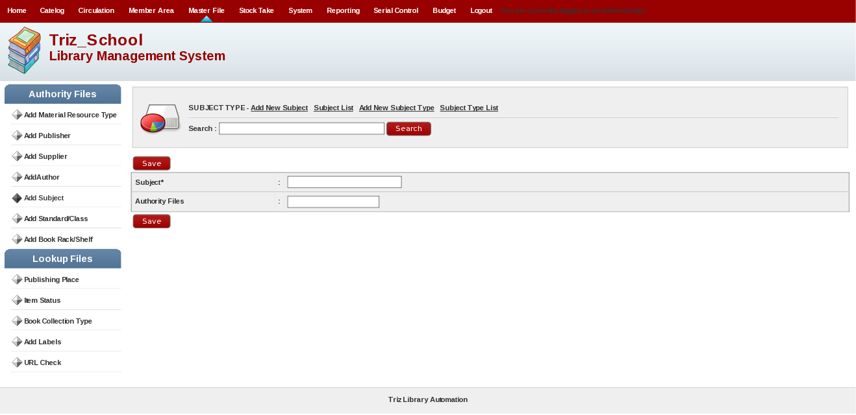
This will add new subject type in the system.

[6] Add Standard/Class

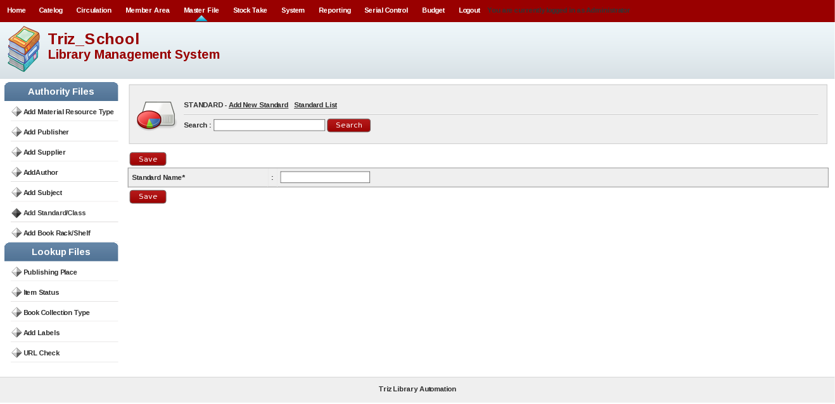
This will add new standard in the system as well as database.
[7] Add Book Rack/Shelf

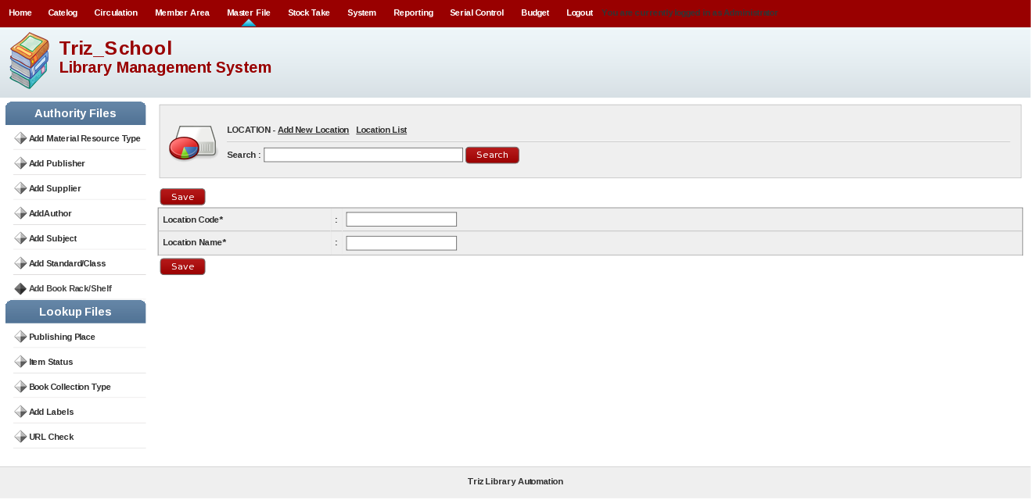
This will add book putting location in the system.

[8] Publishing Place

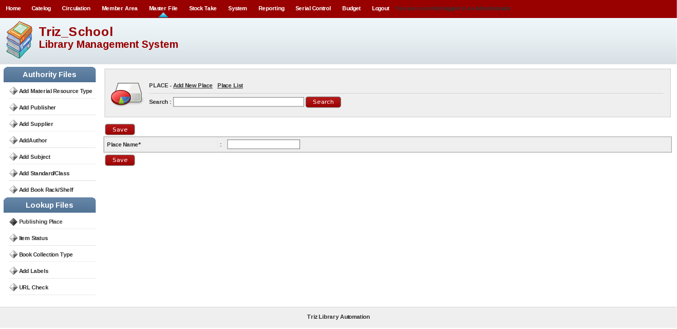
This will add publishing place where material has been published in the system as well as in database.

[9] Item Status

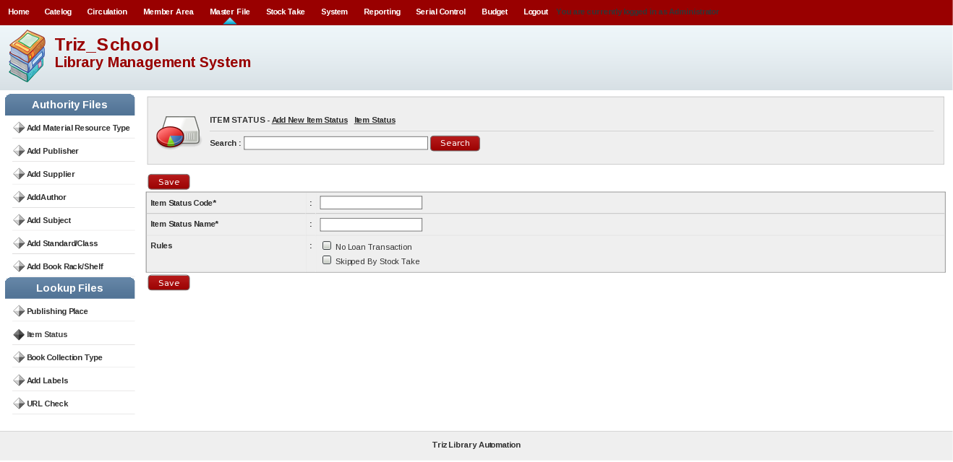
This will add status of item in the system.

[10] Book Collection Type

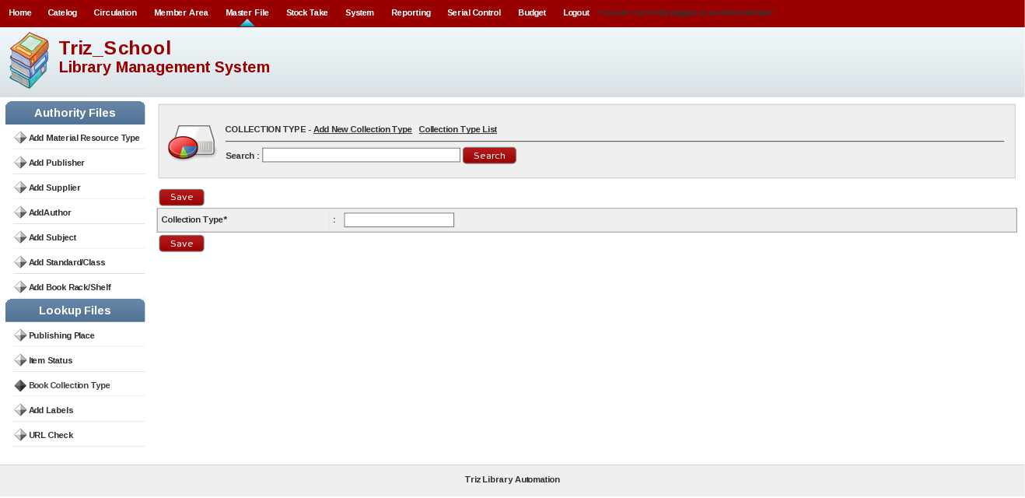
This will add collection type of book in the system.

[11] Add Label

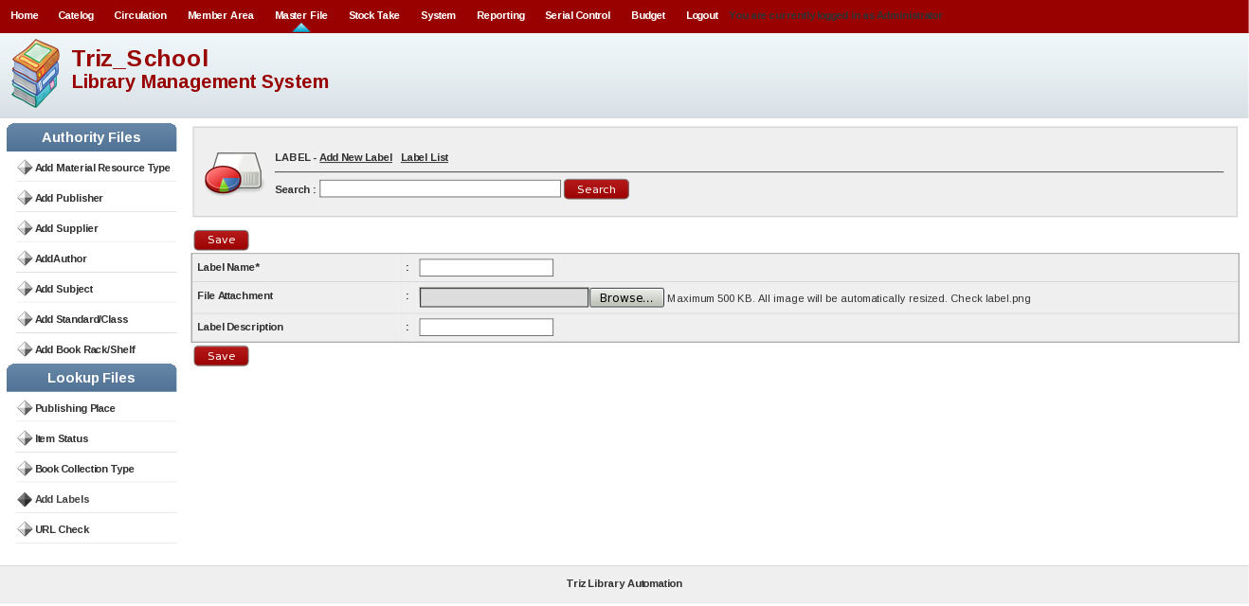
This will add label in the system. This will add URL in the system of virtual resources.

[12] URL Check

This will check URL of virtual resources whether it is active or broken. This will help admin to check URL status.

7. Stock Take Menu

Stock Take Menu Will display following screen and it will include following submenus.

1. Stock Take History
2. Current Stock Take
3. Stock Take Report
4. Finish Stock Take
5. Current Lost Item
6. Stock Take Log
7. Resynchronize
8. Upload List

[1] Stock Take History

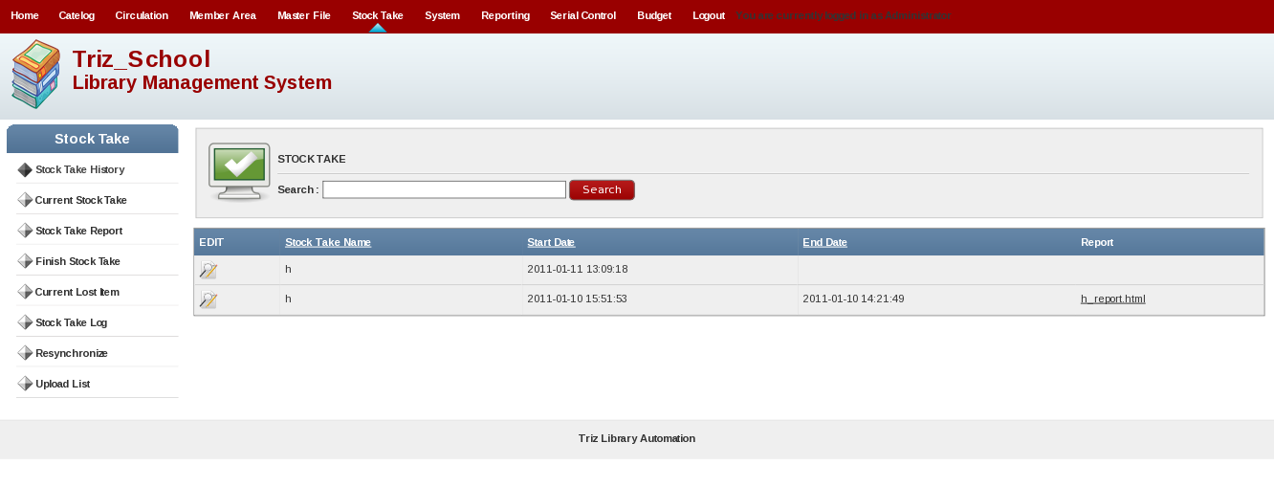
Contains report inventory check has been done. The information in this menu are:
Take Stock Name, Start Date, end Date, Report. Report contains links to documents in the form
. html that contains reports take stock ever undertaken.

[2] Current Stock Take

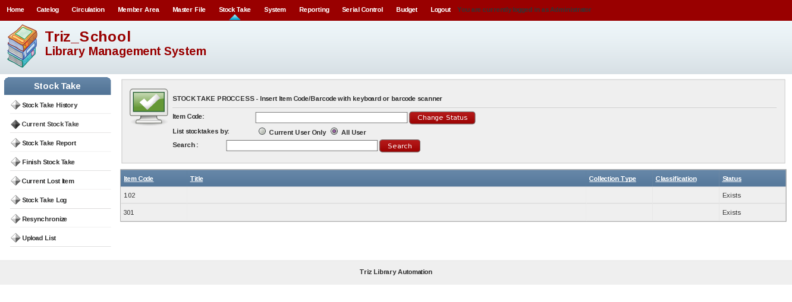
The menu is the main menu to do the stock take. This menu is used to
returns the status of library collections that are considered lost by the system, to
status exist (otherwise there is a collection). In this menu, item id (barcode number) collection
become the main reference for changing the status of collections that are considered lost to
exist (there), do this by entering the barcode number on the column collection
Item Code.

[3] Stock Take Report

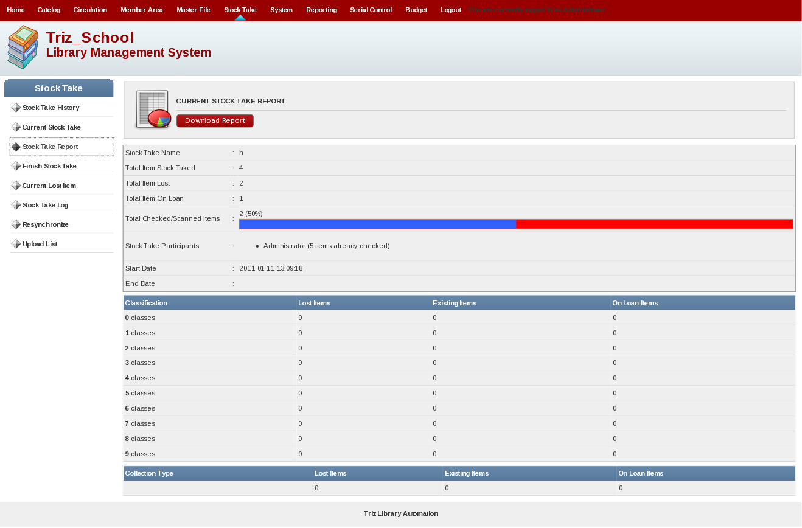
Menu to see the results of the activities that have been done stocke take. Shape
a report (report) containing information about the number of collections
lost.

[4] Finish Stock Take

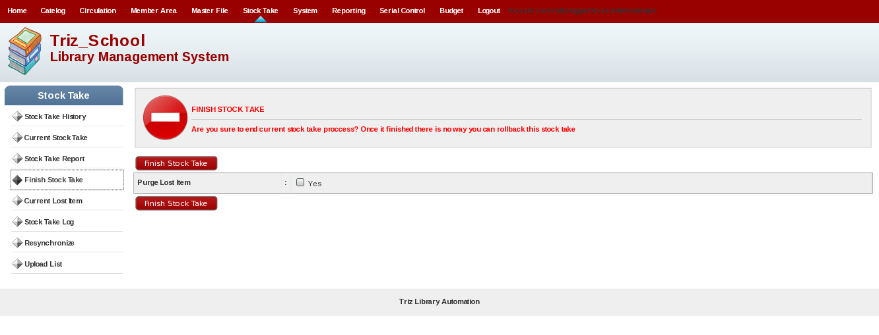
Click on this link when we have finished the inventory taking. In this menu,
there are sub menu items Lost Purge. If we give a check mark in Yes,
then the data item in the bibliography that are in Current Item Lost will be lost,
but the data is still stored bibliographies.

[5] Current Lost Item

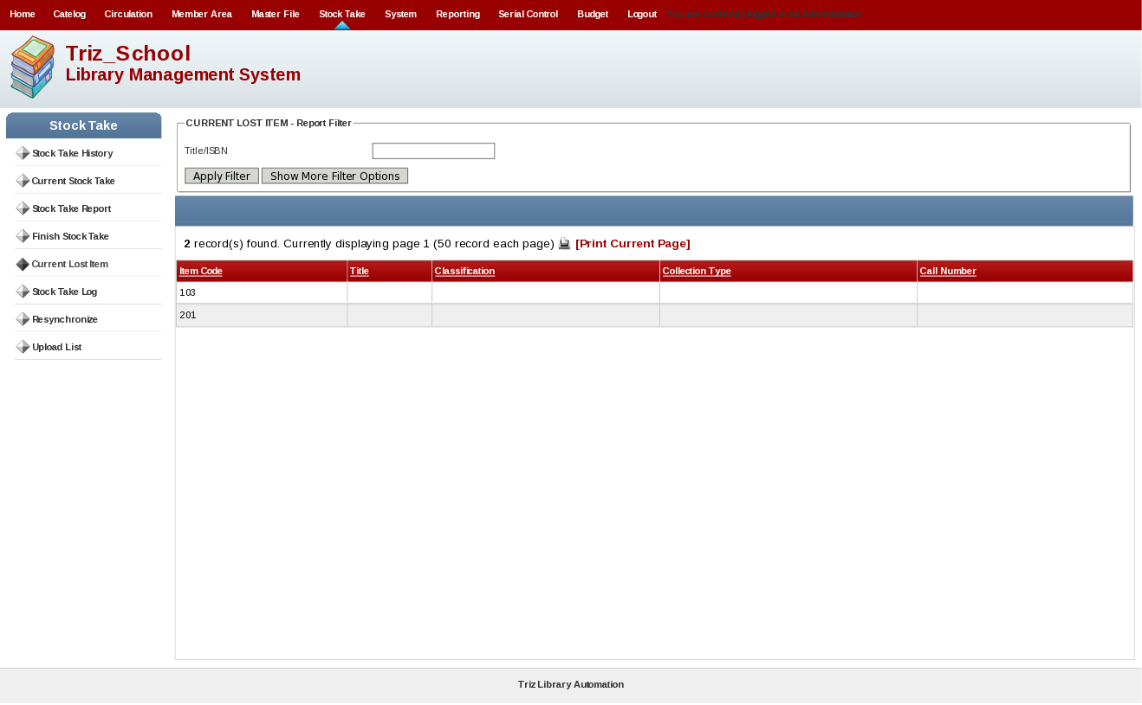
The contents of this menu is a list of collections that are considered lost when the inventory check
in addition to collections on loan.

[6] Stock Take Log

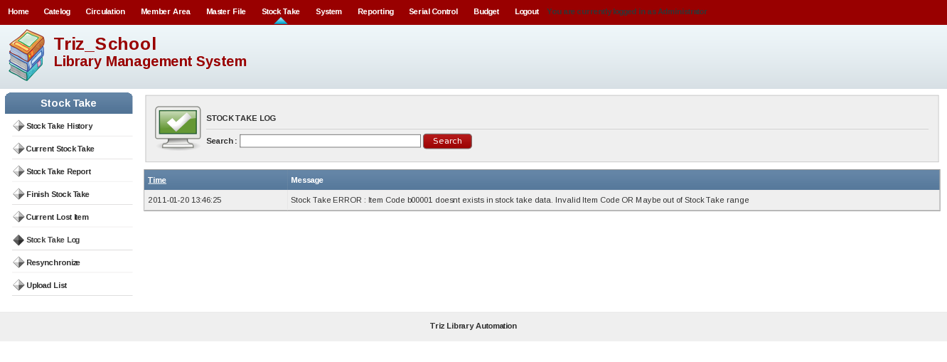
This menu function is to find records (logs) when performing the process of stock
take.

[7] Resynchronize

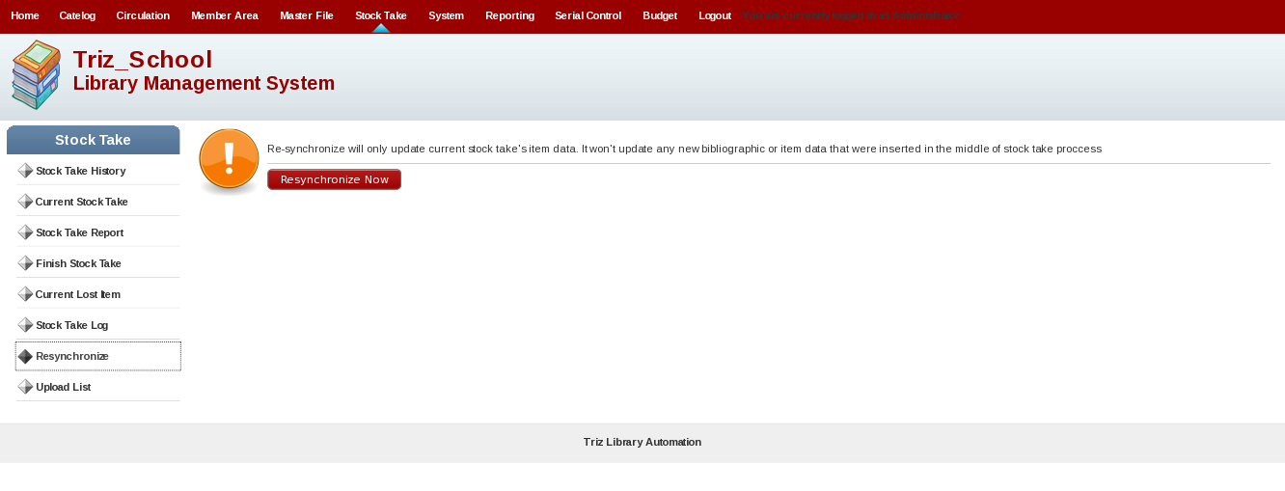
This menu is used to synchronize the edited bibliographic data on
during the activity to take stock of existing bibliographic data on module
take stock. The goal is when we do the editing time of bibliographic data
processes take stock, to result in changes to bibliographic data
contained in the module stock take, necessary data resynchronization.

[8] Upload List

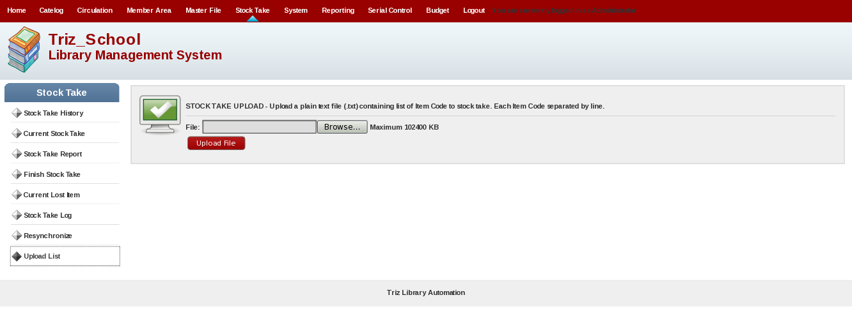
This will upload list of stock in the system.

8. System

System Menu Will display following screen and it will include following submenus.

1. System Configuration
2. Content
3. Modules
4. System Users
5. User Group
6. Holiday Setting
7. Barcode Generator
8. System Log
9. Database Backup
[1] System Configuration

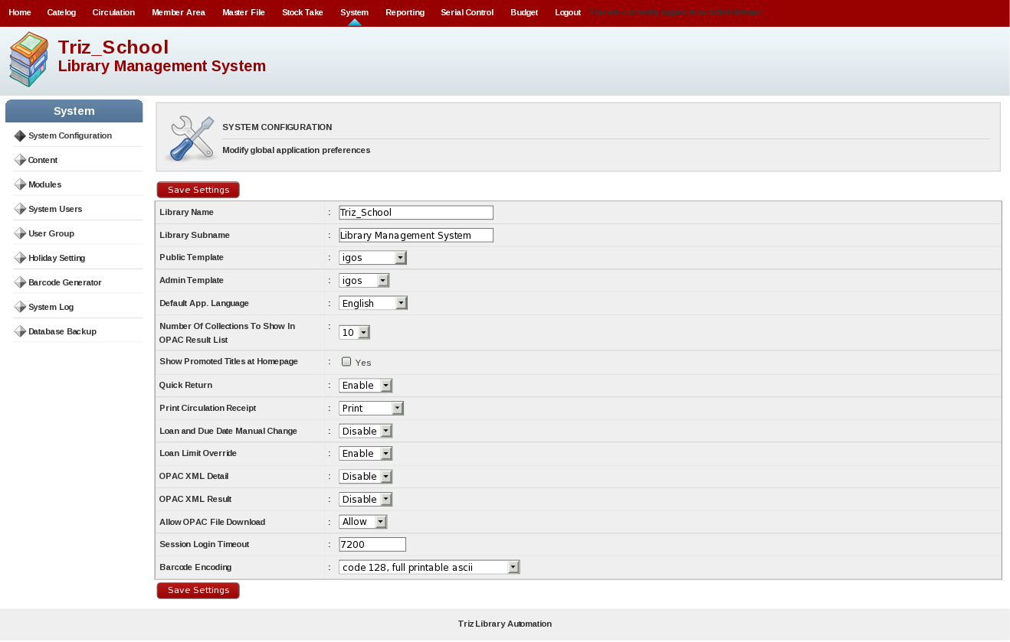
This is for setting system settings which will set theme, loan limit enable etc functionality.

[2] Content

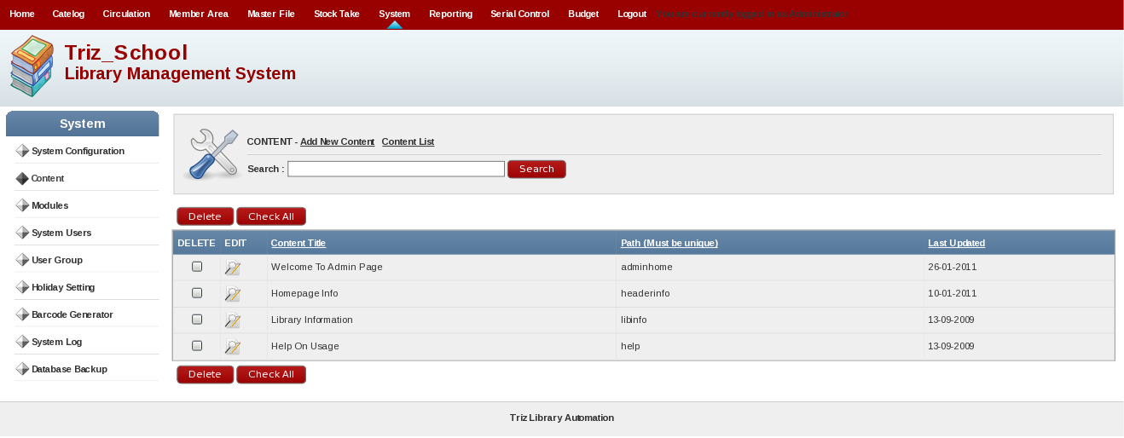
This will set content page of admin in system.

[3] Modules

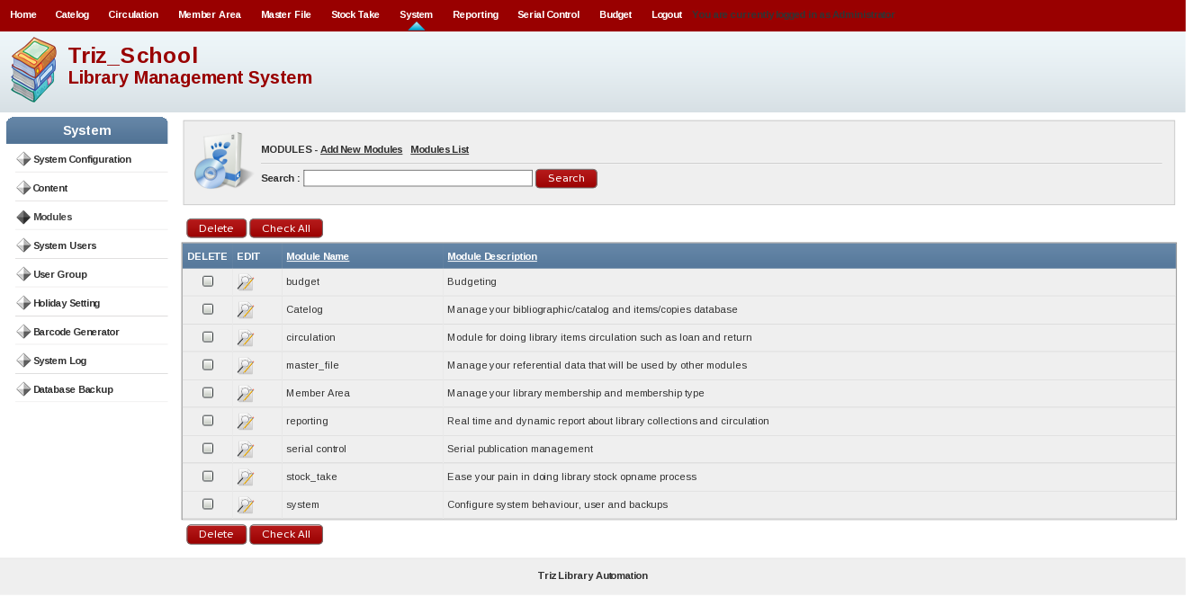
This will add, edit and delete module from the system.

[4] System Users

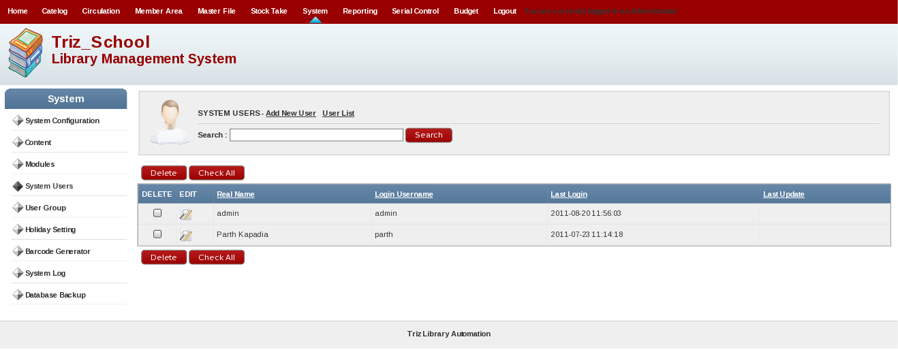
This will create,edit and delete system user for this system.

[5] User Group

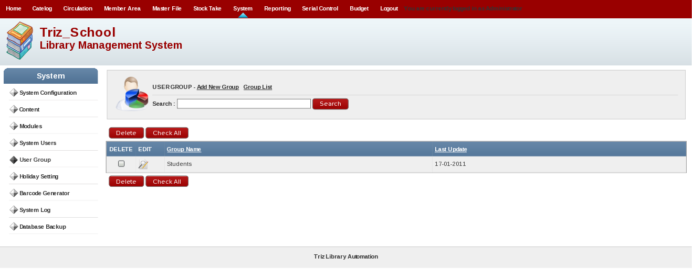
This will create user group in the system.

[6] Holiday Setting

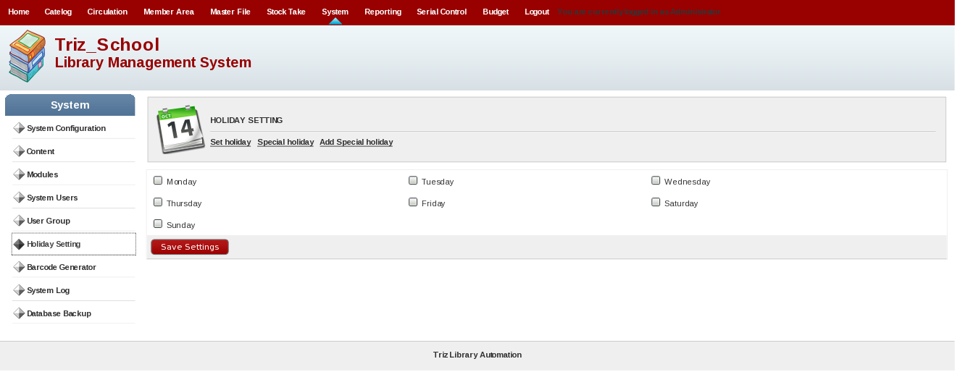
This will set holidays in the system. This will also set special holiday in the system.

[7] Barcode Generator

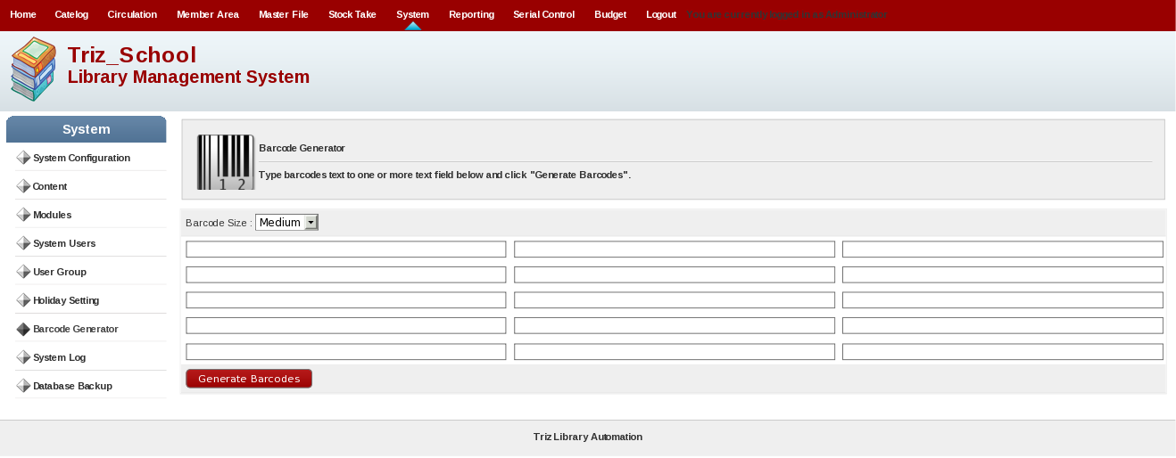
This will generate barcode manually of small, medium and large size.

[8] System Log

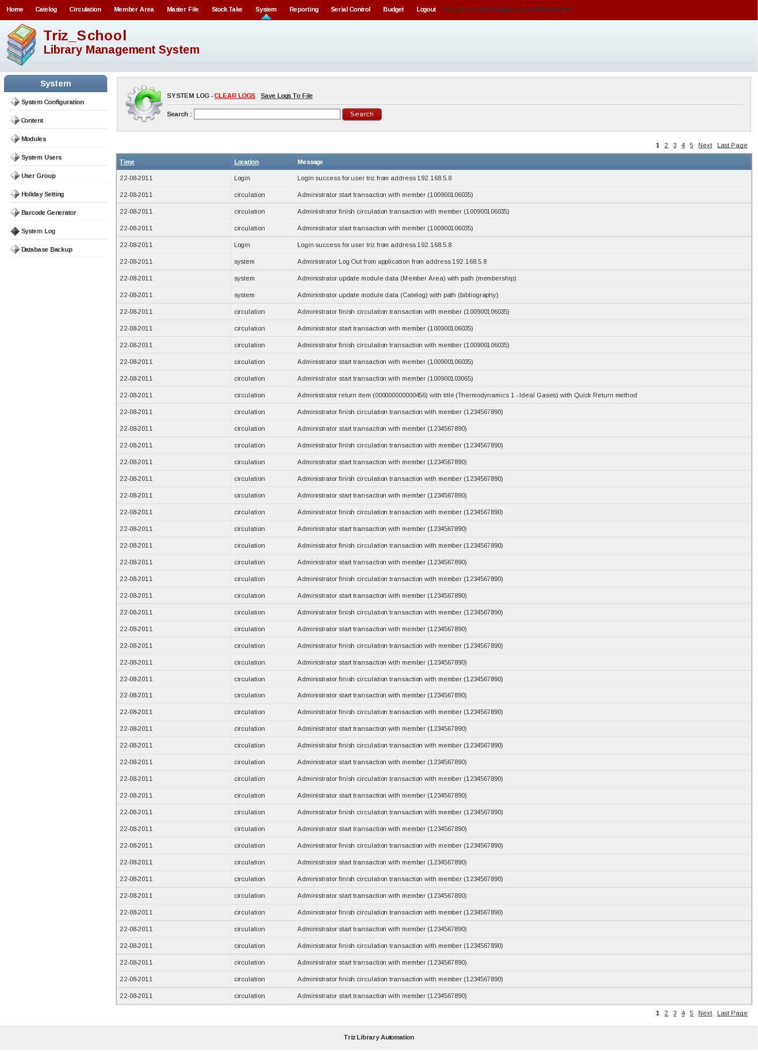

This will display System Activities. It will display log activity in the system.

[9] Database Backup

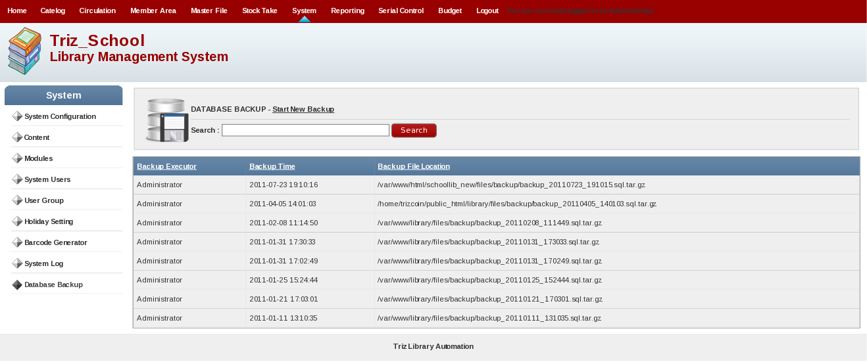
This will display Database Backup list in the system. And also can take backup of database in the system.

9. Reporting

Reporting Menu Will display following screen and it will include following submenus.

1. Collection Statistic
2. Loan Report
3. Membership Report
4. Custom Recapitulation
5. Title List
6. Item Title List
7. Item Usage Statistic
8. Loan by Classification
9. Active/Inactive Report
10. Member List
11. Loan List By Member
12. Loan History
- Due Date Warning
- Overdue List
- Staff Activity
- Visitor Statistic
- Visitor Statistic(By Day)
- Visitor List
- Fines Report

[1] Collection Statistic
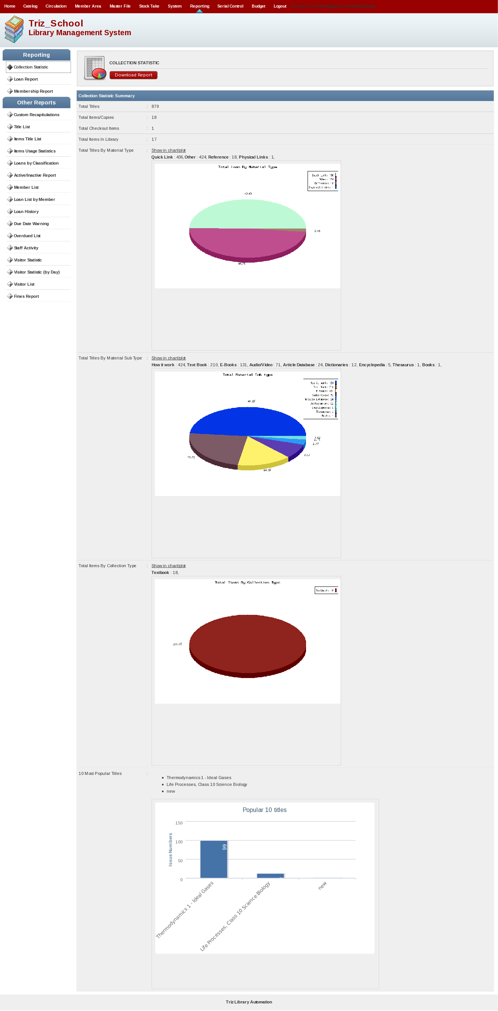
This will display Various collection type and charts of it.

[2] Loan Report

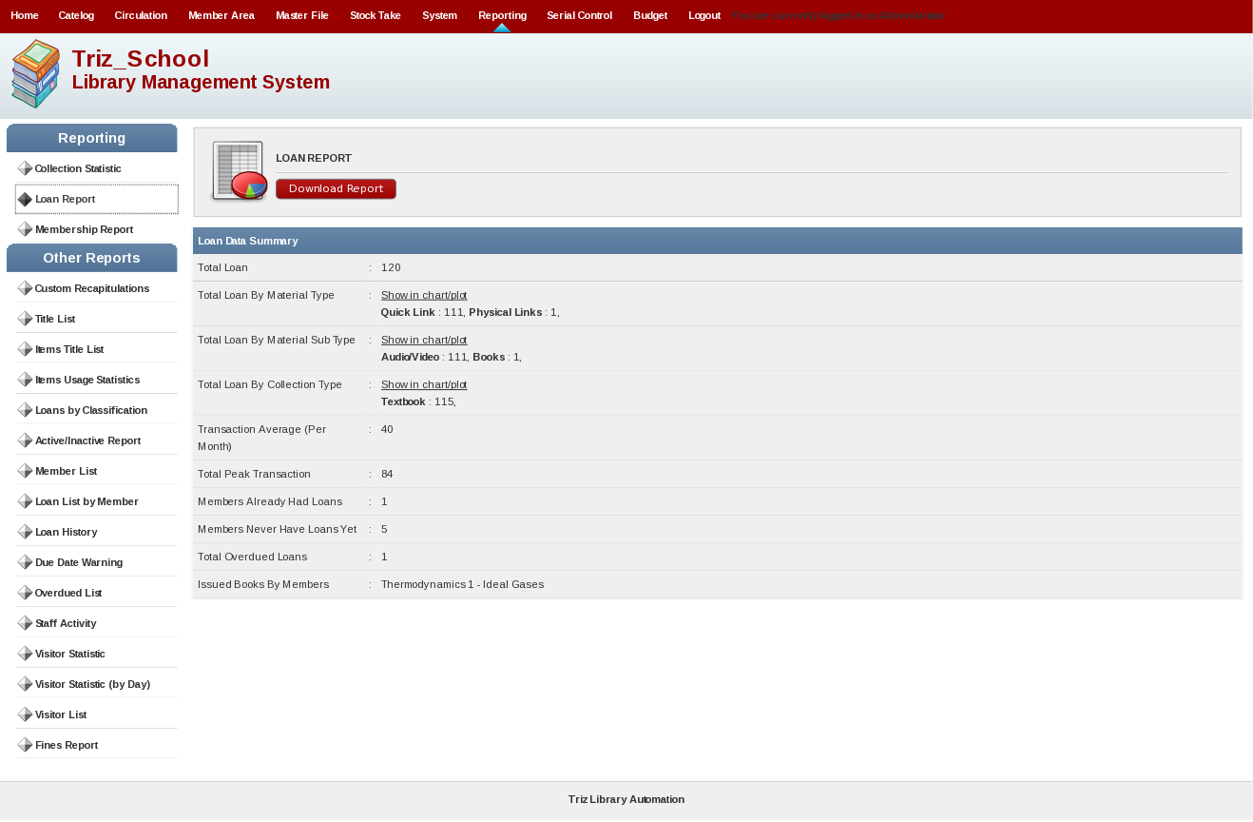
This will display reports related to loans.

[3] Membership Report

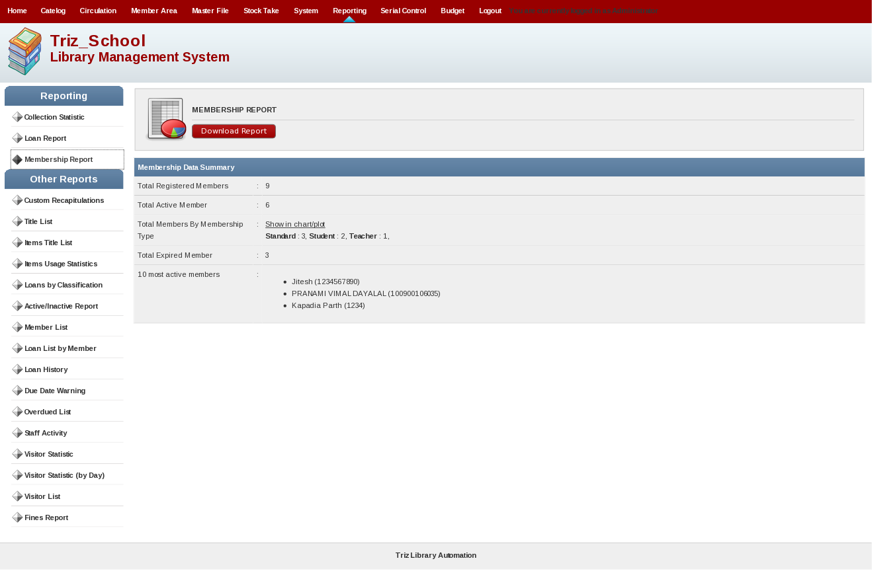
This will display membership related all reports.

[4] Custom Recapitulation

This will display number report related to GMD, Material Sub Type, Classification, Collection Type and Language.

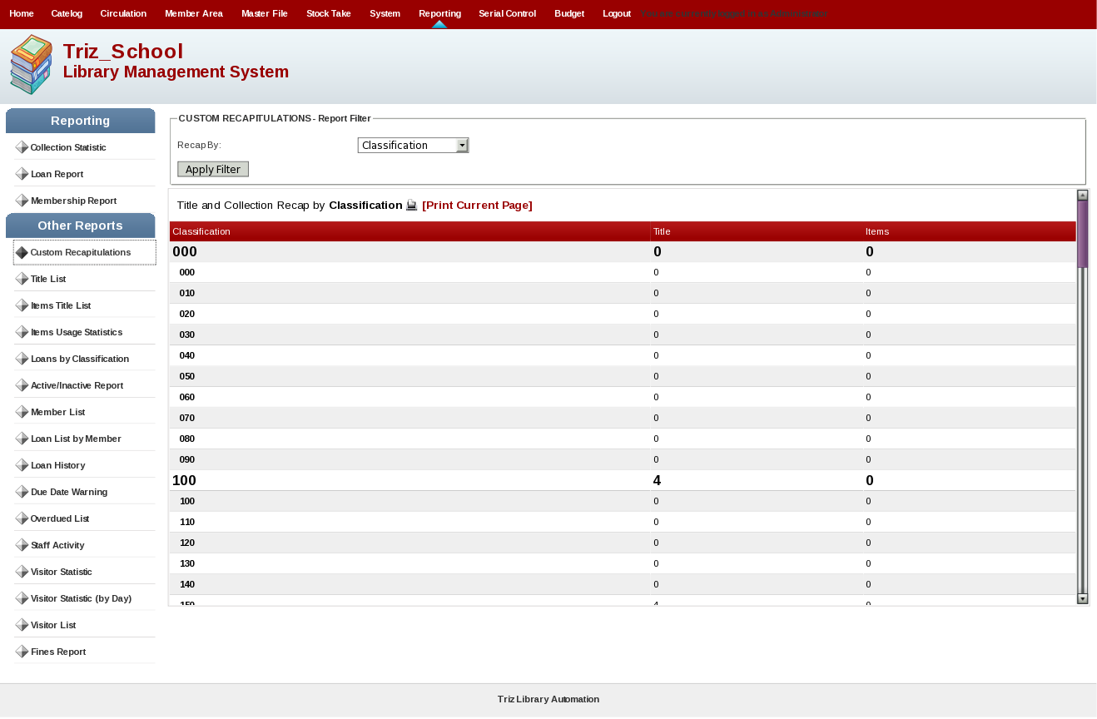

[5] Title List

This will display List by title in the system. You can print such report.

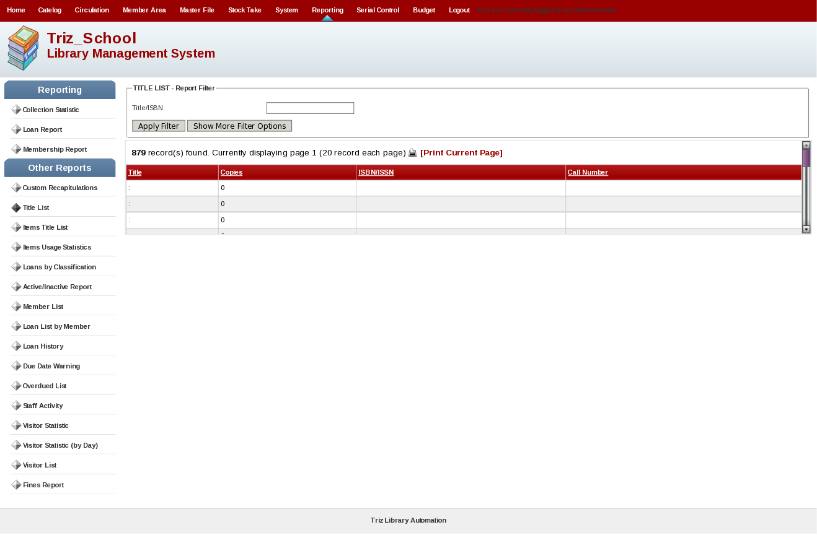

[6] Item Title List

This will display Item List by title in the system. You can print such report.

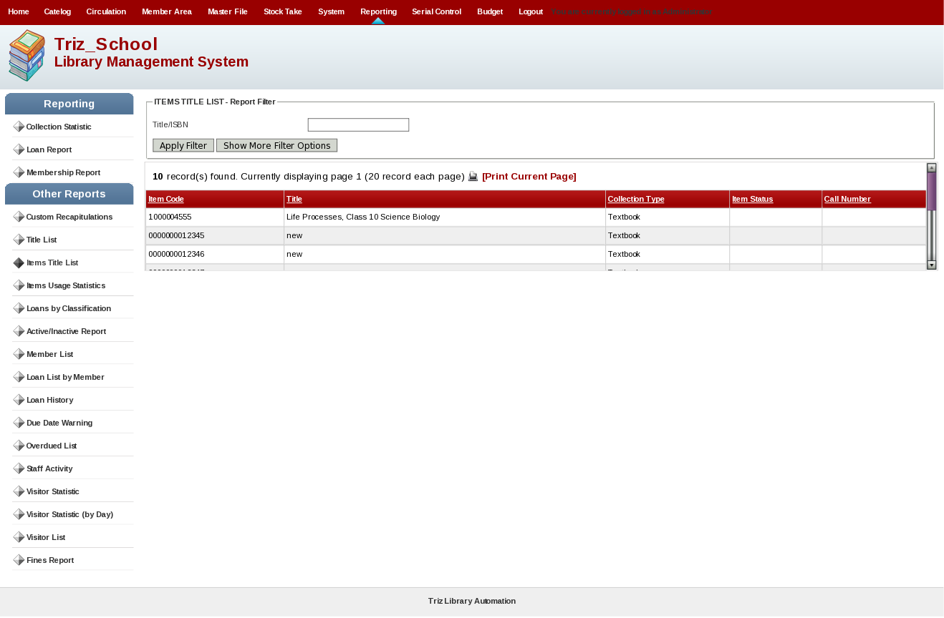
[7] Item Usage Statistic

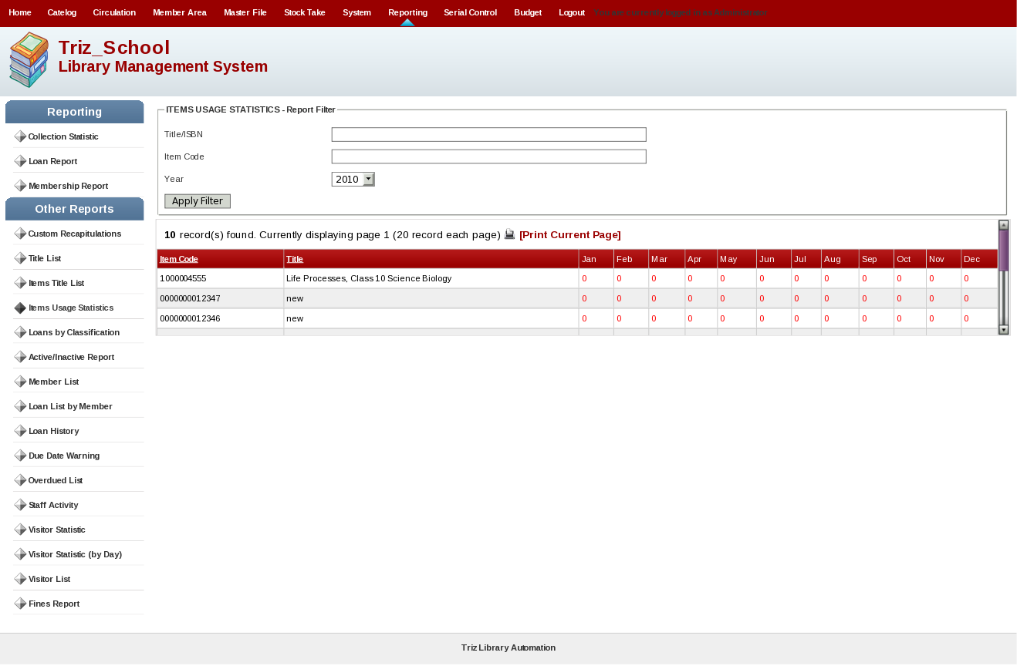
This will display item numeric report for item usage by monthly display. This will print report.

[8] Loan by Classification

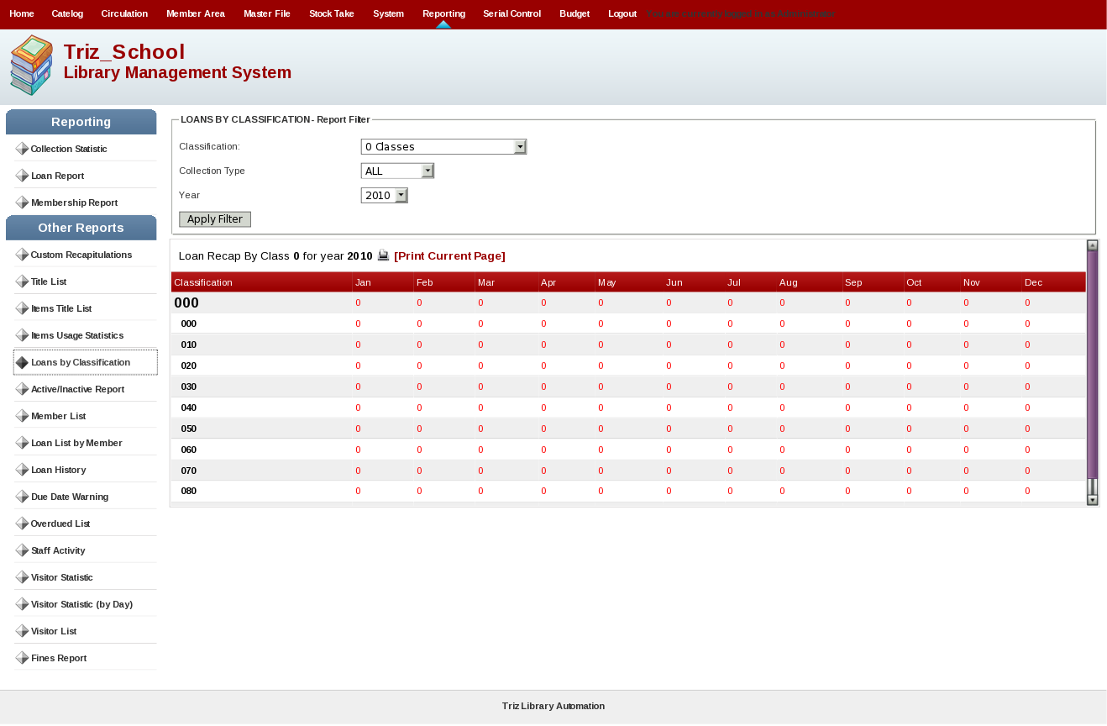
This will display report of Loan by classification number and will print the report.

[9] Active/Inactive Report

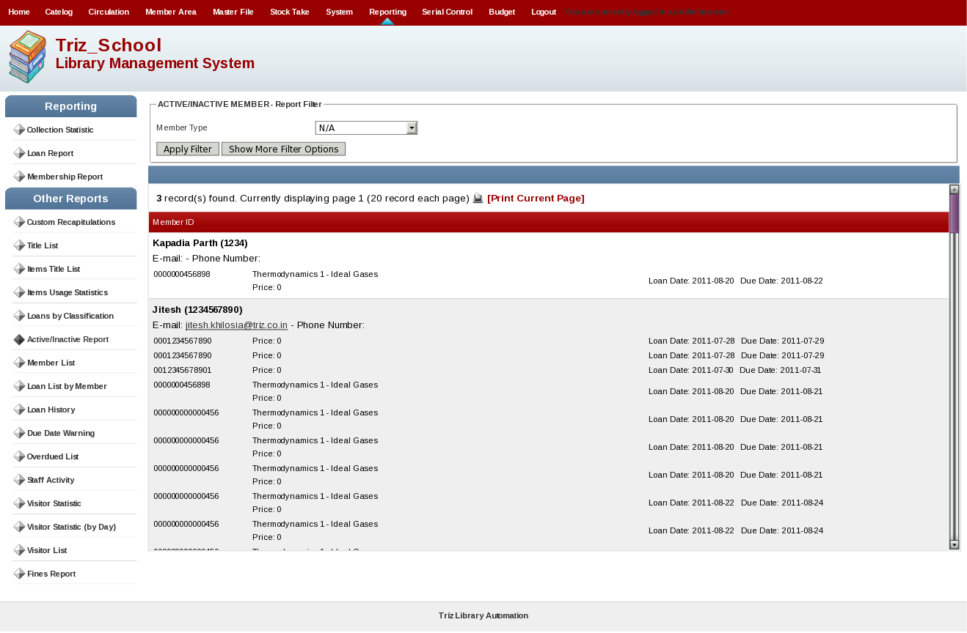
This will display active/inactive report of particular member. This will print such report.

[10] Member List

This will display member list report and will also print such report.

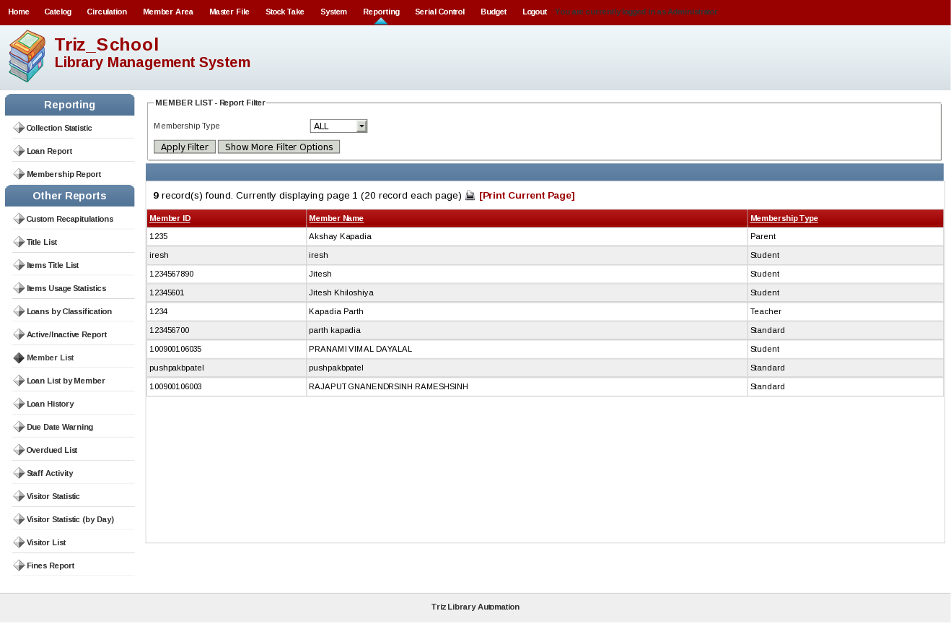

[11] Loan List By Member

This report will display loan list by member. All history of that member will display. This will print report also.

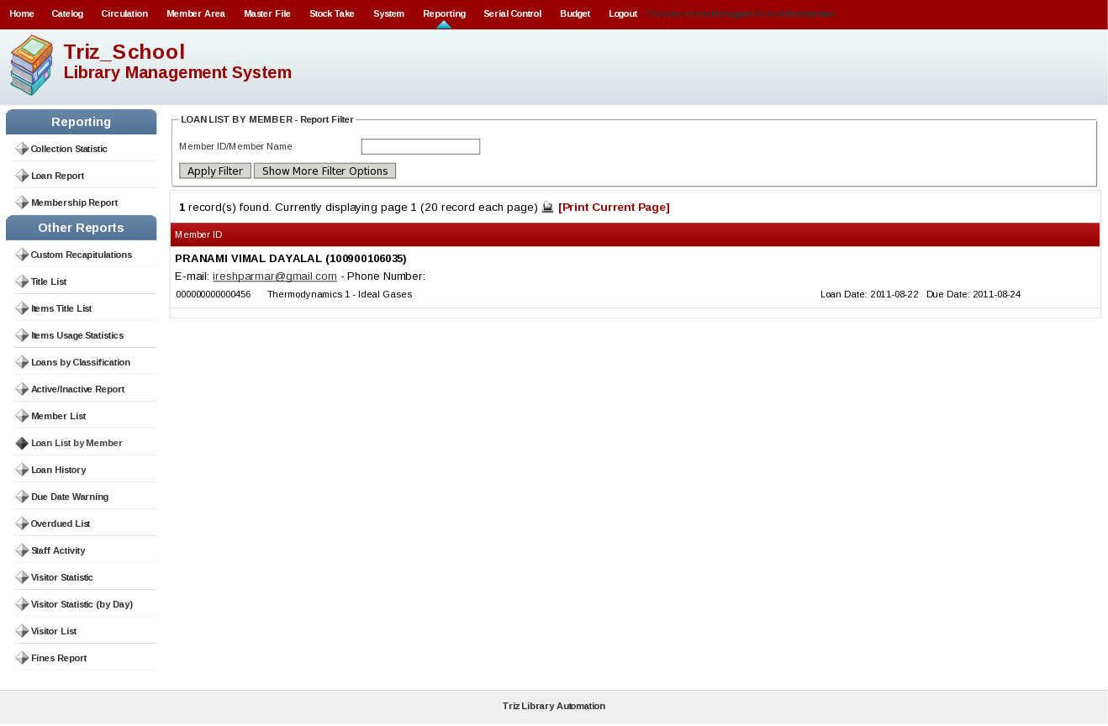

[12] Loan History

This will display loan history lost. This will print report also.

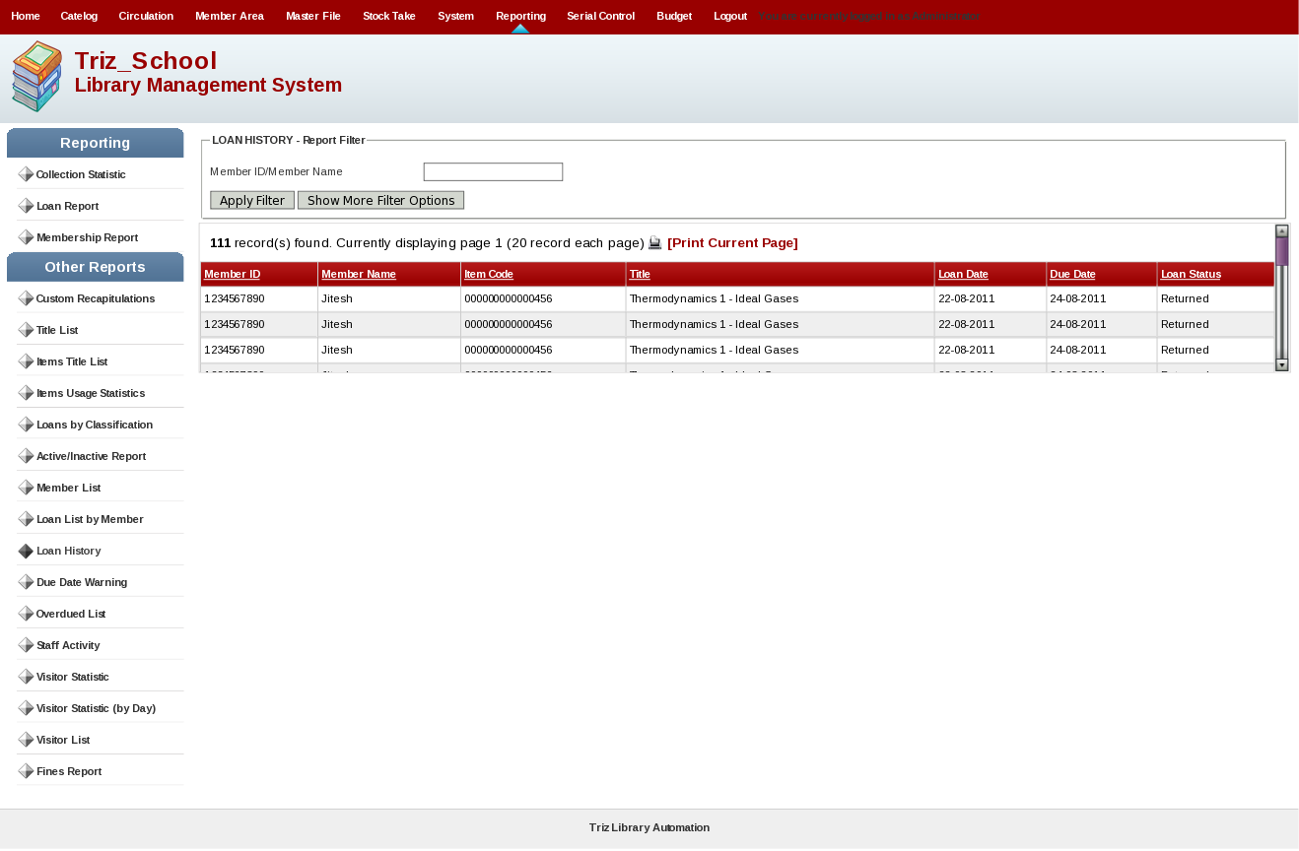
[13] Due Date Warning

This will display due date warning report. You can print this report.

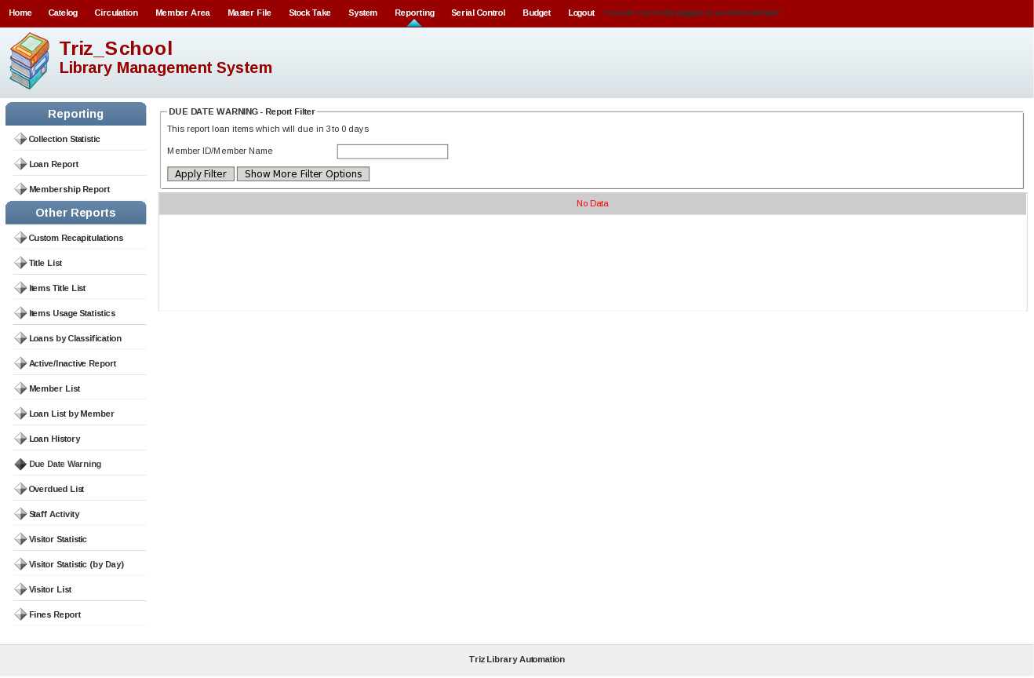
[14] Overdue List

This will display overdue list report. This will print report.

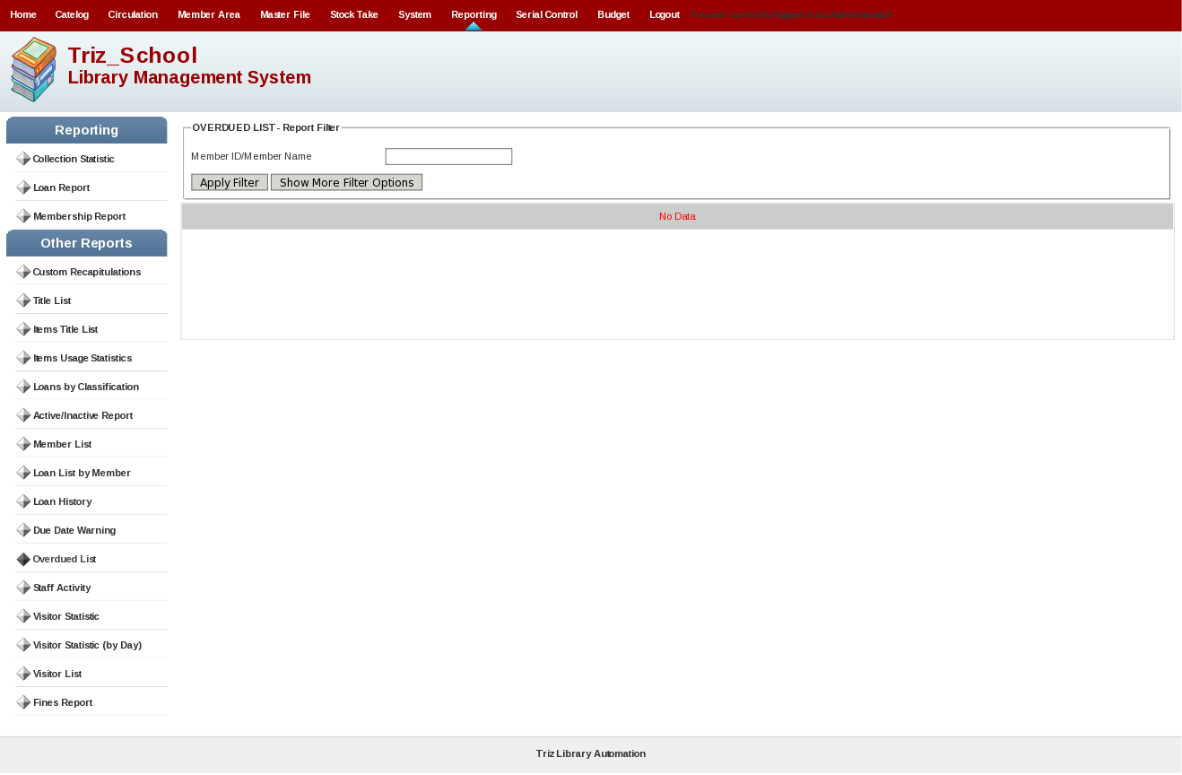
[15] Staff Activity

This will display staff activity means what staff member has done in this system.

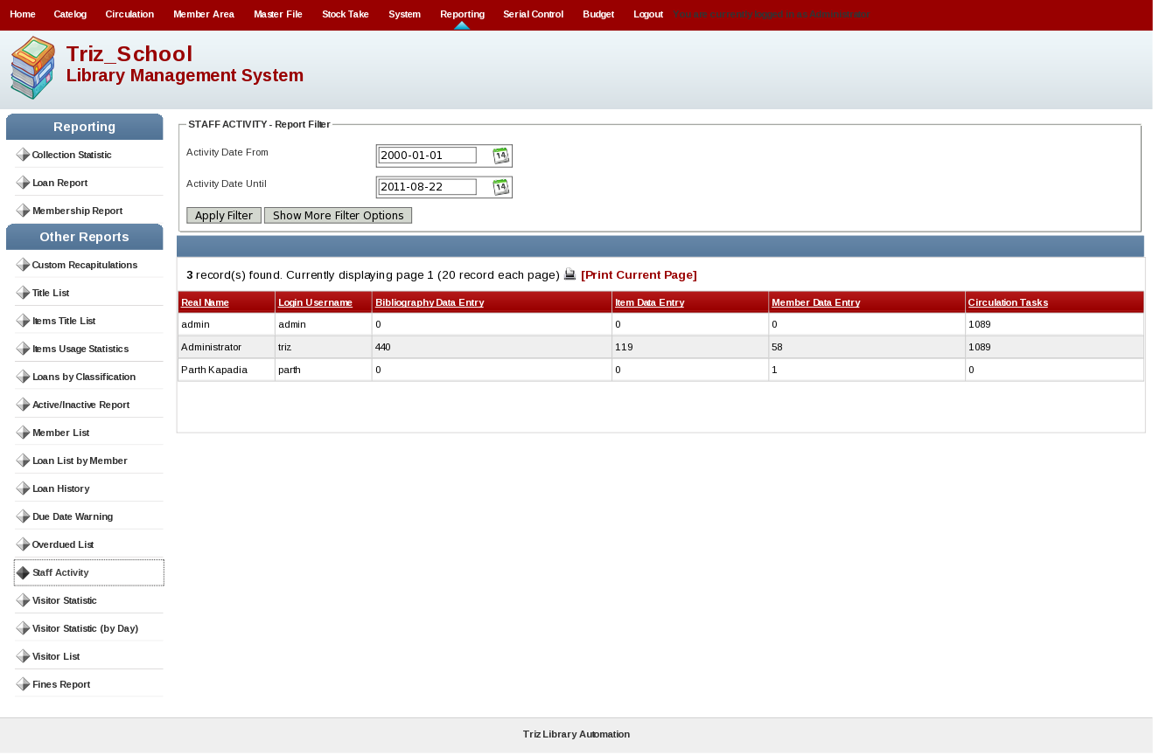
[16] Visitor Statistic

This will display visitor's statistic by month. You can print such report.

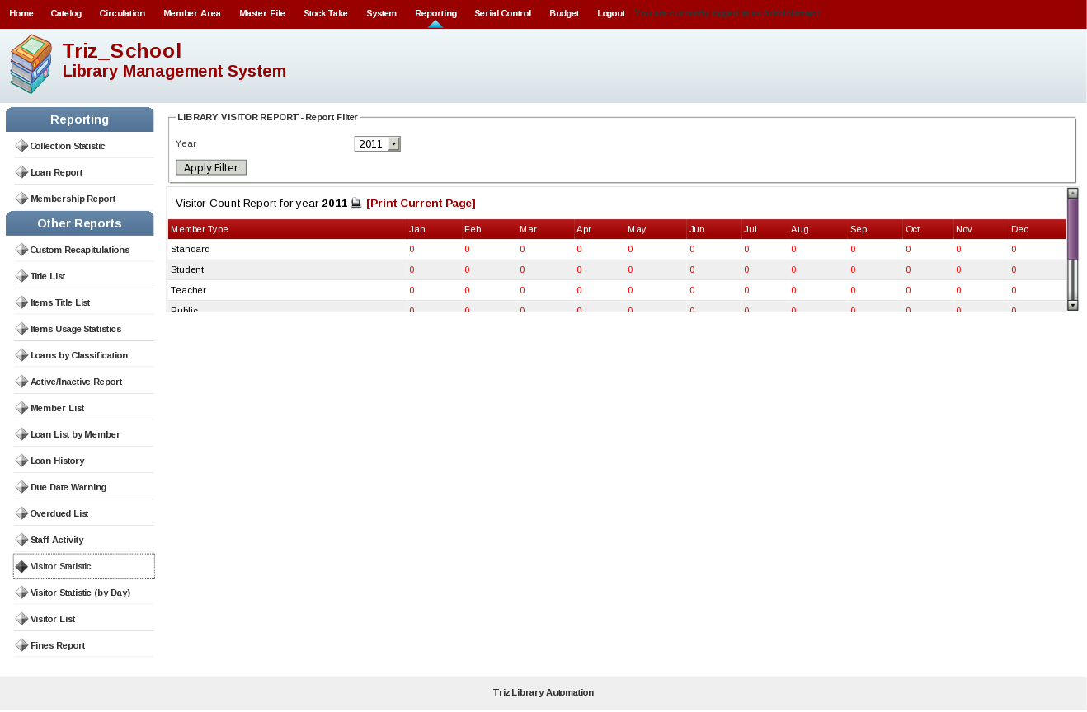
[17] Visitor Statistic(By Day)

This will display visitor's statistic by day. You can print such report.

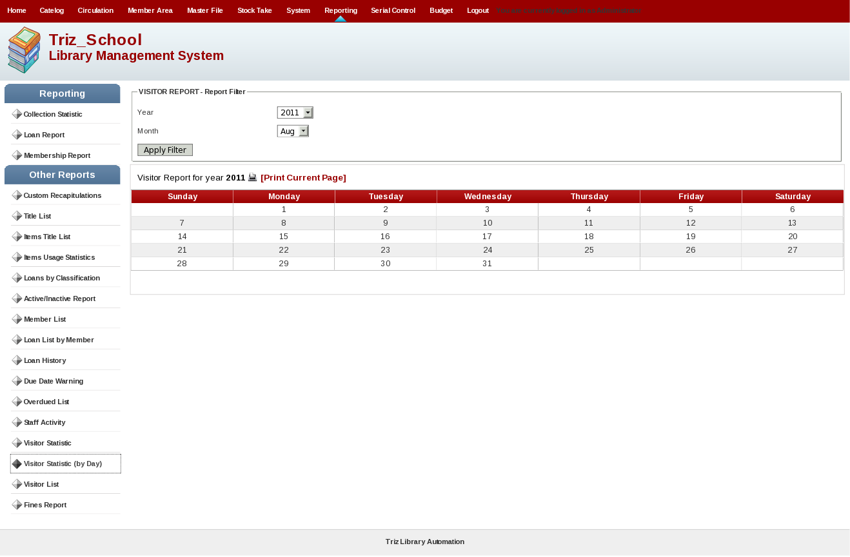
[18] Visitor List

This will display visitor list. You can filter such list by start and end date. You can print such report.

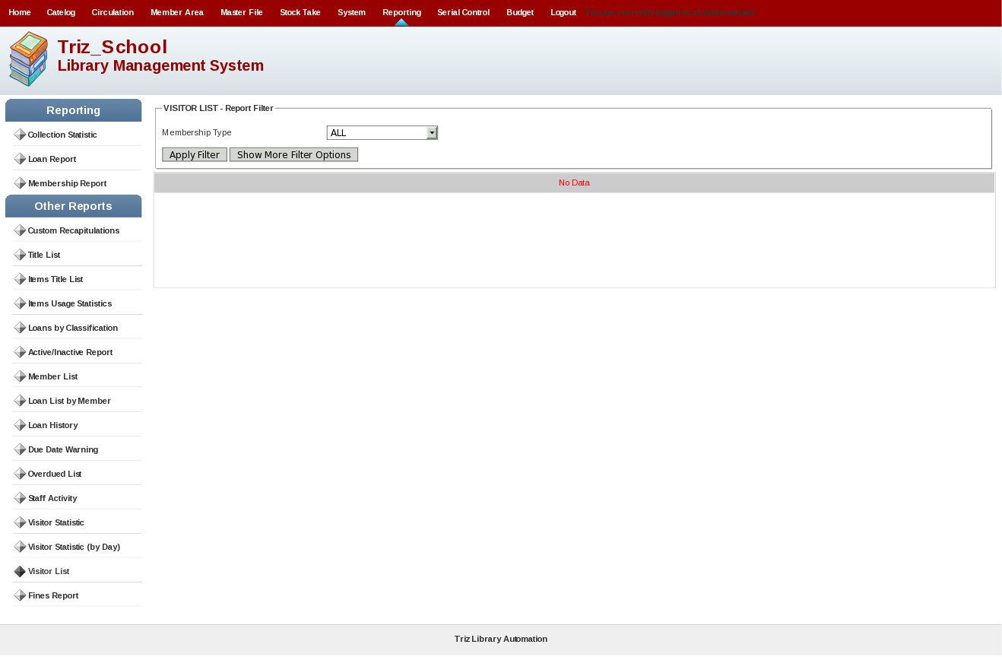
[19] Fines Report

This will display Fines report By day. And you can also filter such report. You can print such report.

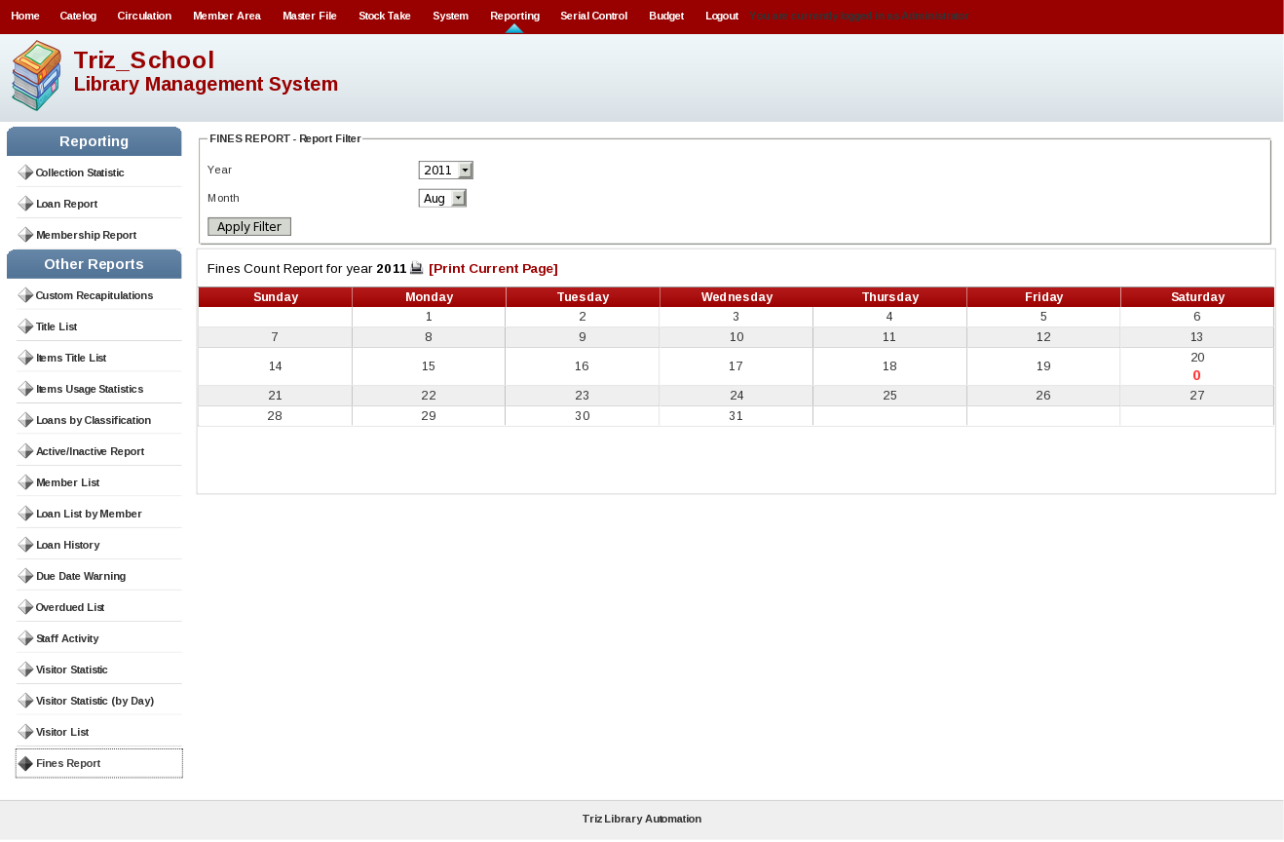

10. Serial Control

Serial Control Menu Will display following screen and it will include following submenus.

1. Subscription

[1] Subscription

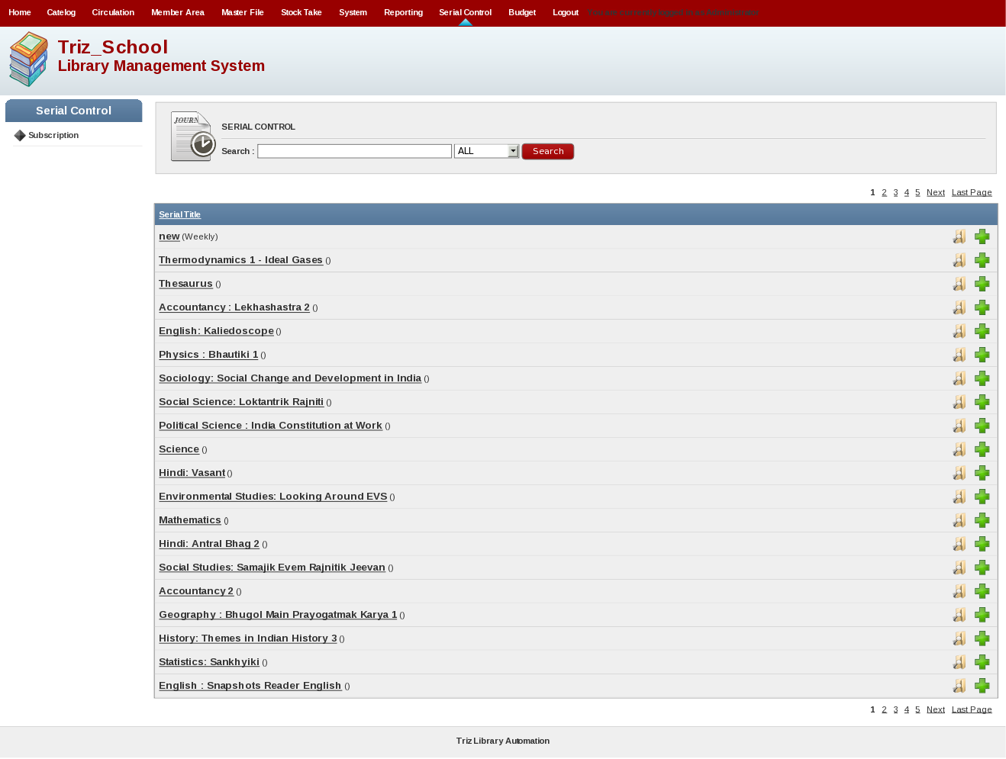
This is for subscription of regular material. You can edit and add subscription. You can also delete such subscription. This will keep record of subscription.

11. Budget

Budget Menu Will display following screen and it will include following submenus.

1. Budget

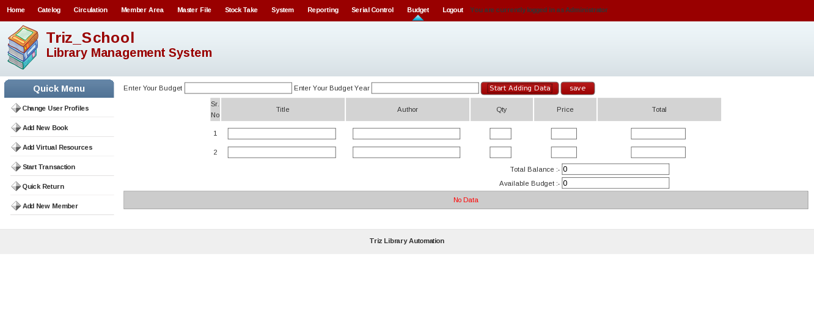
This module is for making budgeting for library. This will display title, Author, Quantity, Price, and Total. Also it will display Total Balance, Available Balance, Enter Your Budget and Enter Your budget year. You can also delete such budget made.

4.2 Member

1) Login

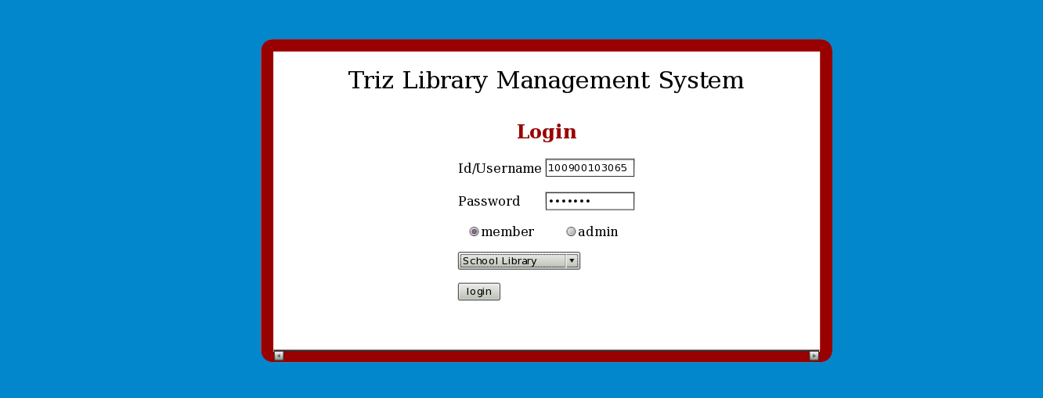
As shown in figure you can see there are two fields Id/Username and Password.

Before clicking on login you need to select which type of user you are whether member or admin. And also you need to select in which library you have to enter school library or engineering library.

Here we are selecting member and school library and after clicking on login you will see following page based on member type.

2) Member Home Page

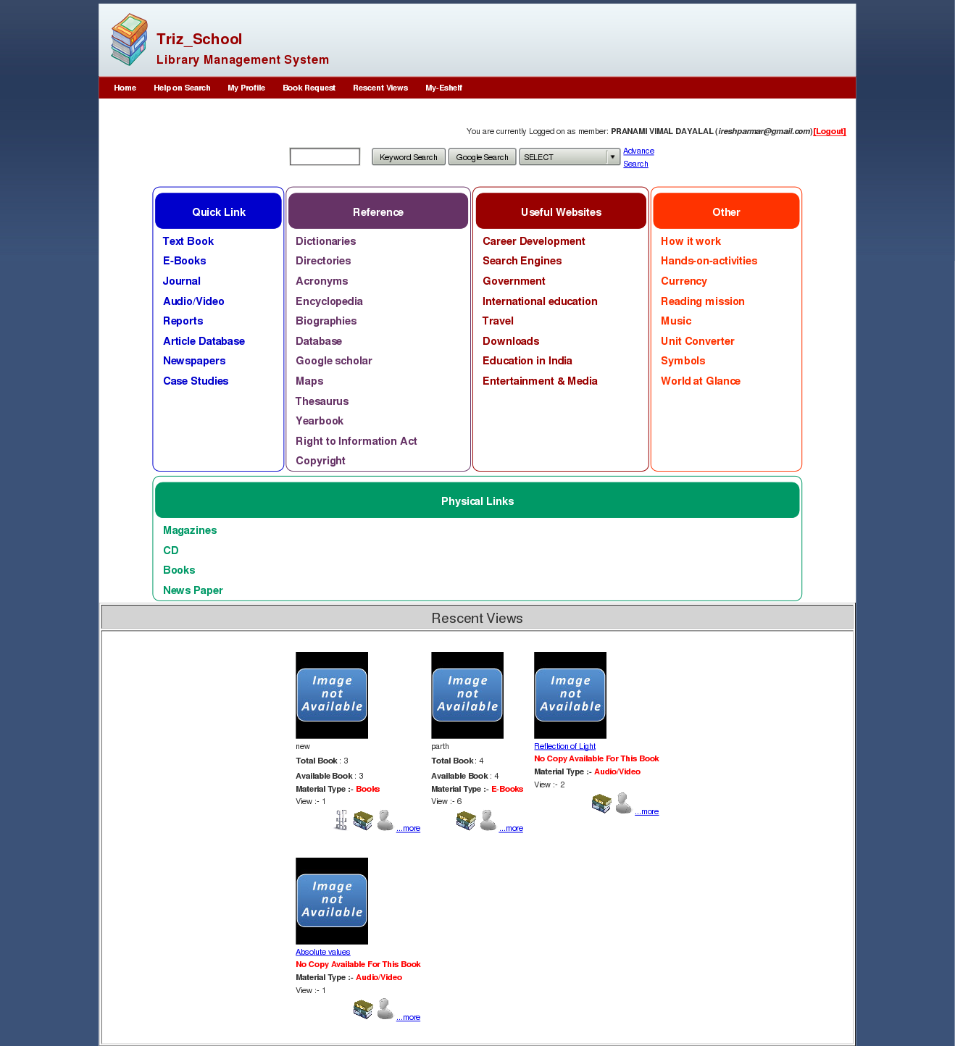
In above figure you can see there are various search criteria for materials is available. Google Search for material is integrated with such view. You can see res-cent viewed materials. Advance search for particular material is integrated with this view. This is student view. Parent, and Teacher view is as follow.

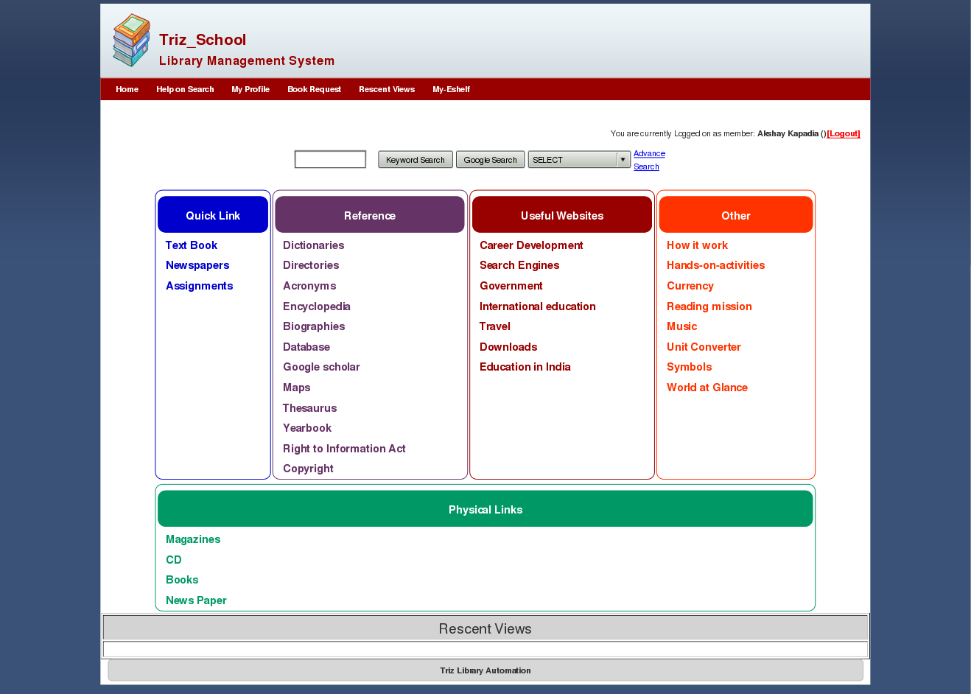
This is Parent view.

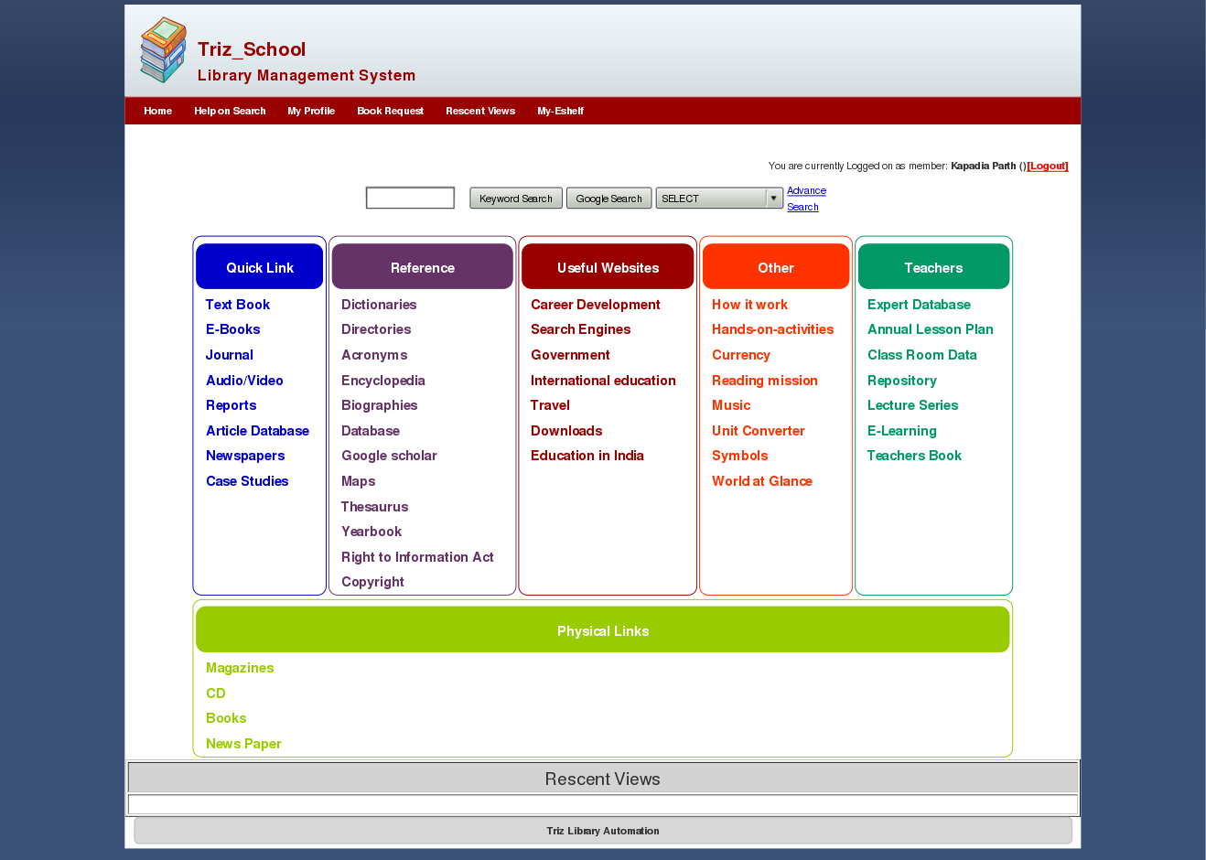
This is Teacher view.

3) Help On Search

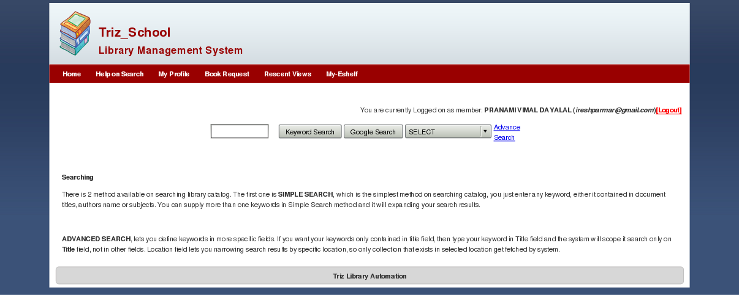
This will display Help on Search Page which will instruct user for searching criteria.

4) Book Request

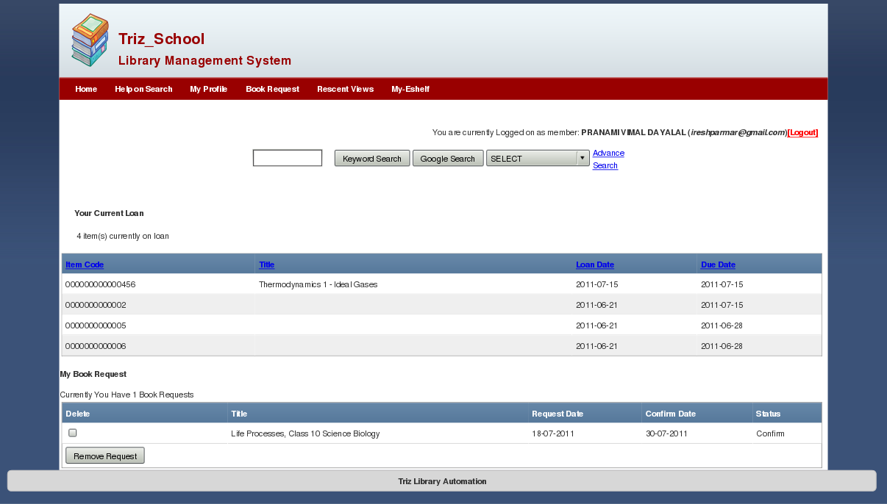
This will display loan issued by member logged in. And also display book requested by member. He can remove such request from here.

5) Material Detail Page

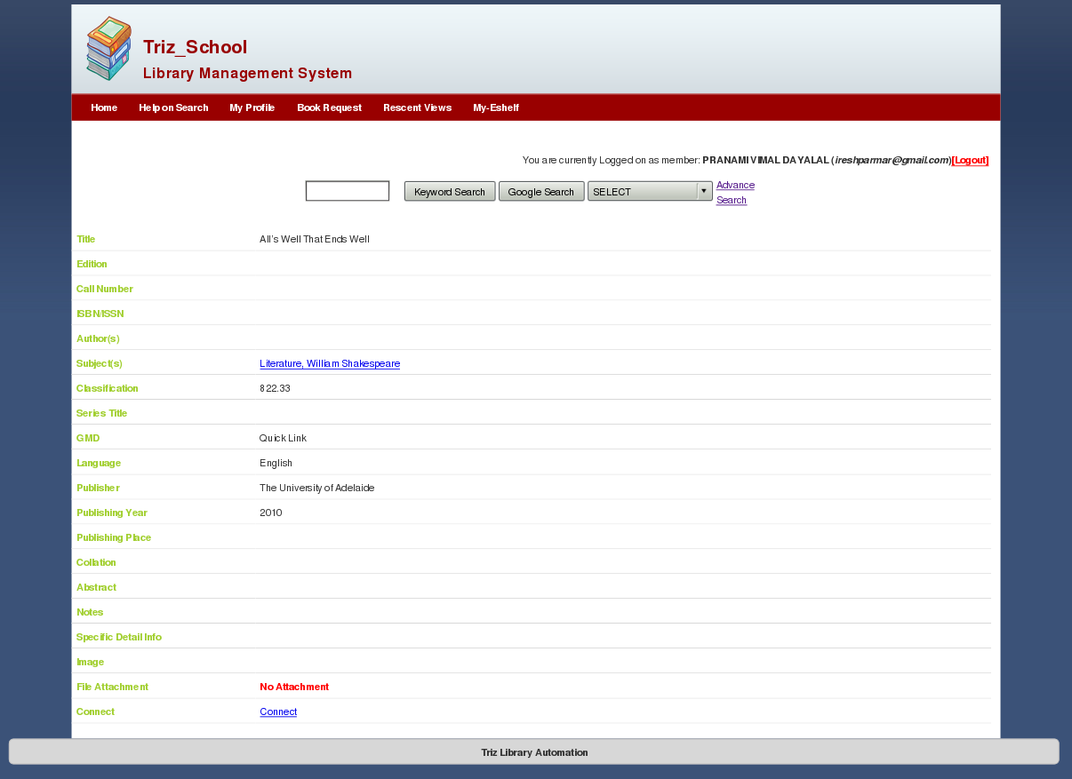
This will display material detail on which will display after clicking on more link. It will also display any file connected with this material. This will display Title, Edition, Call Number, ISBN/ISSN, Author(s), Subject(s), Classification, Series Title, Material Type, Language, Publisher, Publishing Year, Publishing Place, number of Pages(Collation), Abstract, Notes, Specific Detail Info, Image, File Attachment, Connection link for virtual resources.

6) MyEshelf Page

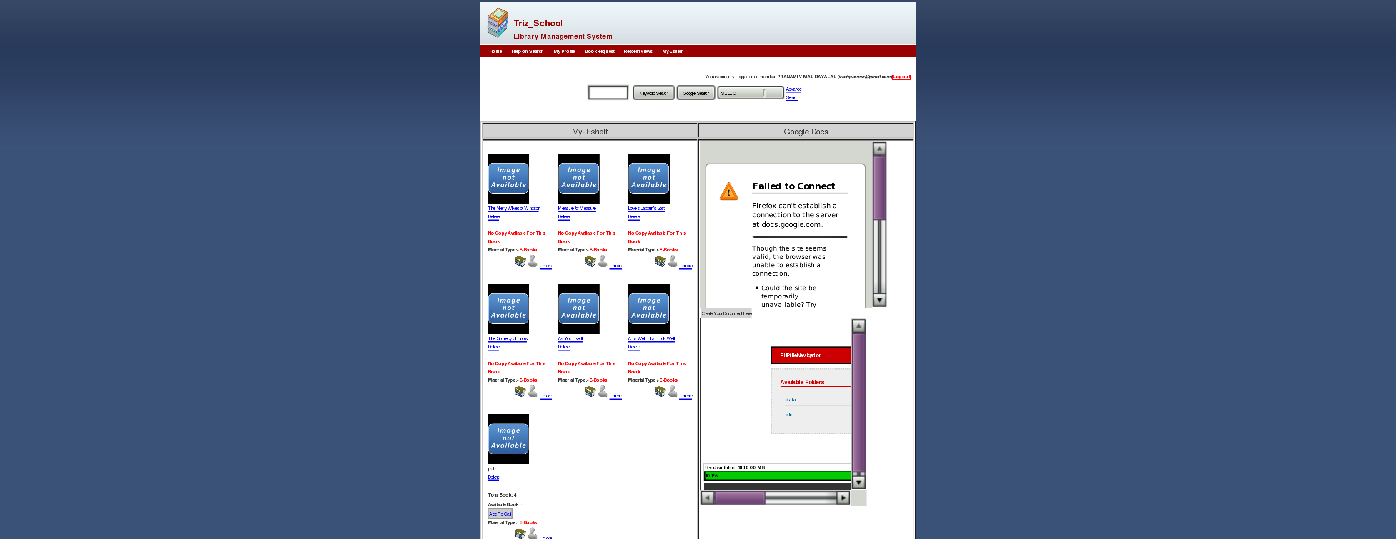
This page will display added material in the my-shelf, It is integrated with google docs, and also it will display document creator which will be useful for creating documents.

7) My Profile Page

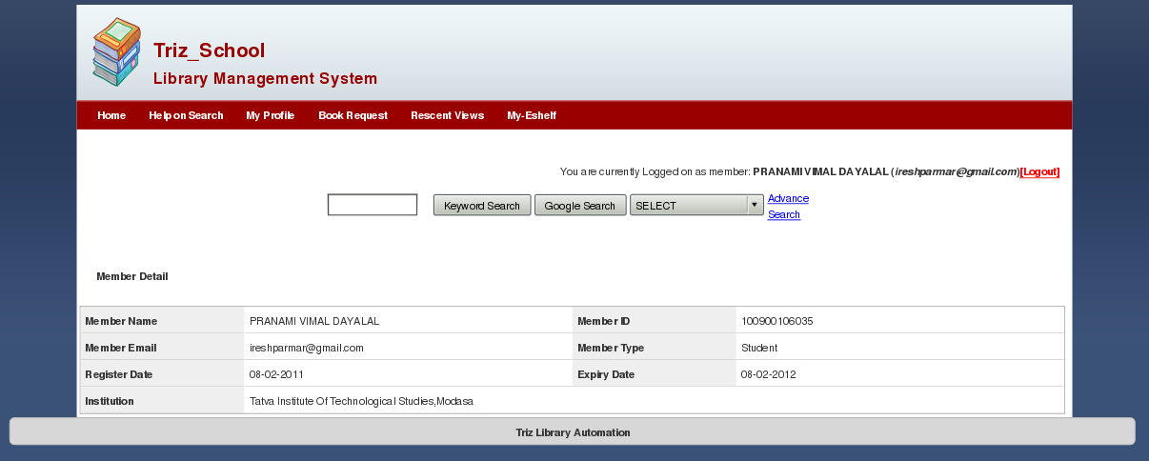
This will display member detail in this page. This will include Member Name, Member Email, Register Date, Institution, Member ID, Member Type, and Empty Date.

8) Re scent View Page

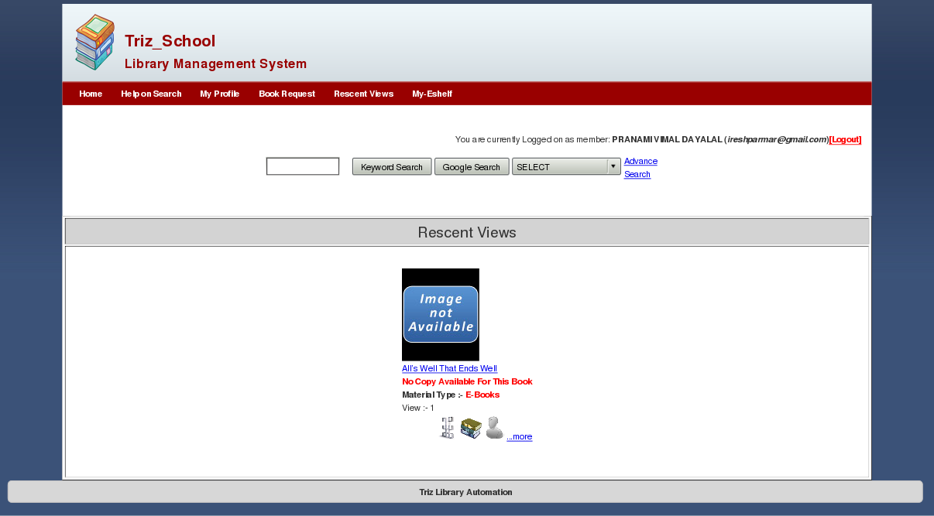
This will display the materials which are viewed rescently. It is record of rescent material viewed.

9) Quick Link->E books Page

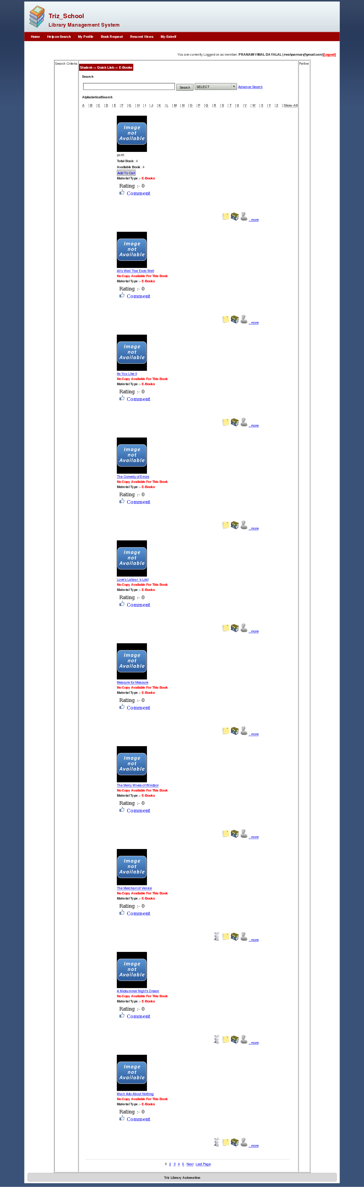
When you click on Any material sub type link on front page You will redirect to such like page which will display that material sub type's material. Here we have display only E books. You have more link at the end of every e books which will display full information of such material.

10) Home Page Keyword Search

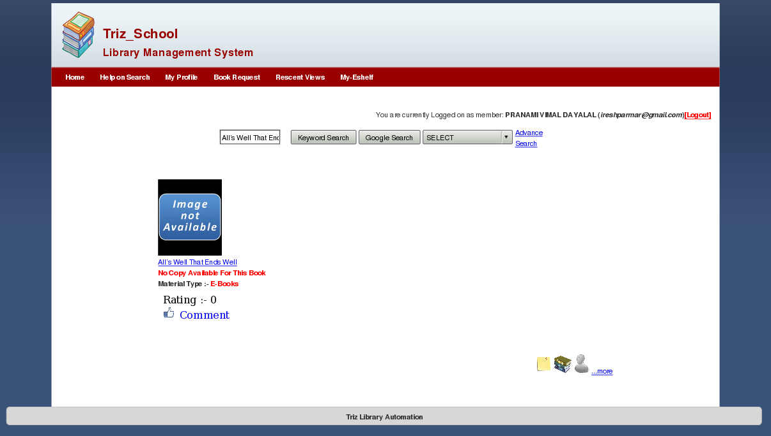

This is keyword search of home page which will display search result for All's well that ends well keywords result.

11) Home Page Google Search



This will display google search of keywords enter in text box. Here we have result for All's Well That ends well book. You can read such book here.

12) Home Page Advance Search

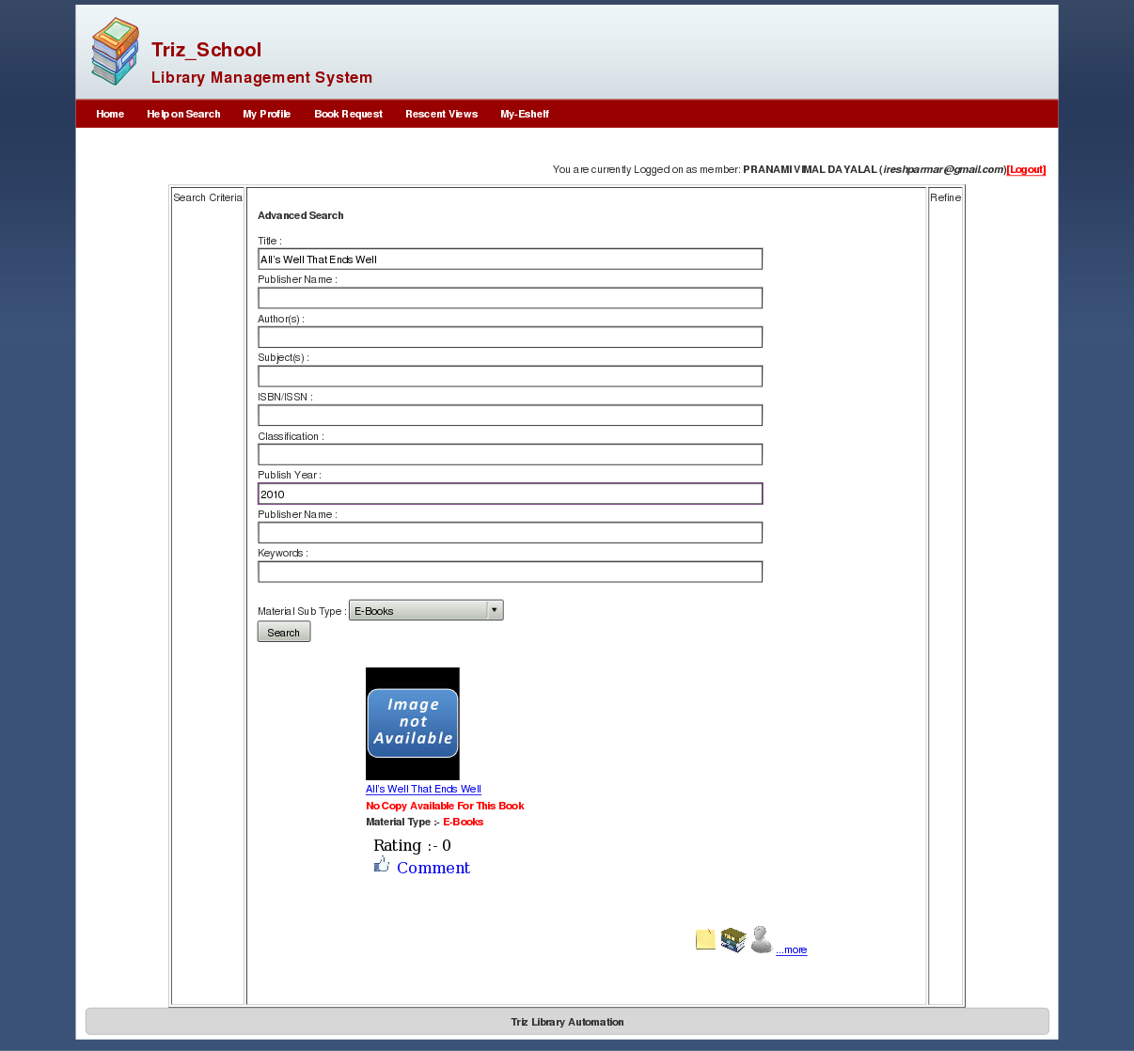
This is home page advance search page. You can search by Title, Publisher Name, Author(s), Subject(s), ISBN/ISSN, Classification, Publisher Year, Publisher Name, Keywords and Material Sub Type.

13) Ebooks Simple Search

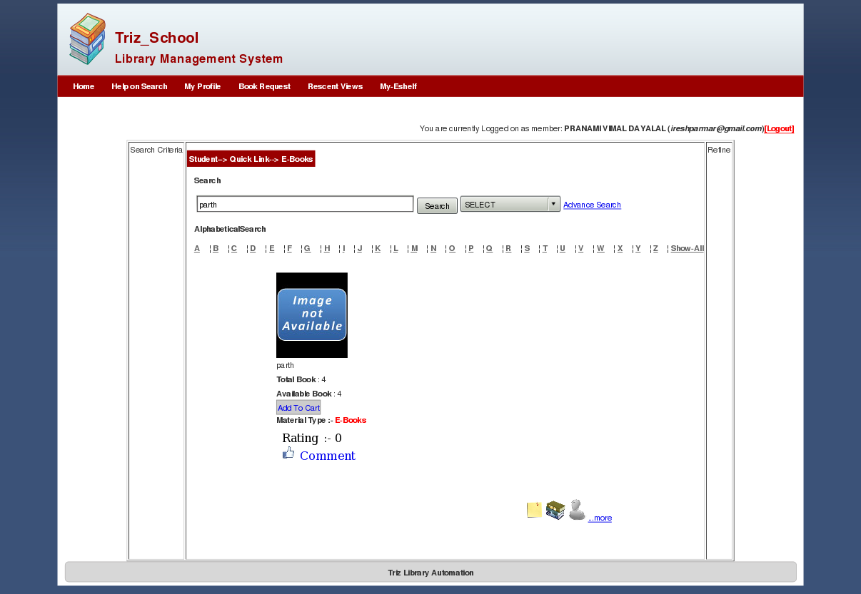
This is same as home page search the difference is that you can search only for Ebooks.

14) Ebooks Advance Search

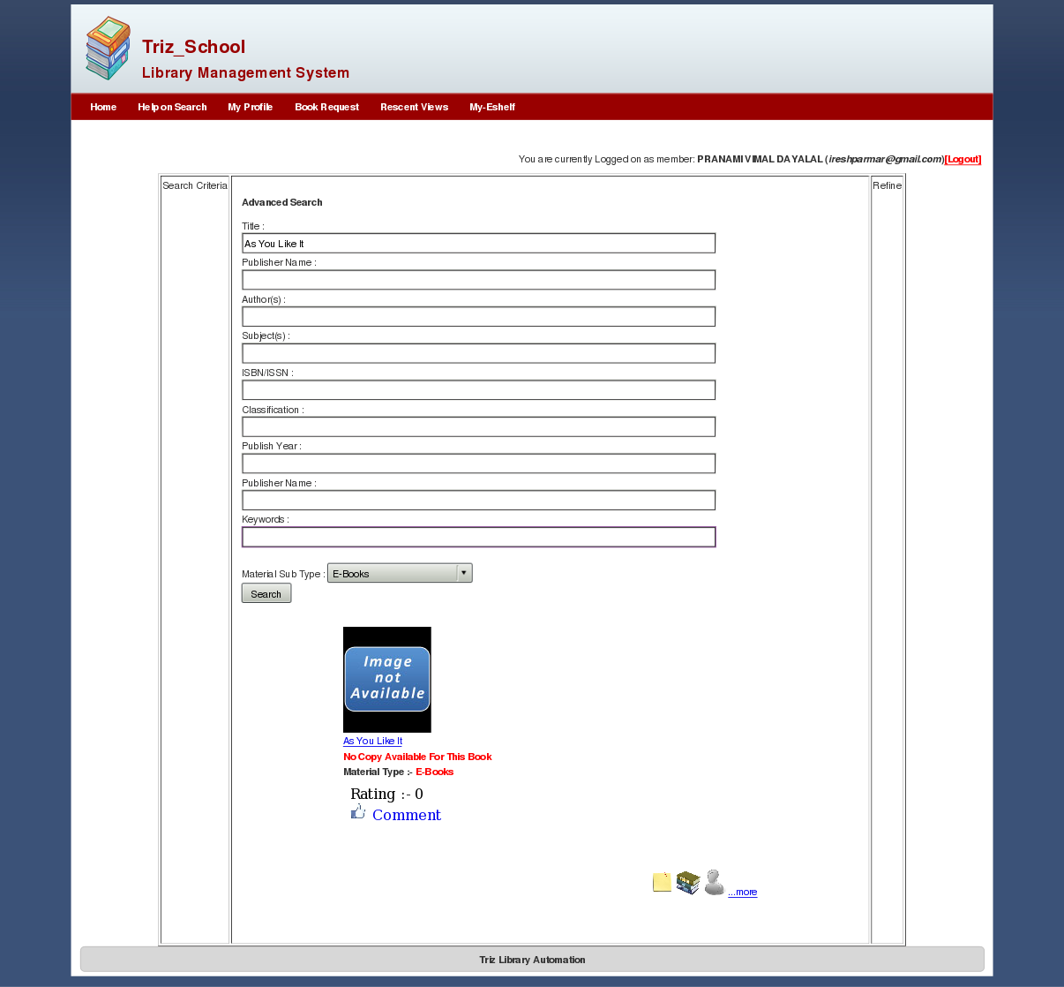
This is same as home page search the difference is that you can search only for Ebooks.

15) Document Creator of MyEshelf page

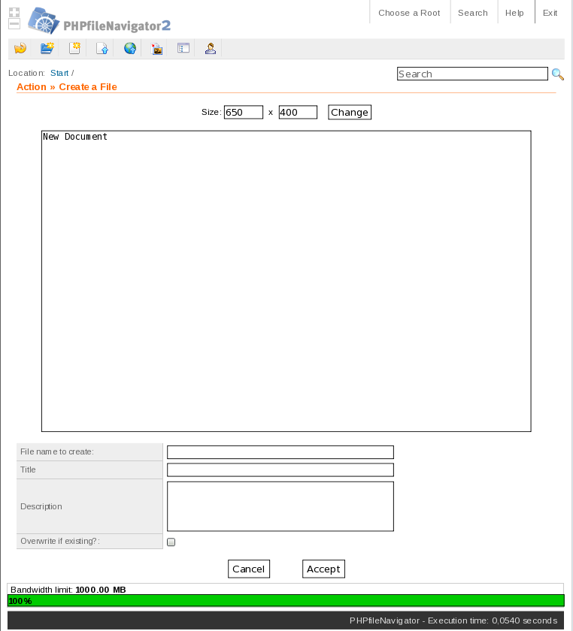
By Using this member can create document and store at particular place.

5. Future Integration

In Future we will try to implement more user friendly system. We will try to make more fast searching criteria, wild level of searching functionality, try to give more wild and rich level of resources, improvement in design.

